**SCHOOL OF ENGINEERING AND TECHNOLOGY**

**ASSIGNMENT / PROJECT SUBMISSION FORM**

**PROGRAMME : BSc (Hons) in Computer Science**

**SEMESTER : Jan / Apr / Aug 2023**

**SUBJECT : WEB1201 / WEB2014 Web Fundamentals**

**DEADLINE : 3August 2023 23:59 MYT**

**INSTRUCTIONS TO CANDIDATES**

* This is a(n) ~~individual~~ / group project.

**IMPORTANT**

# The University requires students to adhere to submission deadlines for any form of assessment. Penalties are applied in relation to unauthorized late submission of work.

# Coursework submitted after the deadline but within 1 week will be accepted for a maximum mark of 40%.

# Work handed in following the extension of 1 week after the original deadline will be regarded as a non-submission and marked zero.

**Lecturer’s Remark** (Use additional sheet if required)

List down the name of the group members and the student IDs here.



Lee Xing Le (Student’s Name) 21030234 (Student ID) .............................. (Signature/Date)



Liew Jieh Cheng (Student’s Name) 21045471(Student ID) .............................. (Signature/Date)



Tee Yu Chen (Student’s Name) 21030317 (Student ID) .. (Signature/Date)



Yen Ming Wey (Student’s Name) 21030457 (Student ID) .............................. (Signature/Date)



received the assignment and read the comments.

**Academic Honesty Acknowledgement**

“I Lee Xing Le, Liew Jieh Cheng, Tee Yu Chen, Yen Ming Wey (Student’s Name) verify that this paper contains entirely my own work. I have not consulted with any outside person or materials other than what was specified (an interviewee, for example) in the assignment or the syllabus requirements. Further, I have not copied or inadvertently copied ideas, sentences, or paragraphs from another student. I realize the penalties *(refer to page 16, 5.5, Appendix 2, page 44 of the student handbook diploma and undergraduate programme)* for any kind of copying or collaboration on any assignment.”

….................................. (Student’s signature / Date)



….................................. (Student’s signature / Date)

....... (Student’s signature / Date)



….................................. (Student’s signature / Date)



**Data Protection**

The protection of personal data is an important concern to Sunway University and any personal data collected on this form will be treated in accordance with the Personal Data Protection Notice of the institution.

http://sunway.edu.my/pdpa/notice_english (English version)

http://sunway.edu.my/pdpa/notice_bm (Malay version)

**1. Introduction**

*[Provide an overview description of the website, including the objectives, scope, and the chosen theme or topic for the website.]*

The "OOTD" website, short for "Outfit of The Day," is a fashion-focused online platform that aims to provide users with a seamless and engaging experience while browsing and purchasing fashion items. The website consists of five key pages: Home Page, Browsing Page, Item Page, Wishlist Page, and Shopping Cart Page. Each page serves a specific purpose in the users’ journey, offering unique features and functionalities to enhance the overall shopping experience.

The main objective of the OOTD website is to provide a user-friendly interface that allows customers to explore and purchase fashion items effortlessly. The website aims to showcase the latest fashion trends, provide comprehensive product information, and enable users to create wish lists while managing their shopping carts efficiently. The scope of the website is to deliver a visually appealing platform incorporate with a seamless and enjoyable shopping experience to our customers.

The design concept for the OOTD website revolves around creating a clean, minimalistic, and modern aesthetic. The primary color scheme incorporates a classic white-greyish background as the base with a touch of vibrant pink shade as the secondary color to evoke visual interest and capture users' attention. The chosen font, Inter, a sans-serif typeface, is selected for its versatility and readability across different age groups. It enhances the website's overall clarity and ensures that users can easily read the contents and navigate through various pages. A URW Chancery L cursive font is also occasionally used to provide diversity to the fonts.

**2. Design Concept**

*[Explain the design concept and rationale behind the visual appearance and layout of the website. Discuss how the design choices align with the target audience and the overall goals of the project. If there are any changes to your initial design submitted, explain and justify.]*

**Header and Footer**

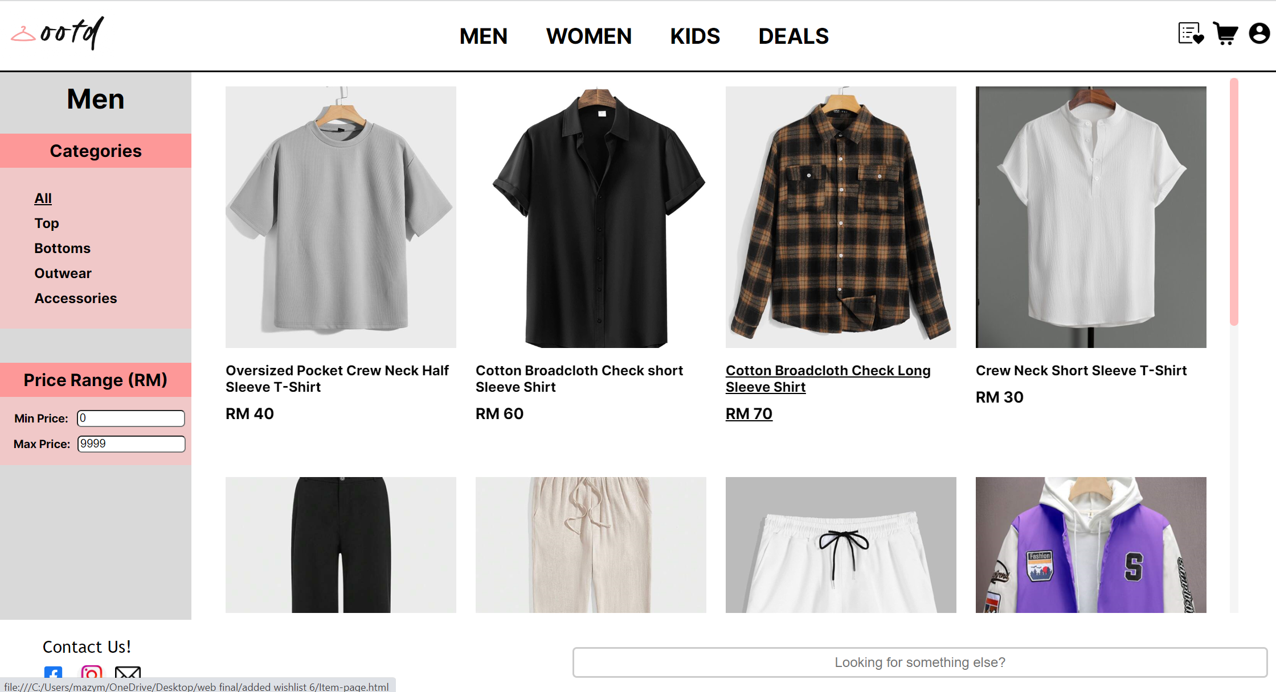

The consistent header and footer across all pages offer users easy access to essential links, ensuring convenient navigation. Our logo is prominently placed at the top left corner and serves as a visual anchor, establishing brand recognition and providing a direct link to the Home Page. The navigation bar, placed in the middle of the header, allows users to quickly navigate to different webpages. Visual indications such as underlined links upon hover provide clear indications of the selected page, enhancing the overall user experience. The right side of the header incorporates utility links that improve user convenience and accessibility by offering quick and easy access to essential features such as links to the Wishlist Page, Shopping Cart Page, and Account Page.

Furthermore, the footer includes a "Contact Us" link on the left side, directing users to the dedicated contact page. The contact page provides users with an easy-to-use form to submit inquiries or feedback, ensuring effective communication between our website and users. The search bar is placed on the right side of the footer, enabling users to quickly search for specific items or information related to the website. This enhances user convenience by allowing them to easily find what they want without navigating through multiple pages.

**Home Page**

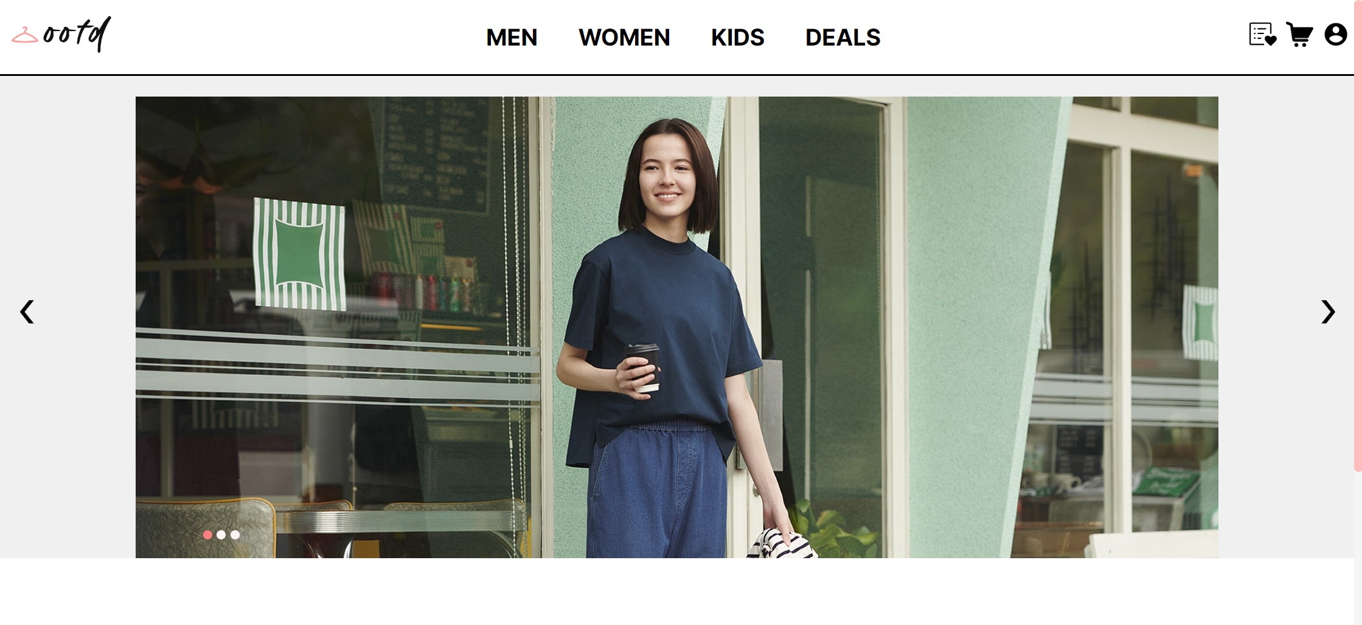 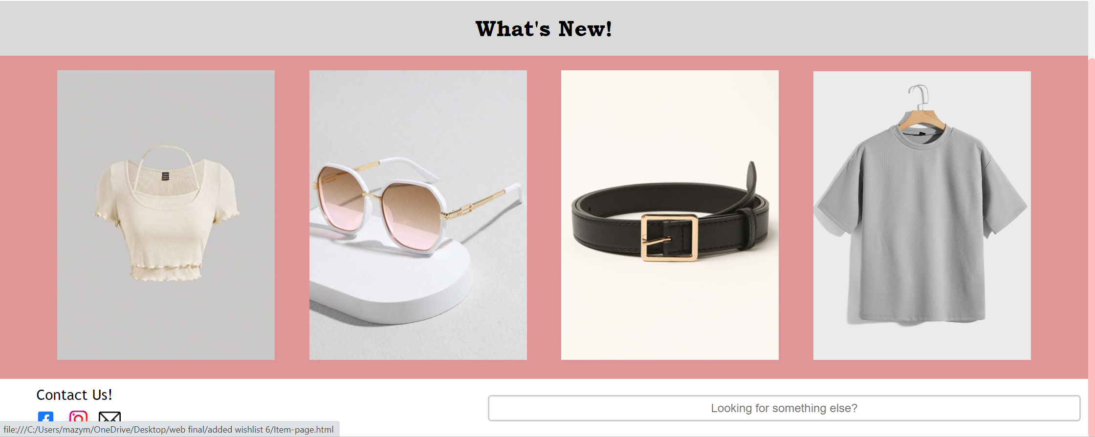

The Home Page serves as a visually captivating entry point for users. A prominently displayed model image occupies a large space in the middle of the Home Page. It is presented as an image carousel that automatically changes every 5 seconds, showcasing different outfits or looks. The visually striking images instantly draw attention and engage the audience. The model image highlights the latest fashion trends, styles, or featured items. By featuring attractive and well-styled models, this webpage aims to encourage users to explore further into our webpage.

The left and right arrow indicators and dot indicators in the model image section facilitate effortless navigation and browsing of featured items. These elements allow users to navigate through the carousel images, providing a visual cue of their current position and enabling them to easily browse and explore the content. The dot indicators indicate the number of available sections and highlight the active section, while the left-right arrows provide intuitive navigation controls, allowing users to move back and forth between the model images with ease.

Located below the model image, the Home Page includes a dedicated "What's New" section. This section showcases the latest items or products offered by the website. It presents users with direct links to the specific item pages, allowing them to explore and learn more about the featured products. By highlighting new and trendy items, the website aims to encourage users to stay updated and explore the latest offerings.

**Browsing Page**



The Browsing Page focuses on providing users with a convenient and intuitive way to explore fashion items. The page incorporates a fixed sidebar positioned on the left side, which serves as a convenient navigation tool. The sidebar displays a large title that clearly indicates the current navigation page, helping users orient themselves within the website. This ensures that users always know their location and can easily switch between different categories or sections.

Within the sidebar, users can choose, and filter items based on specific categories, allowing them to narrow down their search. Each category is presented in a visually appealing manner, and when selected, the system provides visual feedback to indicate the active category. This interactive feature makes it effortless for users to explore different categories and find items that match their preferences.

Moreover, the Browsing Page offers a price range section, empowering users to view items within their desired price range. This feature is particularly useful for users with a specific budget or those who prefer browsing within certain price limits. By providing this option, the website caters to diverse user preferences and offers a more personalized shopping experience.

The main content area adjacent to the sidebar provides ample space to display a wide selection of items. Users can seamlessly scroll through the list of items, enabling them to browse through numerous options without the need to navigate to different pages. The items are thoughtfully organized, ensuring spacing and an aesthetically pleasing layout.

One of the features that we did not implement from our design is the press-to-top button. The reason behind this is that the button will block the images of some of the items, which will be a hinderance to the user’s overall pleasure.

**Item Page**

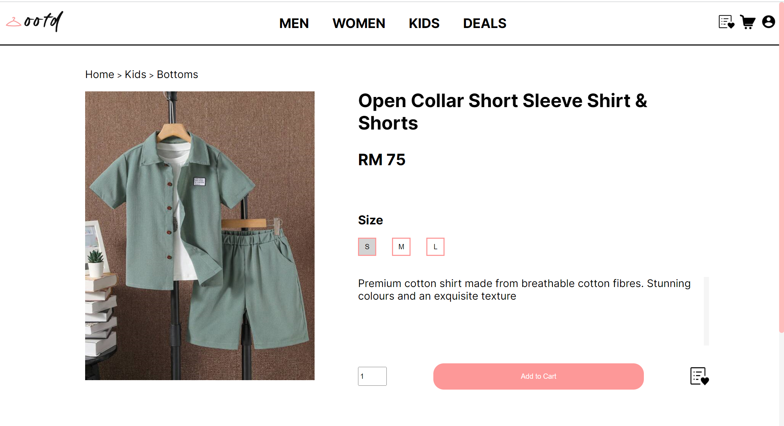

The item page aims to provide users with a comprehensive overview of each product. The layout of the Item Page is carefully structured to enhance usability and facilitate a seamless browsing experience. The page is divided into two main sections, with the left side featuring the item image and a navigation state, while the right side provides detailed product information. This division allows users to focus their attention on the visual representation of the item, while simultaneously offering relevant details in a concise and organized manner.

The rationale behind this layout is to capture the user's attention with the image and create a visual hierarchy with the navigation state that guides their interaction. Placing the item image on the left side allows users to observe it in detail, evoking a sense of desire and curiosity. The navigation state positioned above the image provides users with contextual information, helping them navigate through the website's hierarchy and facilitating their exploration of related items.

On the right side, the product information is presented in a structured manner. The title and price information are displayed prominently at the top, ensuring that users can quickly grasp the key details. Below that, the size information and corresponding buttons allow users to choose their preferred size effortlessly. The description of the item provides additional details and highlights unique features, enabling users to make informed decisions. The quantity selection and buttons that are used to add the item to the Shopping Cart or Wishlist are strategically positioned, ensuring ease of use and a streamlined user flow.

The layout of the page is specially designed to suit fashion-conscious individuals seeking visually appealing and well-presented fashion items. By emphasizing the product image and providing relevant information in a clear and organized manner, the Item Page aims to create an immersive experience that enhances user engagement and encourages them to make confident purchase decisions.

**Shopping Cart Page** 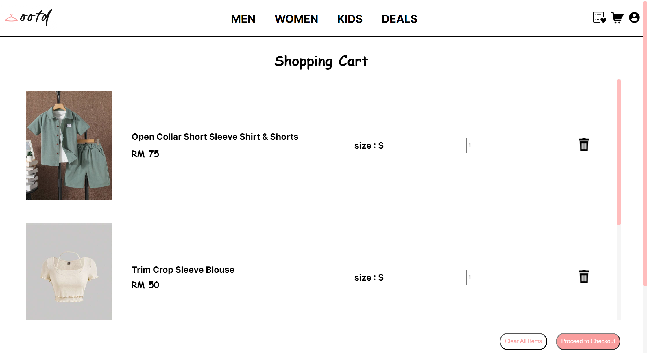

The Shopping Cart Page optimizes the user's purchasing journey by displaying selected items in a horizontal layout. Each item is presented in its own section, horizontally aligned for easy scanning, and checking of details. This layout enables users to quickly review their selected items, ensuring transparency and minimizing errors during the checkout process.

The placement of key functionalities, such as modifying quantities and removing items, is strategically positioned within each item section. This allows users to make changes effortlessly without confusion or unnecessary navigation. Additionally, the presence of a dedicated button to clear all items in the shopping cart streamlines the user experience, saving time and effort.

By providing a visually appealing and user-friendly interface, the design choices enhance usability, instil trust, and encourage users to proceed with their purchases. The layout and visual appearance of the Shopping Cart Page contribute to the overall goals of the project by creating a smooth transition from product selection to checkout, promoting customer satisfaction, and facilitating successful transactions.

**Wishlist Page** 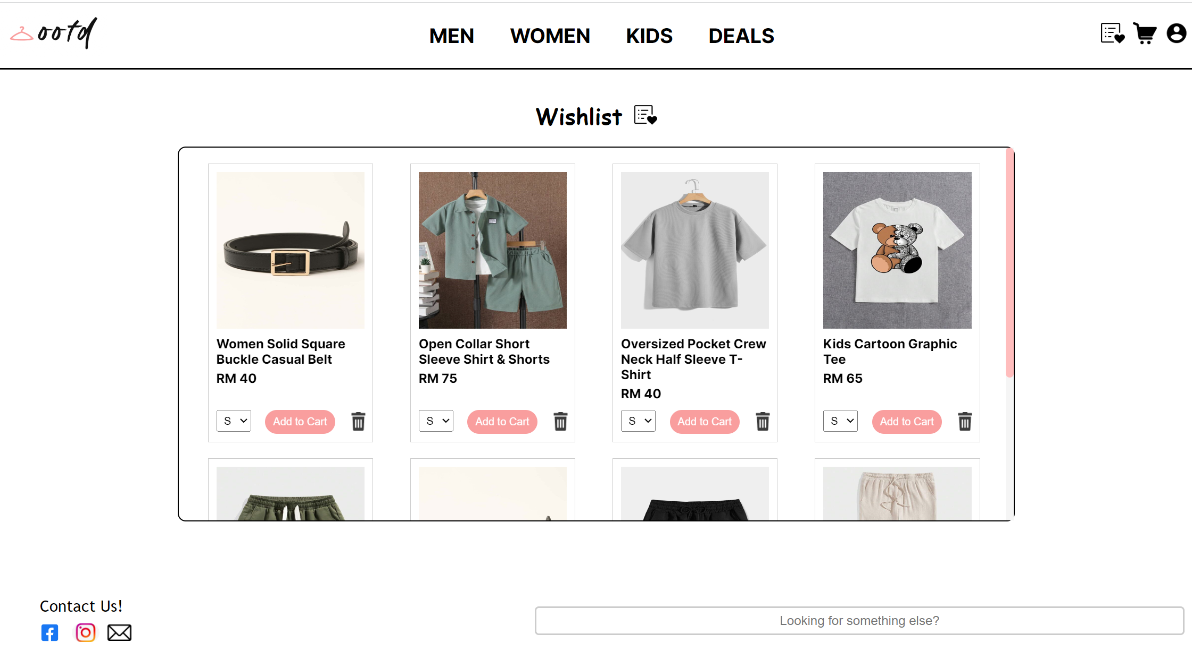

The design concept for the Wishlist Page focuses on simplicity, clarity, and organization. The goal is to provide users with a dedicated space to manage their desired items efficiently and effortlessly. The white color background ensures that the user's attention is directed towards the fashion items showcased in the Wishlist Page.

The layout of the Wishlist Page is designed to promote easy browsing and navigation. The centered title immediately draws attention, emphasizing the significance of the Wishlist as a personalized collection of desired fashion items. The use of a container layout allows for clear separation and organization of individual items, making it easy for users to browse through their Wishlist. Each item is presented with an accompanying image, name, and price, enabling users to quickly identify and locate their items.

The design choices made for the Wishlist Page align with the target audience's preferences and expectations. Fashion enthusiasts and shoppers who enjoy customizing their own personal style will appreciate the simplicity and elegance of the Wishlist Page. The clean layout and organized presentation of items make it convenient for users to review and manage their selections. The inclusion of a bin icon for each item allows users to easily remove undesired items without leaving the page, enhancing usability and control.

**Login Page**

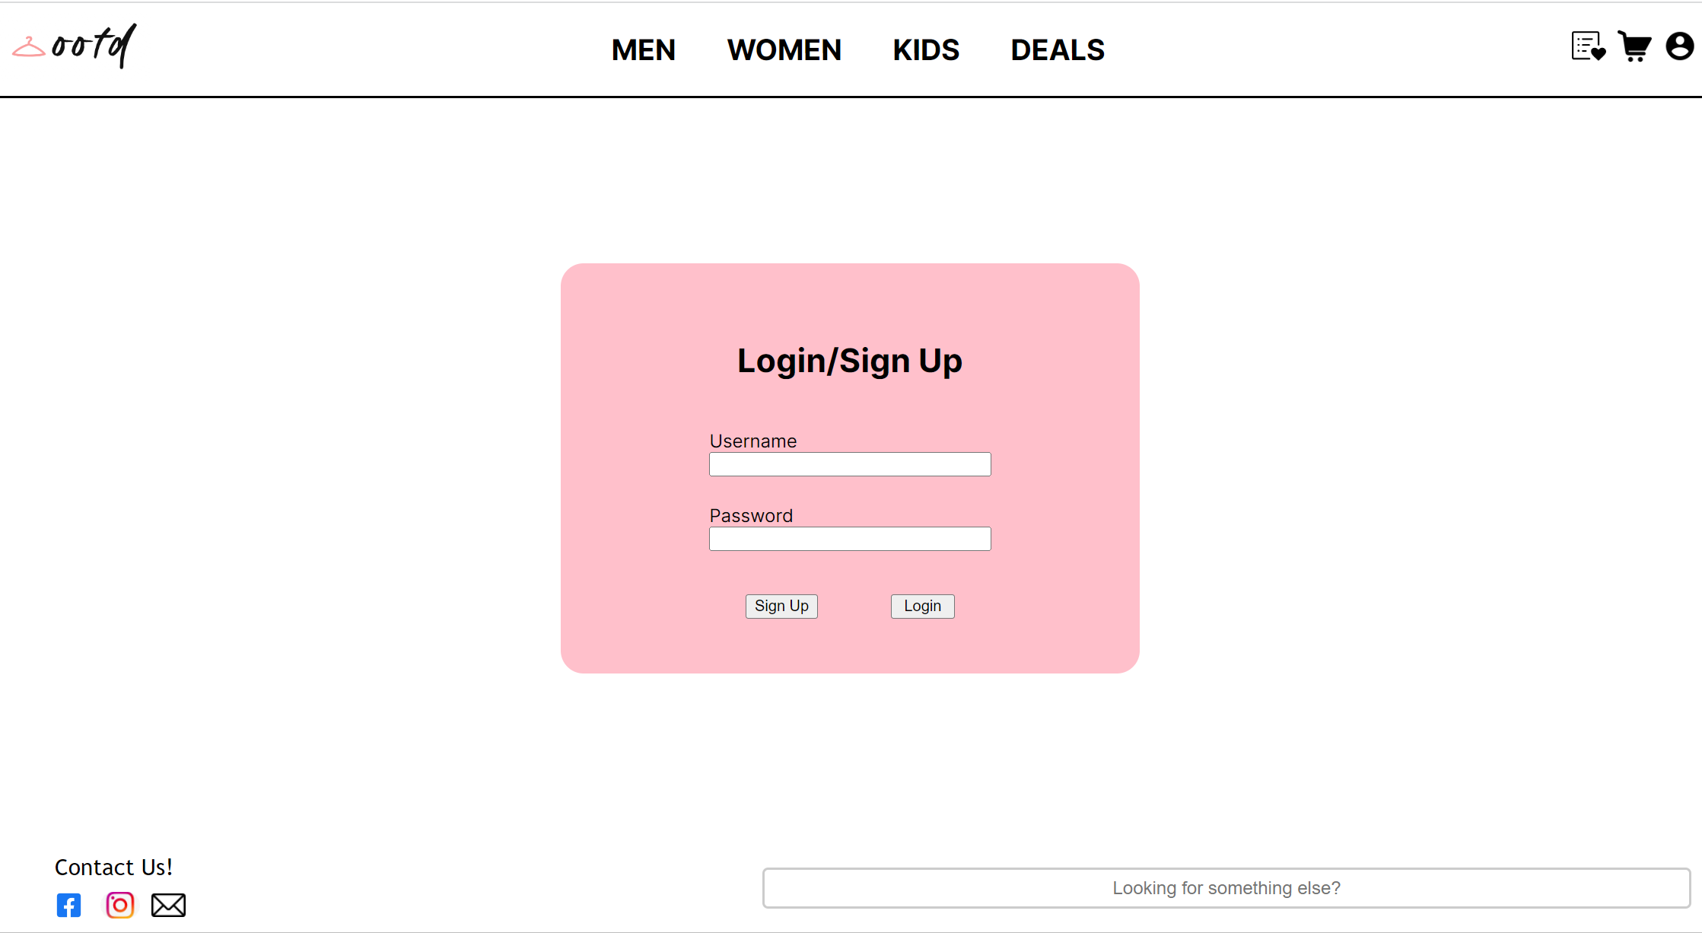

The login page starts with a clear and prominent heading “Login/Sign up”, followed with input fields of username and password. This is to show the purpose of this page to users clearly. It allows existing users to login into their account and new users to sign up by inputting their username and password.

This page is implemented error handling to avoid any error or empty input. If the username or password is wrong, it will display a clear error message “Wrong username or password!” to notify users there is an issue with their login attempt. To ensure user enter their username and password. Moreover, if the user leaves the input fields of username and password as blank, a clear error message “Please fill out this field” will be displayed to alert user that the input fields of username and password is required to fill out. Once the user has filled out the required fields and pressed the sign-up button, system will display a message to inform user that he/her has successfully sign up their account.

**Contact Us Page**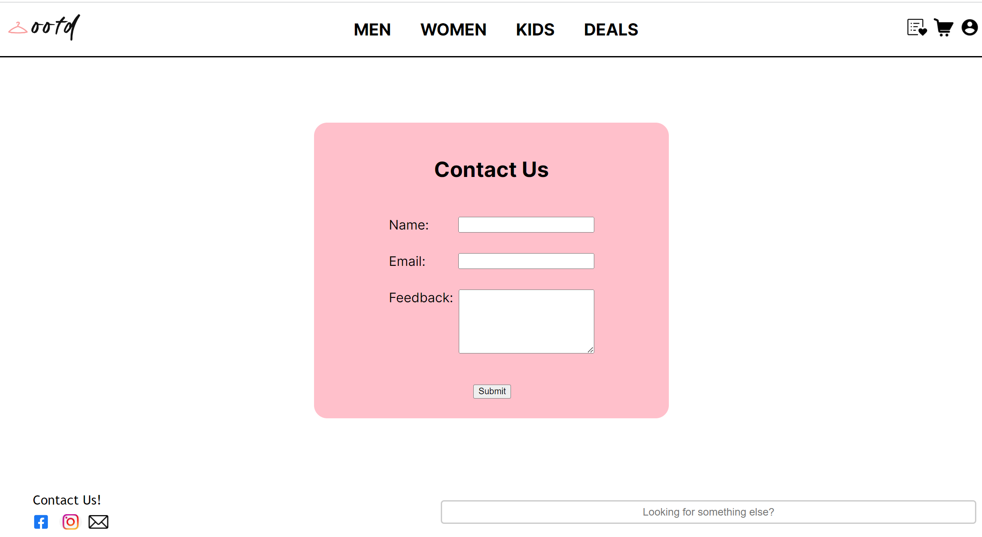

The contact us page is designed to let users provide feedback to us to enhance our service. It starts with a clear and prominent heading “Contact Us”, followed with input fields of name, email, and feedback. This is to show the purpose of this page to users clearly. Users can perform this action by inputting their name, email, and feedback, then pressing the submit button to send to us. After receiving feedback, we will email the user to get in touch with the user to have a further interpretation of the user’s feedback.

Validation is also implemented in this page to avoid any error or empty input. If one of the fields is not input, system will display a clear error message “Please fill out this field” to alert users that it is necessary to fill out the following field. Therefore, users won’t miss out any part accidently and submit incomplete feedback to us. Furthermore, when user has fill out all the required fill and press the submit button, system will display a clear submitted message “Submitted!” to inform user that his/her feedback has successfully send to us.

**3. Challenges and Solutions**

*[Describe any challenges or obstacles encountered during the project and the solutions implemented to overcome them. Discuss how the team addressed issues related to design, functionality, compatibility, or teamwork.]*

Throughout the journey of this project, our team faced several significant challenges that requires a collaborative discussion and problem-solving skills from every member in our team.

The first challenge our team faced was ensuring the responsiveness of each webpage to look and function well across various devices and screen sizes. With a wide range of devices such as laptops, tablets, monitors, and mobile phones, it is crucial that our webpage is displayed clearly on each device without any issues. Therefore, when using the inspector tool (F12) to observe our website's changes in response to different device widths, we discovered multiple instances where our webpages looked awkward or unorganized when the width of the pages was altered to a smaller size. For example, the size of an item image on our webpages might be too small in a smaller viewport. After conducting some research and reading, we found that the implementation of @media queries is crucial to solving this issue. Three main @queries screen sizes must be considered: the laptop view, tablet view, and mobile view. From laptops to mobile devices, the displayed details are gradually reduced to focus more on the main content. For instance, in our navigation menu, the original inline list navigation transitions to a drop-down selection menu to accommodate more space for the utilities link and our logo image. This same feature is also applied on the Browsing Page, where the categorical selection list changes to a filter button in the mobile version.

While using @media queries to design our websites, another impending issue has surfaced during the coding process, which revolves around the dilemma of whether to use pixels or percentages to set the width and height for each division. As our group began coding the website in a laptop viewport, there was a tendency to use pixel measurements for the height, width, and margins. However, this approach caused a major issue during viewport changes. For instance, let's consider the usage of a margin-top of 100 pixels in the main content to accommodate a fixed navigation menu at the top, which looks fine on a computer. However, when the viewport size is reduced, and the height of the navigation header increases, the main content with a fixed margin-top of 100 pixels starts overlapping with the header. This inconsistency in layout is undesirable and needs to be addressed. To overcome this issue, we need to use percentage-based measurements instead of fixed pixels to ensure better responsiveness and adaptability to different viewport sizes. By employing percentages, elements will proportionally adjust their sizes based on the available space, thus avoiding overlap, and maintaining a more consistent layout across various devices.

Another challenge worth mentioning is the collaboration difficulties faced during the coding process. Initially, dividing tasks among team members to design each webpage seemed straightforward, but it led to some issues due to the varying coding styles employed by each member. Differences in naming conventions, indentation, and formatting created confusion among us and made our code harder to understand and maintain. Furthermore, simultaneous editing of the same webpages by different group members resulted in version update errors. To address these challenges, our team had discussions to find effective solutions, and we realized that improved communication within the team is key to a smooth project completion. We decided that anything that is unclear or requires clarification would be openly discussed among members to prevent any future issues from arising. Additionally, we established a practice of informing each other whenever changes are made to the webpages, ensuring that everyone is aware of the latest version. To prevent against accidental code overwrites, we implemented a system where backup copies of the files are regularly saved.

During the website designing phase, we effortlessly created an aesthetically pleasing user interface (UI) without encountering any difficulties. However, we soon came to realize that the functionality aspect was crucial for an E-commerce website. At that time, we lacked knowledge of JavaScript, which was essential for adding the necessary functionalities. Despite this, we were determined to improve the website's functionality and enhance the user experience. As we delved into learning JavaScript and its applications, we faced challenges in figuring out how to incorporate specific features into the website. The task of implementing functions such as creating a carousel to display different images, enabling the "add to cart" feature, and adding filters to the Browsing Page seemed tough at first. However, we sought external resources like W3Schools to better understand JavaScript and its Document Object Model (DOM), which allowed us to manipulate HTML and CSS elements directly within the code. With perseverance and continuous efforts, we slowly but surely grasped the fundamental concepts and syntax of JavaScript. Armed with this newfound knowledge, we began implementing various functions, each contributing to the website's overall functionality and usability. Overcoming these challenges not only improved our coding skills but also significantly enhanced the user experience of the E-commerce website, making it more interactive and user-friendly.

**4. Implementation and Results**

*[Provide explanations and screenshots of test cases and the test results in relation to the code.]*

**Header and Footer**

**Navigations**

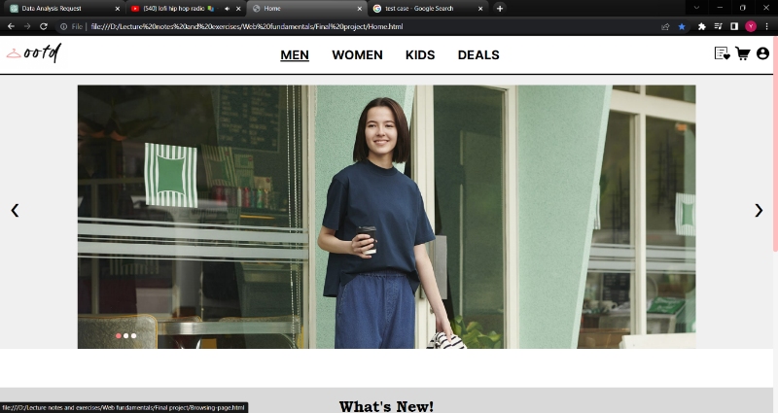

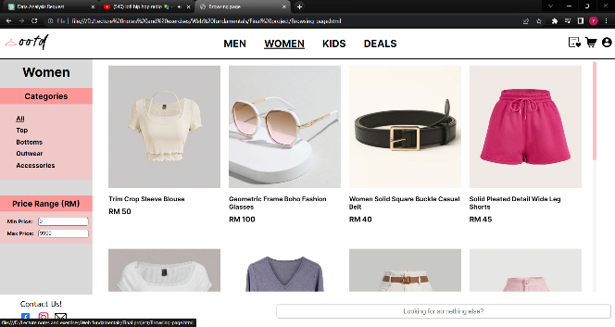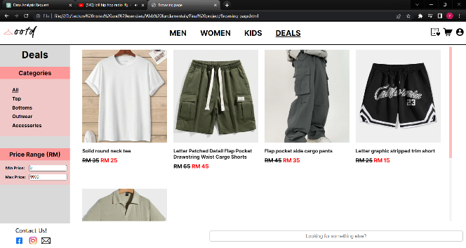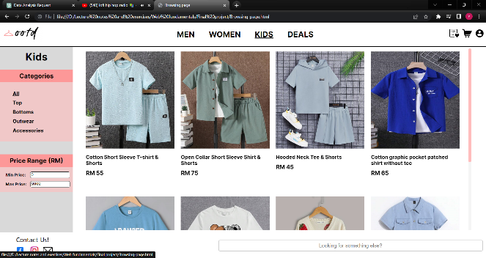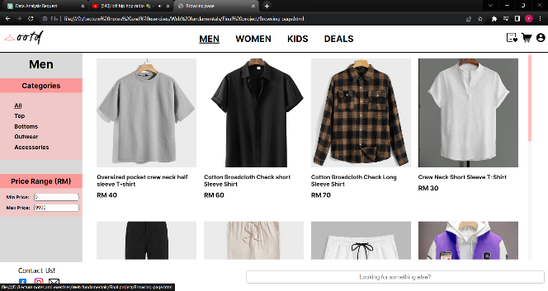To evaluate the website's navigations, we initiated the testing process from the Home Page. We clicked on each section of the navigation bar on the header and footer and observed the following outcomes:

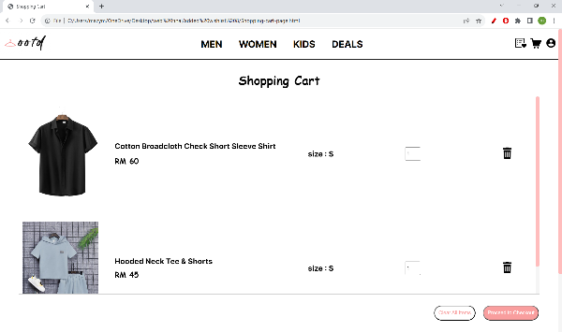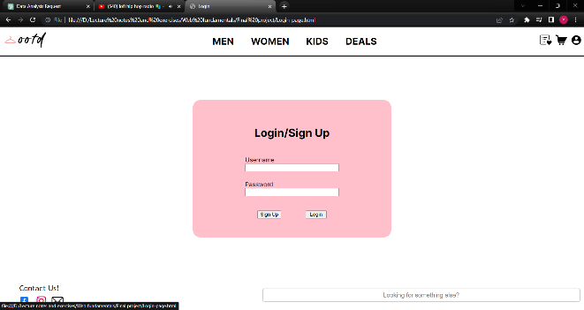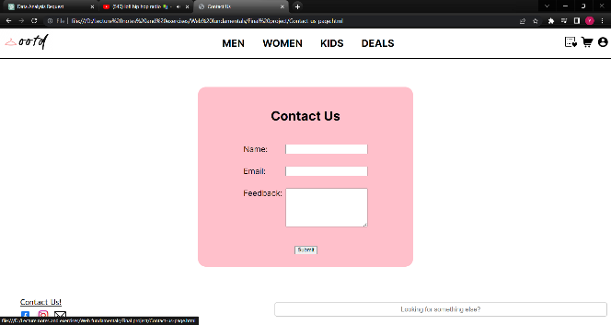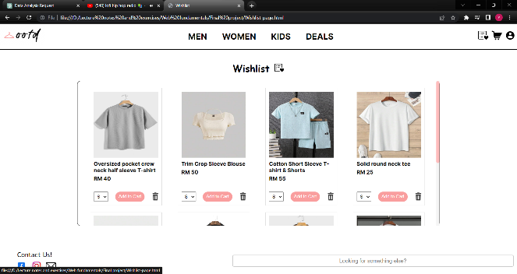

The results of the test indicate that all the navigations are functioning as intended. During the testing of the header, the navigation bar in the middle of the header allowed users to access the Browsing Page for different genders, and the underlined links upon hover provided clear indications of the selected page. The utility links on the right side of the header, including the Wishlist Page, Shopping Cart Page, and Account Page, worked smoothly. In the footer, the "Contact Us" link on the left side led users to the dedicated contact page.

**Code Implementation**

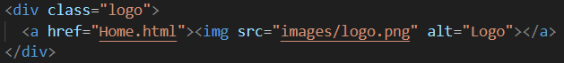

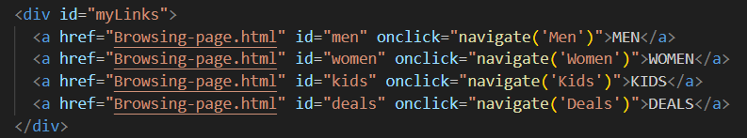

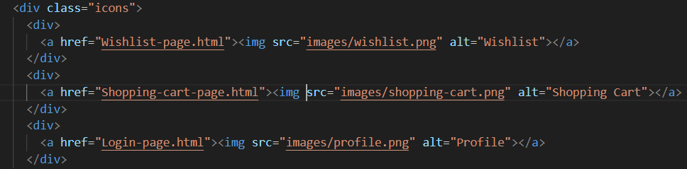

The links between pages are implemented by using the <a> element with the href property as shown in the code snippet above.

**Home Page**

**Image Carousel**

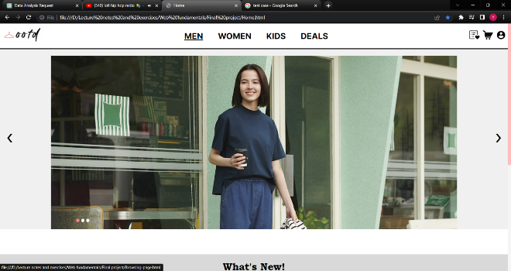

In order to evaluate the image carousel functionality, we will click on the left and right arrows to navigate through the carousel images. We will also observe the carousel when it remains idle to ensure it automatically changes images every 5 seconds.

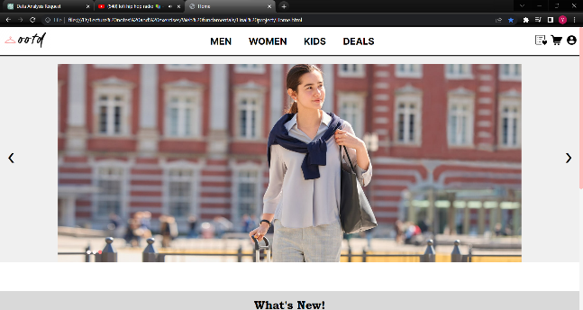

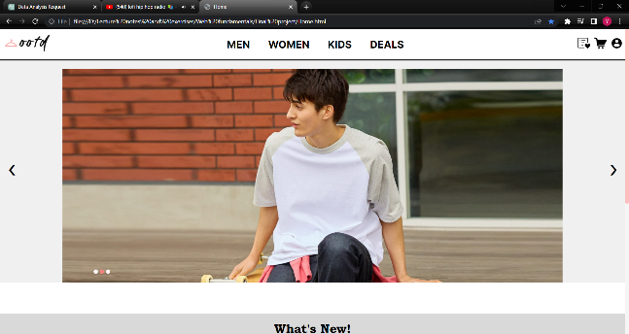

Upon conducting the test case for the Home Page navigation, we found that the image carousel functioned as intended. Images can be navigated by clicking on the left and right arrow indicators. The dot indicators showed the sequence of the image displayed.The image carousel smoothly transitioned between different images every 5 seconds.

**Code Implementation**

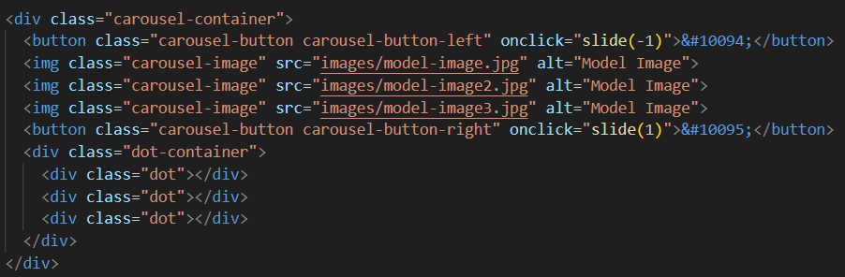

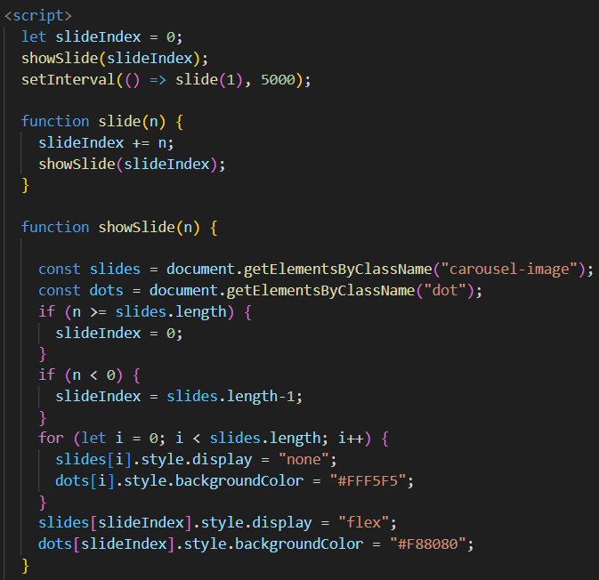

First, the code initialises a variable slideIndex with a value of 0. When the page loads, it always start with displaying the first picture (index 0).When the right button is clicked, 1 is passed into the javascript function slide as the argument. The slideIndex value is incremented and the showSlide function is then called. The display property of images are all set as none. By using the slideIndex, the display property of images that matches to the current value of the slideIndex is then set as flex. When the left button is clicked, -1 is passed into the function, and the same process will be done to show the previous image. The dots indicator’s background colour is also changed based on the slideIndex. To achieve the transition of images every 5 seconds, setInterval() function is used to call slide(1) function every 5000 milliseconds.

**What’s New Section**

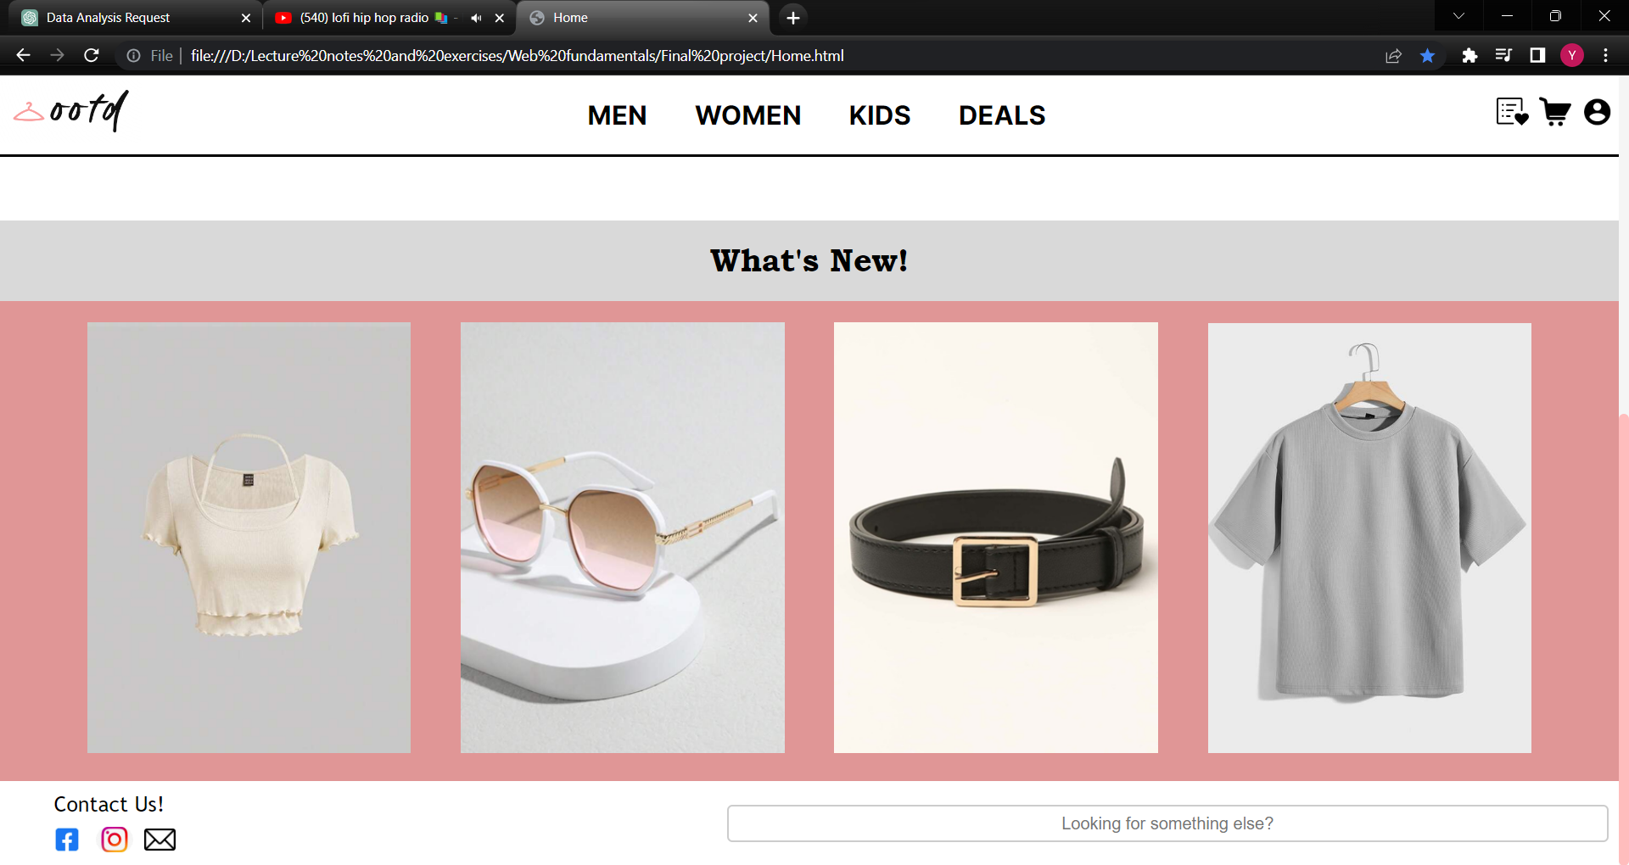

To test the hovering effect and the links of the displayed images to the item page, the images are clicked.

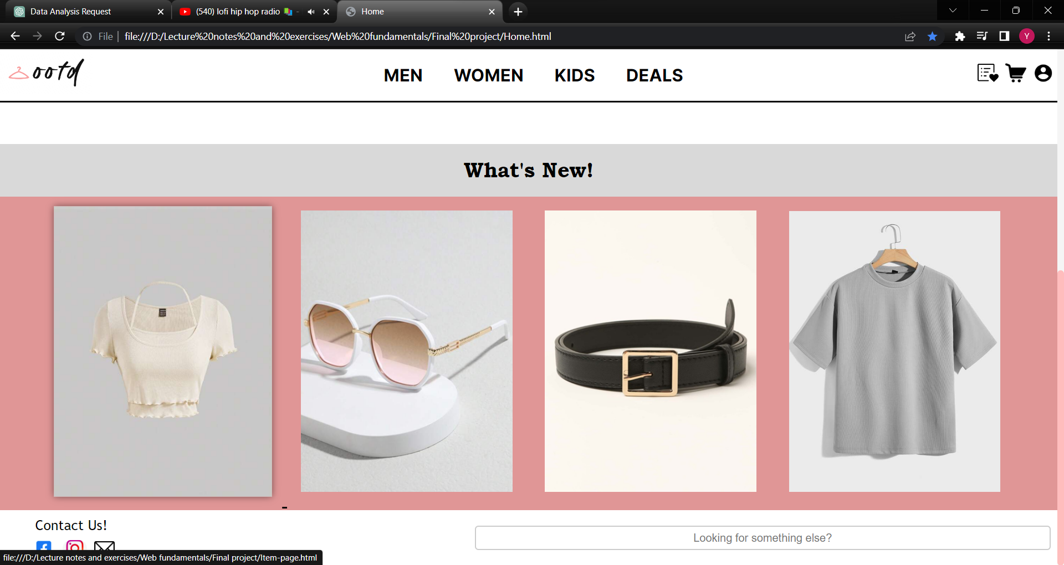

Upon hovering over the first image, the first image is enlarged, and a shadow effect can be observed. This shows that the CSS hover property is working properly.

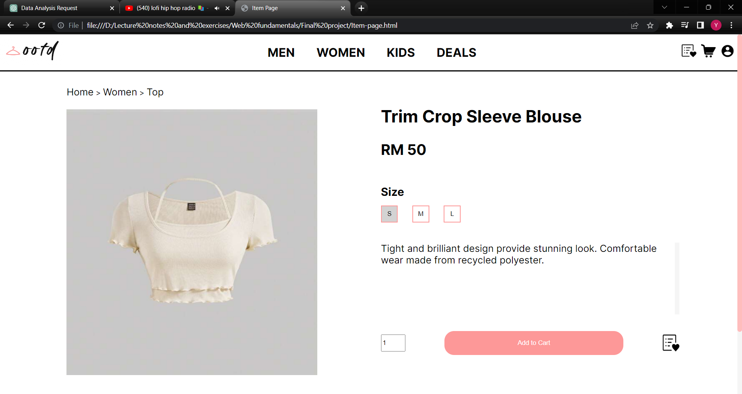

After clicking on the image, the item page showing the item details is displayed. This demonstrates the functioning of the hyperlink associated with the image that links to the item page.

**Code Implementation**

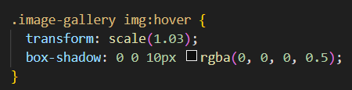

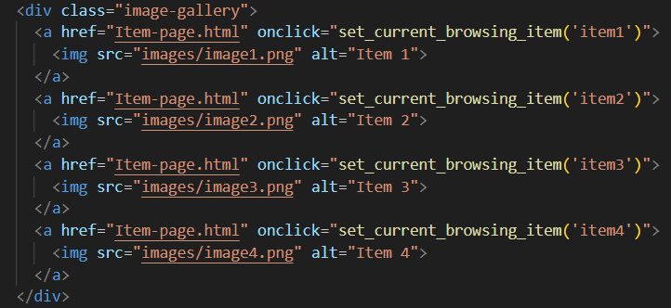

The hovering effect of the images are created using the CSS code above. The image is transformed in a scale of 1.03 and a box-shadow property is added. The links of the images to the item page are added in the href property of the anchor element.

**Browsing Page**

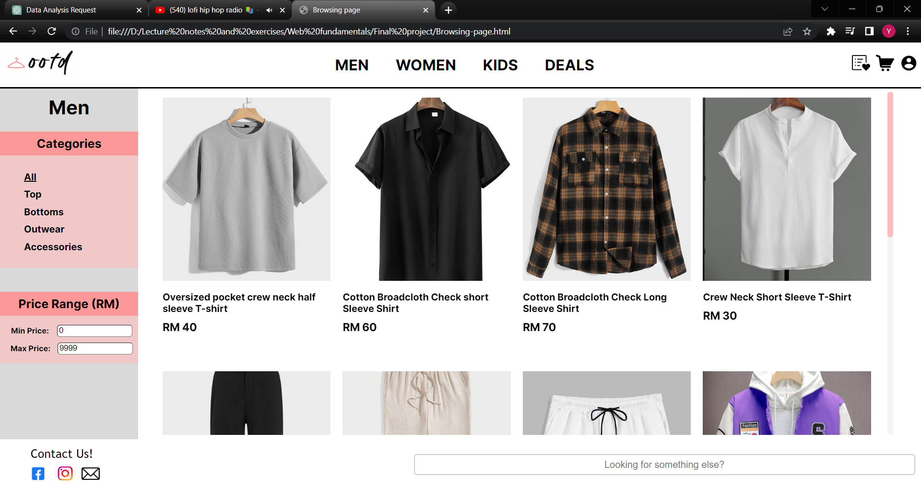

Several test cases are conducted for the Browsing Page to ensure its functionality and usability. Firstly, we will assess the fixed sidebar's performance by verifying that it accurately displays the current navigation page. Next, we will test the category selection feature to confirm that choosing different categories successfully filters the displayed items. We will evaluate the price range section to check if it correctly presents items falling within the specified price range. Lastly, the links to the item page of the images are also tested.

**Sidebar Title**

Navigation links on different genders are clicked. The title of the sidebar changed accordingly based on the current navigation.

**Code Implementation**

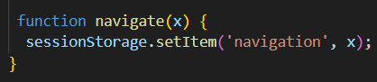

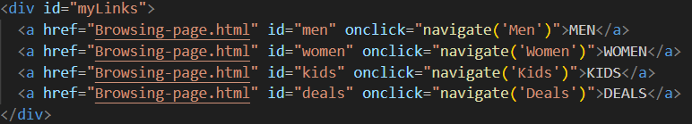



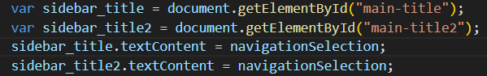

A navigate function is defined to create a sessionStorage and set the value as the passed-in argument. The navigate function is called with by passing the gender of the navigation clicked by the user as a string. The value of the sessionStorage is then retrieved and the textContent of the sidebar title is then changed according to the value.

**Category and price range filter**

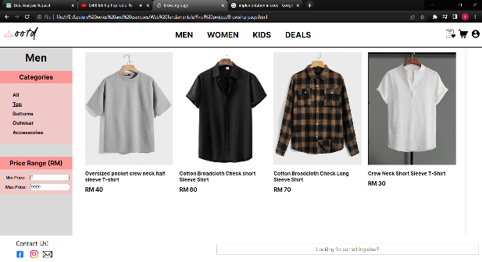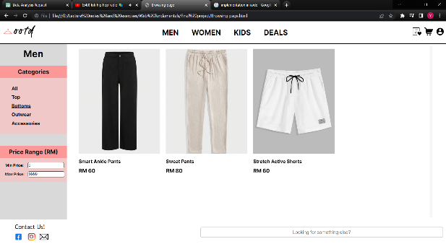

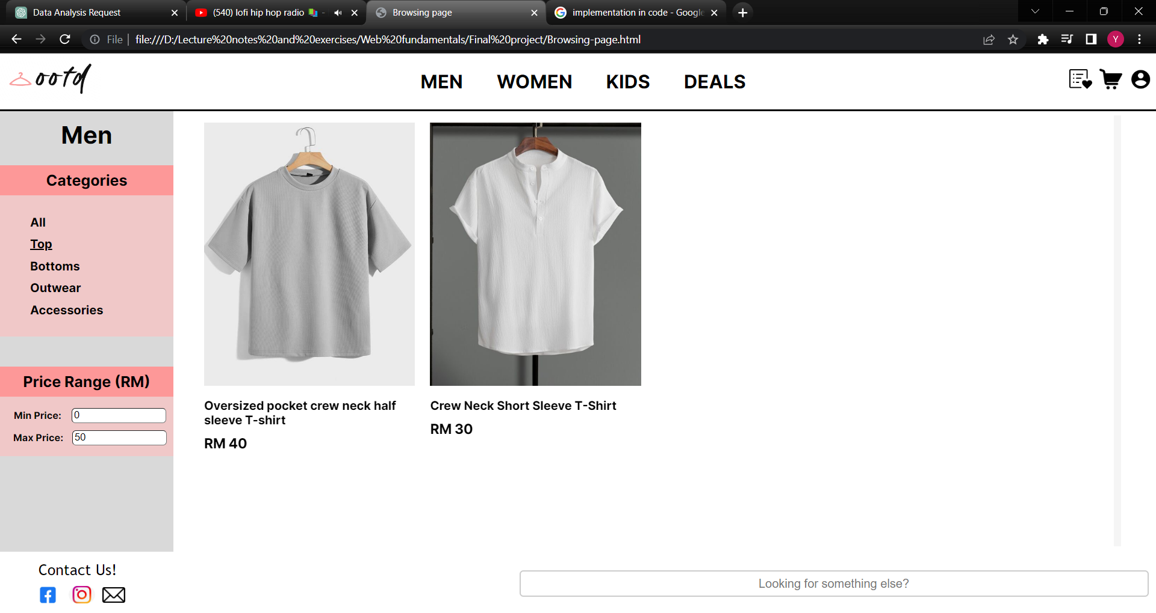

The items displayed are changed based on the values selected on the sidebar filter. Only items that match with the selected category and fall in the configured price range will be shown.

**Code Implementation**

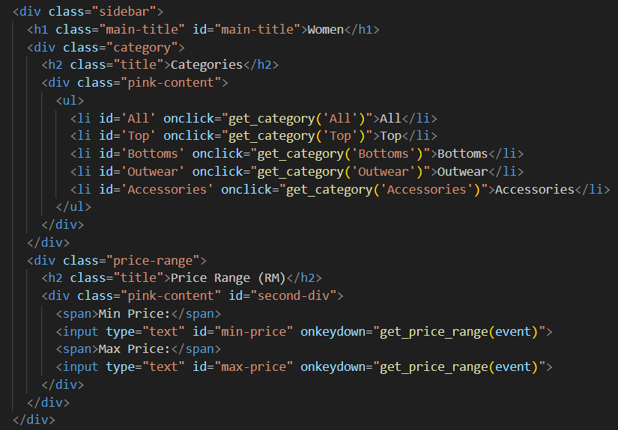

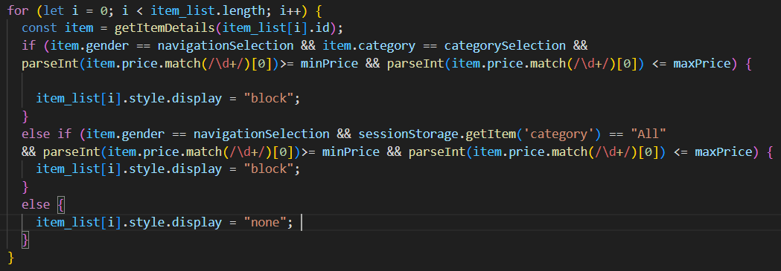

To achieve the desired effect of filtering the displayed items, sessionStorage is used to save the value of the selected category, min-price and max-price when the user clicks on the selections. A for loop is then used to loop through all items that are stored in an array that stores all the details of the item. If the gender, category, and price match the sessionStorage, the item is displayed as block. Else, the item is not displayed in the Browsing Page.

**Item hyperlinks**

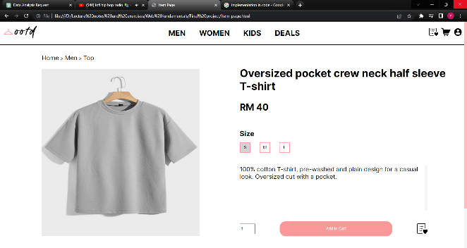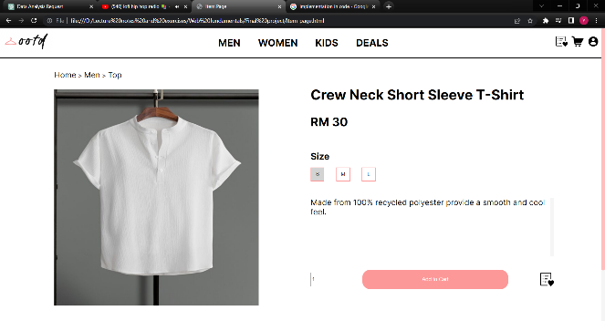

After clicking an item from the Browsing Page, it navigates the user to the item page that shows the item.

**Code Implementation**

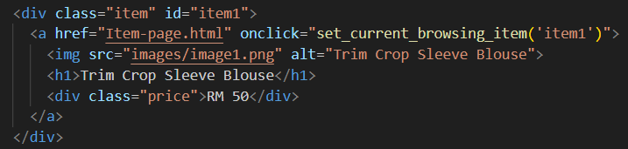

This function can be done by using the href property that links to the item page of the website.

**Item Page**

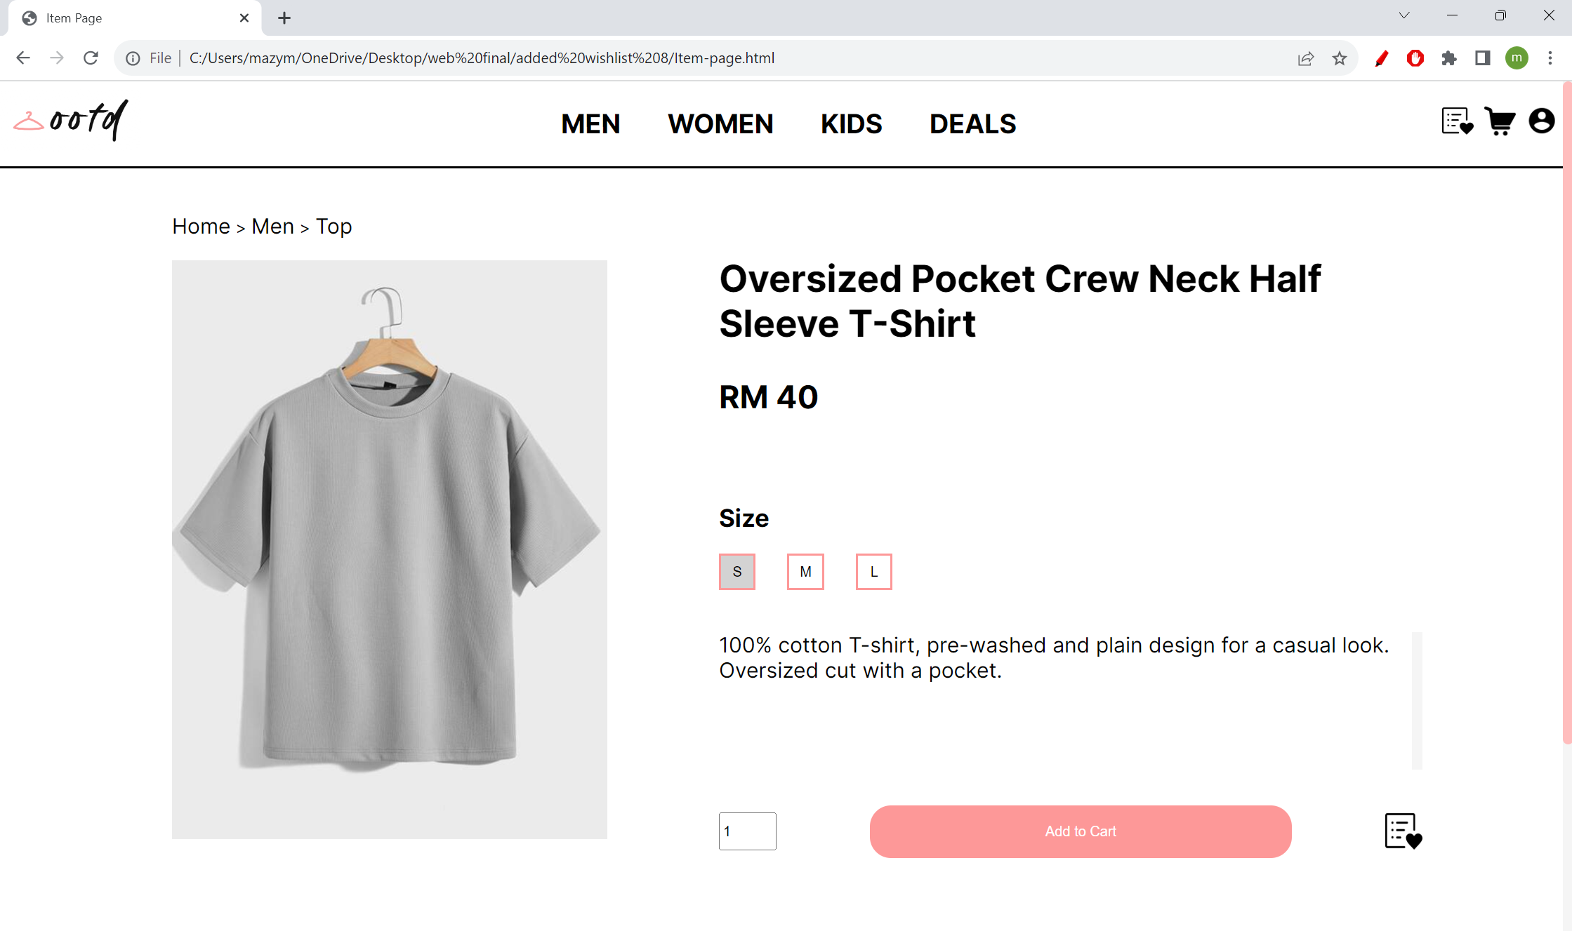

In the upcoming testing phase, we will execute several test cases to thoroughly assess the item page's functionality and user experience. Firstly, we will check that the title, price, and description are correctly displayed and fully functional. We will also verify the quantity and size selection option to guarantee its functionality when users adjust item quantities. Lastly, we will test the "Add to Cart" and "Add to Wishlist" buttons, ensuring they perform as expected.

**Item details**

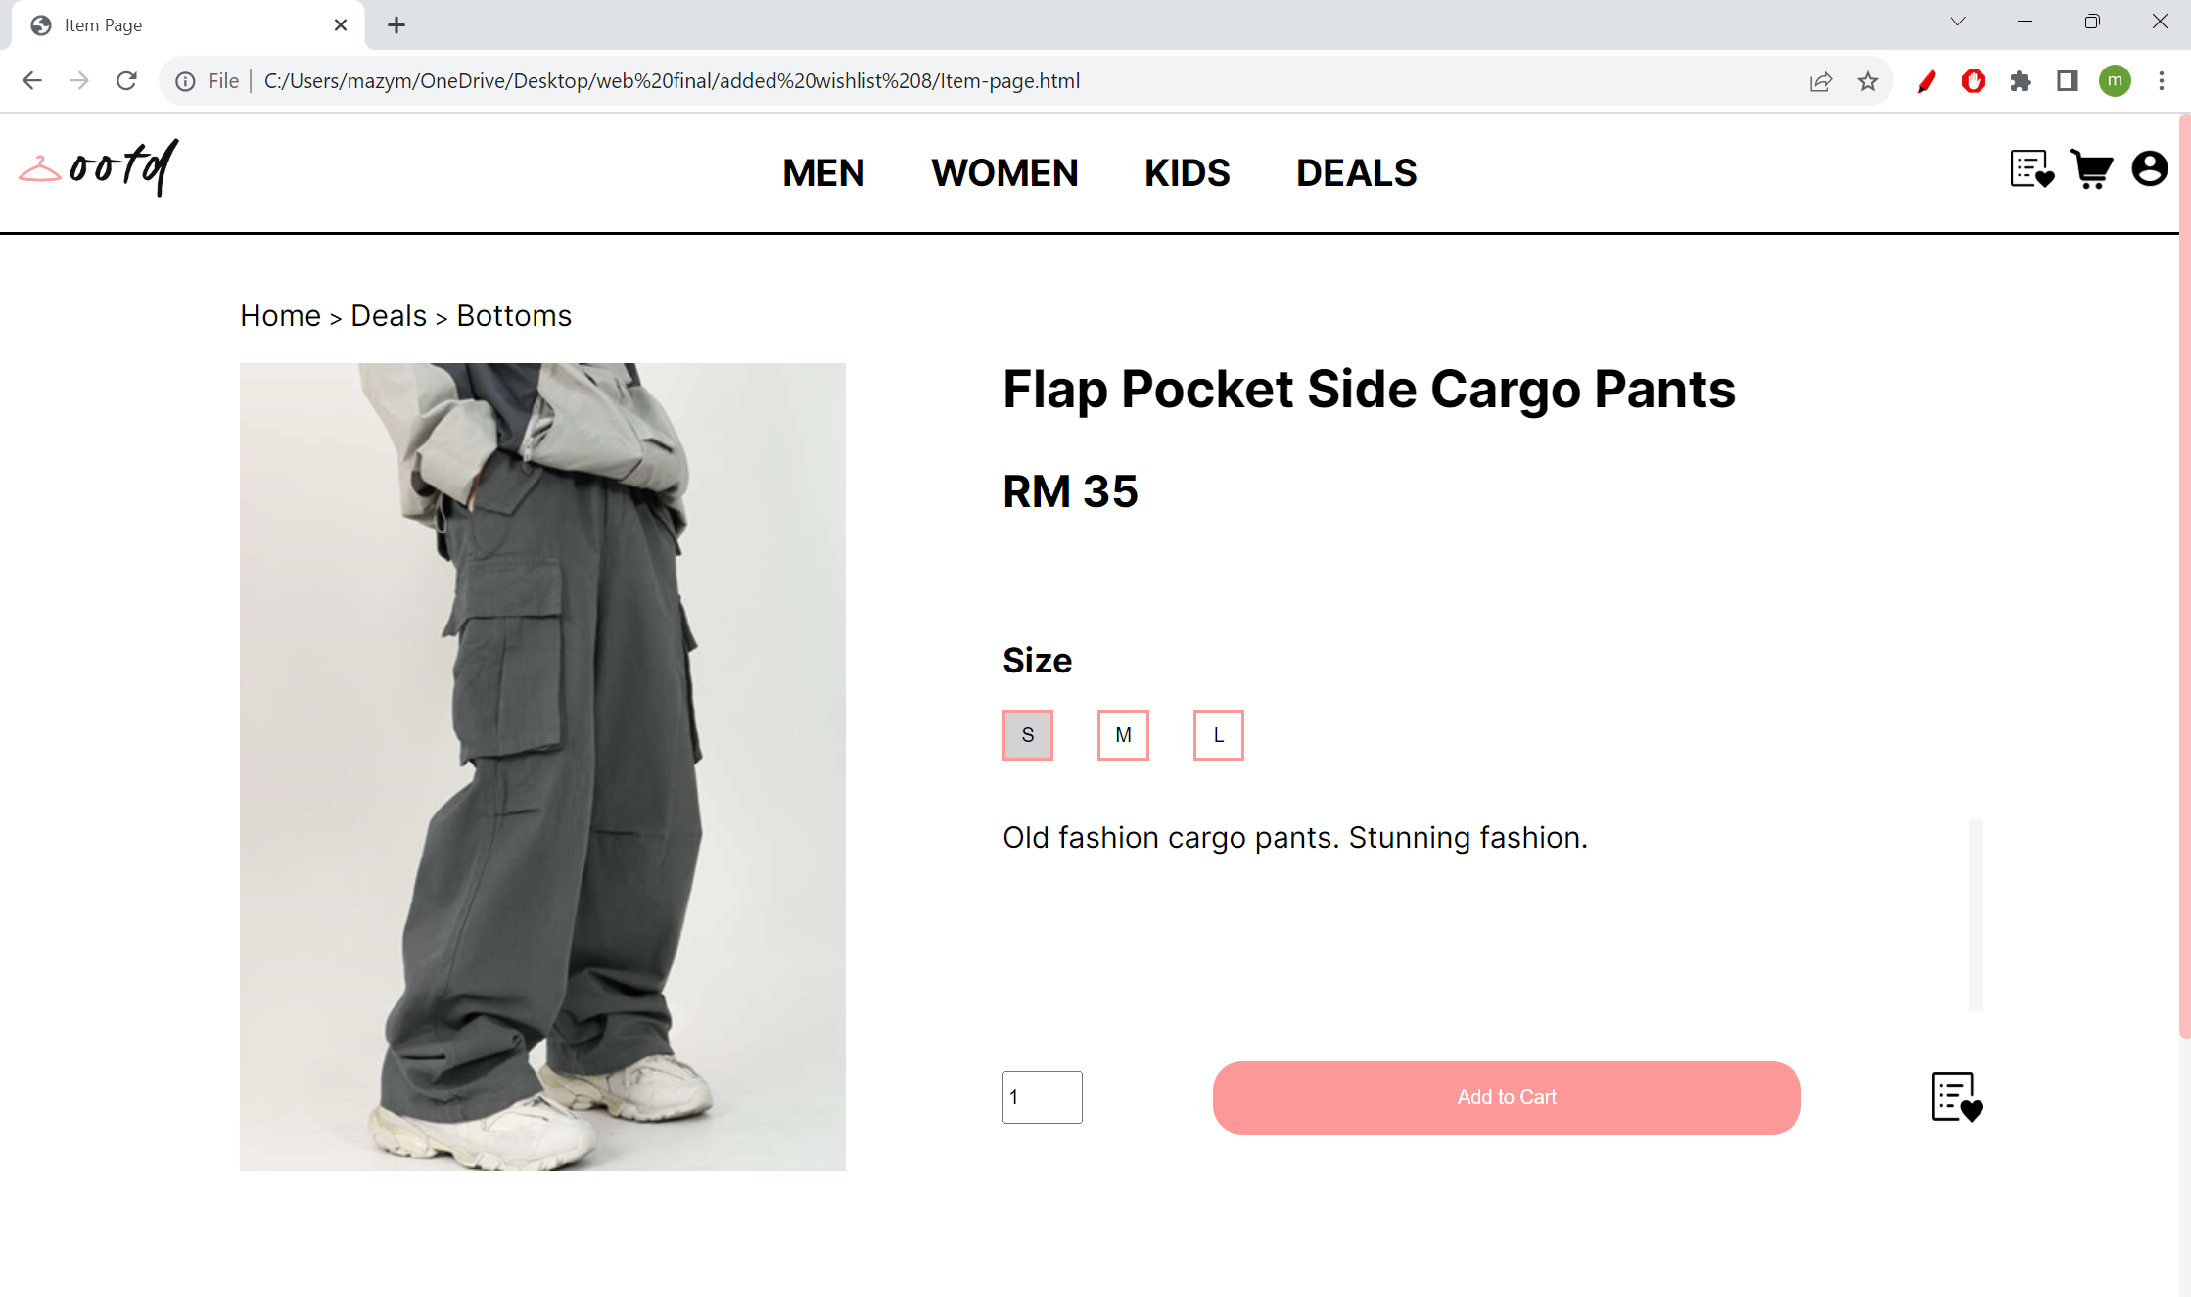

By clicking on different items, the item image, title, price, and description are displayed accurately.

**Code Implementation**

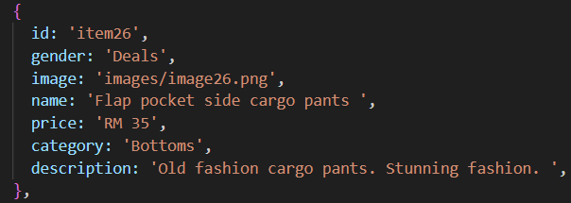



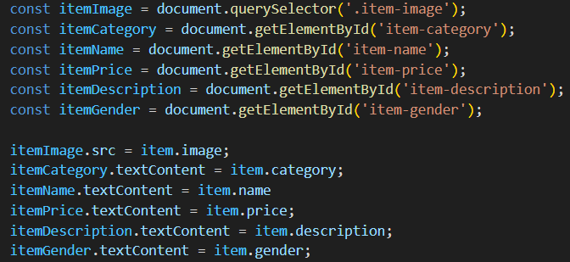

The details of each item are stored in an array. When item is clicked from the Browsing Page, the set_current_browsing_item() function is called to set the value of sessionStorage to the id of the item. When the item page is visited, the javascript programme loops through the array and find the item which the id matches the sessionStorage. The html contents of the item page are then displayed based on the values of the item in the array.

**Size and quantity option**



The size and quantity options can be set and changed by the user by clicking on them.

**Code Implementation**

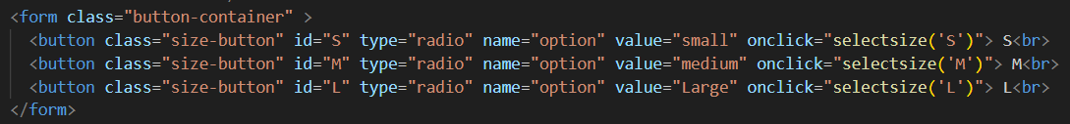

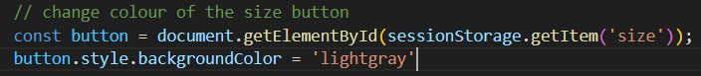



Three buttons element are used for the size options. When the user clicks on the size button, the value is saved in the sessionStorage. The background colour of the button with the selected size is then set as lightgray. For the quantity selector, an input element is used. The min is set as 1, max is set as 10. The value is set as 1 so that the default value is 1.

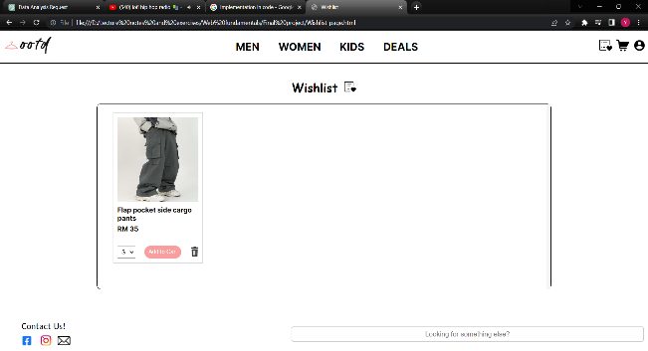**Add To Cart and Add to Wishlist Function**

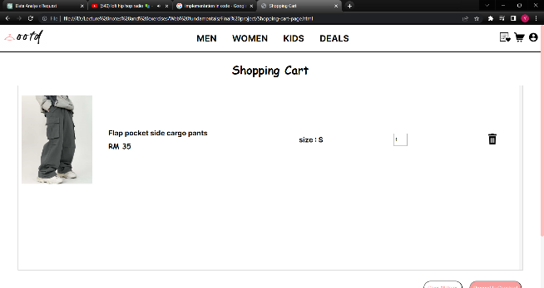

After clicking the add to cart button and Wishlist icon, the items now appeared in the Shopping Cart Page and Wishlist Page.

**Code Implementation**

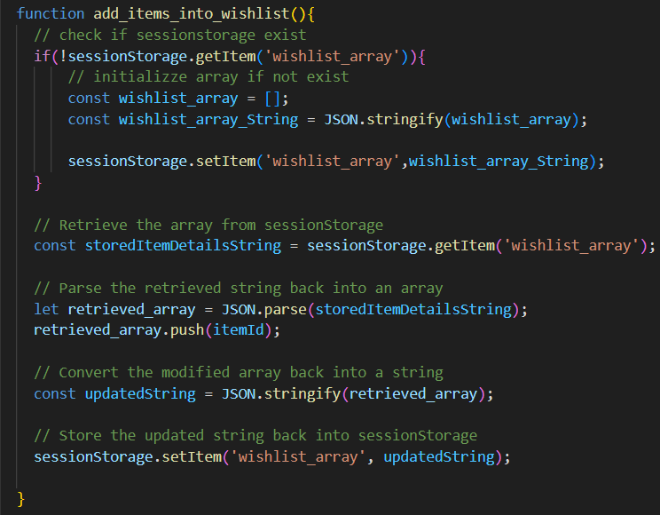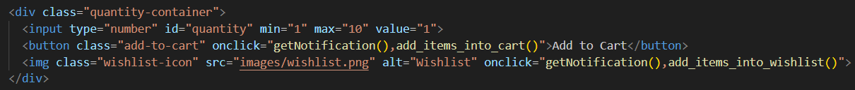

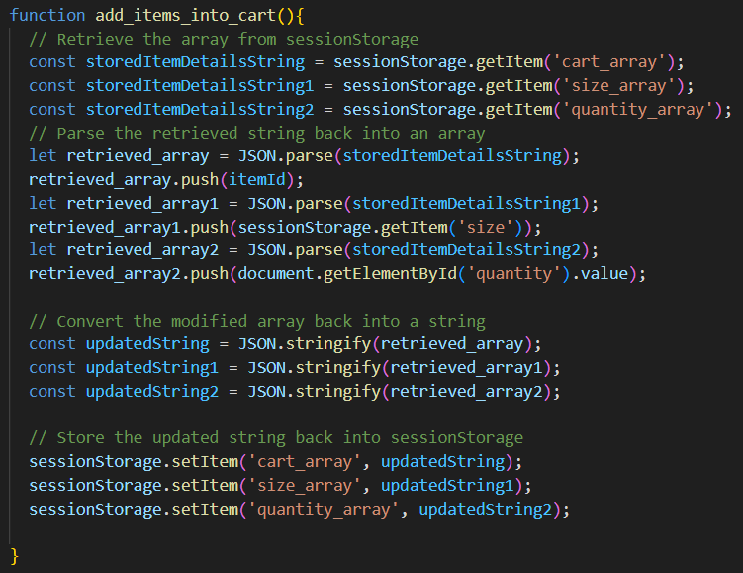

When the add to cart button and the Wishlist image is clicked, the add_items_into_cart() and add_items_into_wishlist() function are called. For the shopping cart, three arrays are used to save the details of the item id, size, and the quantity selected. For Wishlist, only the item id is added to the array. These arrays are then stringified into JSON format to be saved in the sessionStorage. The arrays are retrieved, and the items are displayed in the Shopping Cart Page and Wishlist Page.

**Wishlist Page**

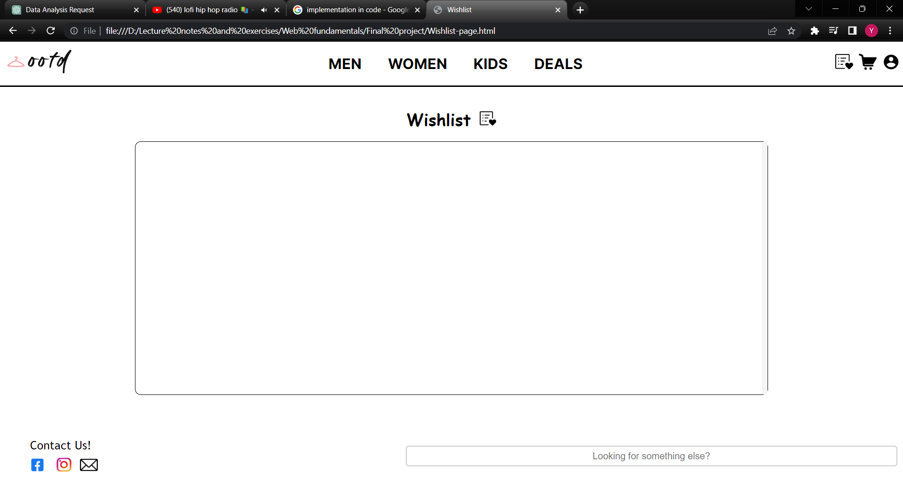

Now, we will assess the functionality of the Wishlist Page on the website. Firstly, we will verify whether the Wishlist Page accurately displays the desired items, including their corresponding images, names, and prices. Additionally, we will examine the function of the bin icon associated with each item, testing its ability to enable users to remove any undesired items from their Wishlist.

**Item details**

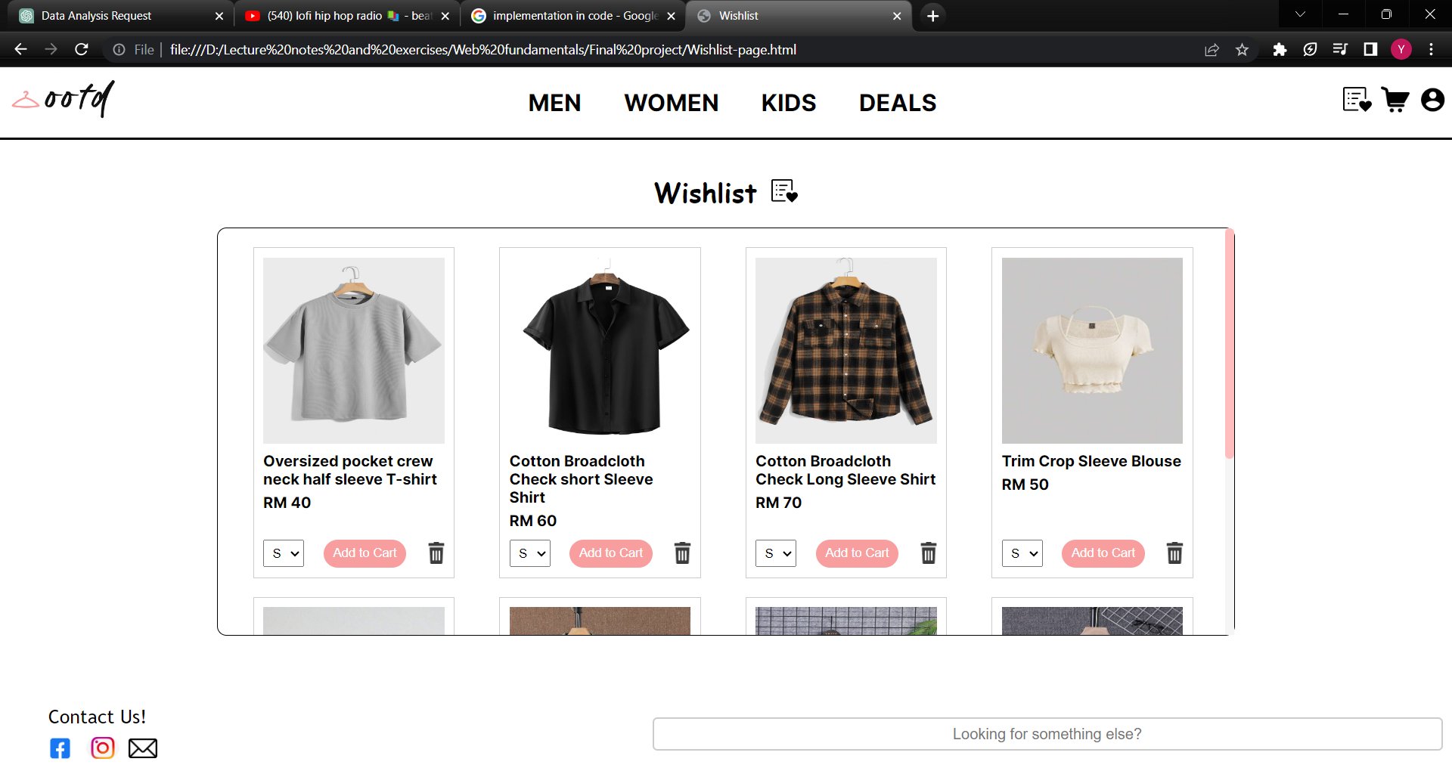

Initially, the Wishlist Page does not contain any items. After adding items into the Wishlist, the name and price of the items will be displayed in the Wishlist Page.

**Code Implementation**

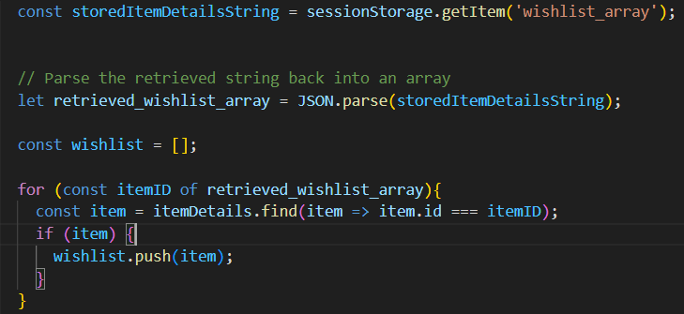

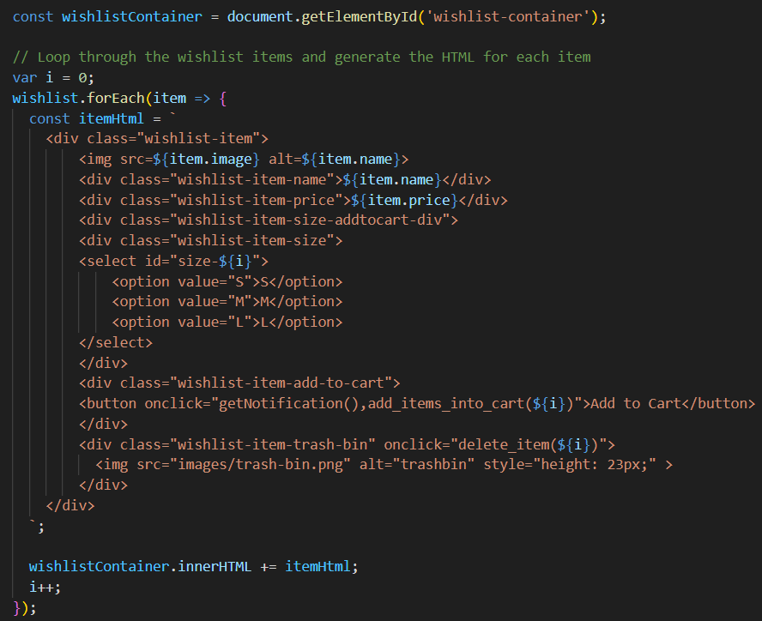

The JavaScript program first retrieved the Wishlist array that is stored in the sessionStorage. The items that match the id stored in the array are stored in another array. A for loop is used to loop through each item in the array and the new HTML for the items are added into existing HTML using the wishlistContainer.innerHTML += itemHTML code. The item details can also be found from the item details array that is created earlier.

**Remove Item Function**



The bin icon is clicked for the second item.

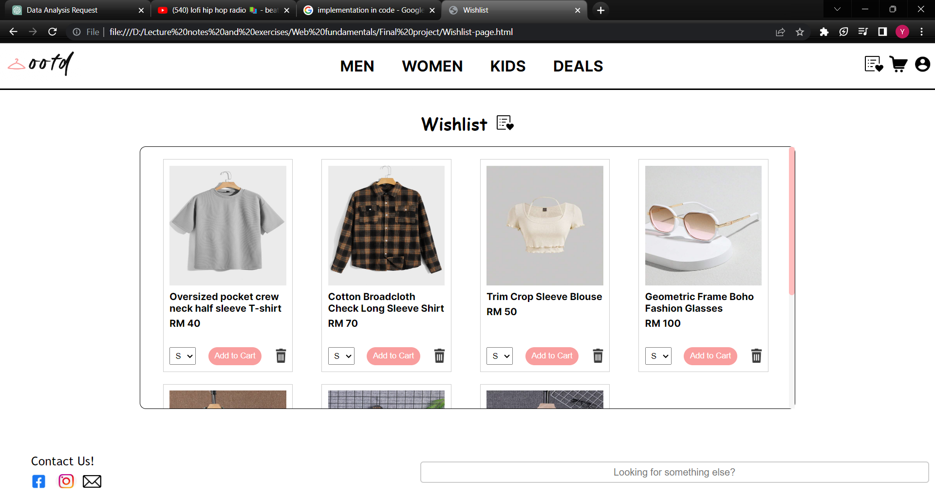

The second item disappears from the Wishlist Page as shown in the diagram above.

**Code Implementation**



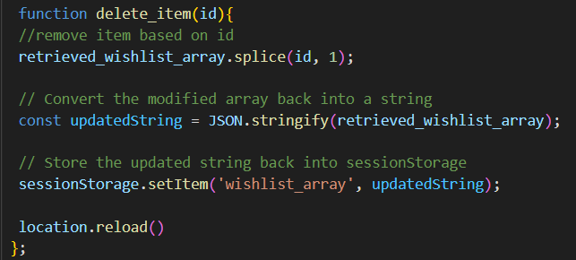

Every bin icon of the items will be associated with the delete_item() function that passes in the index of the itself in the wishlist. When the bin is clicked, the function removes the item id in the wishlist array based on the argument of the function. The wishlist array is then stringified as JSON format and save back to the sessionStorage.

**Shopping Cart Page**

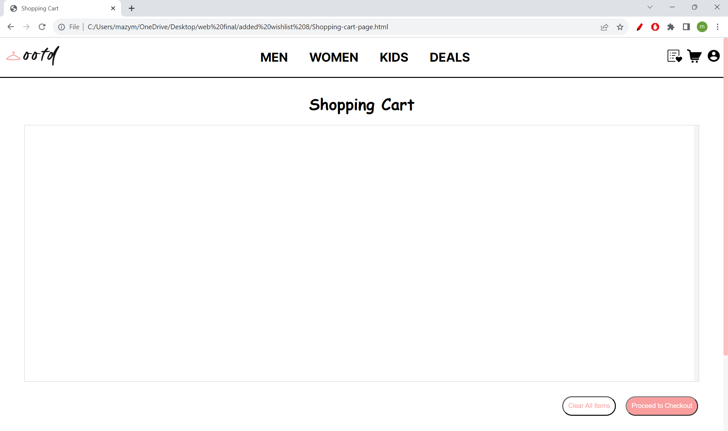

For the next test case, we will verify the horizontal display of selected items in their respective sections. We will also test the functionality of removing items from the shopping cart. Additionally, we will check the "Clear All Items" button to confirm that it functions as expected, effectively emptying the shopping cart when selected.

**Display of items**

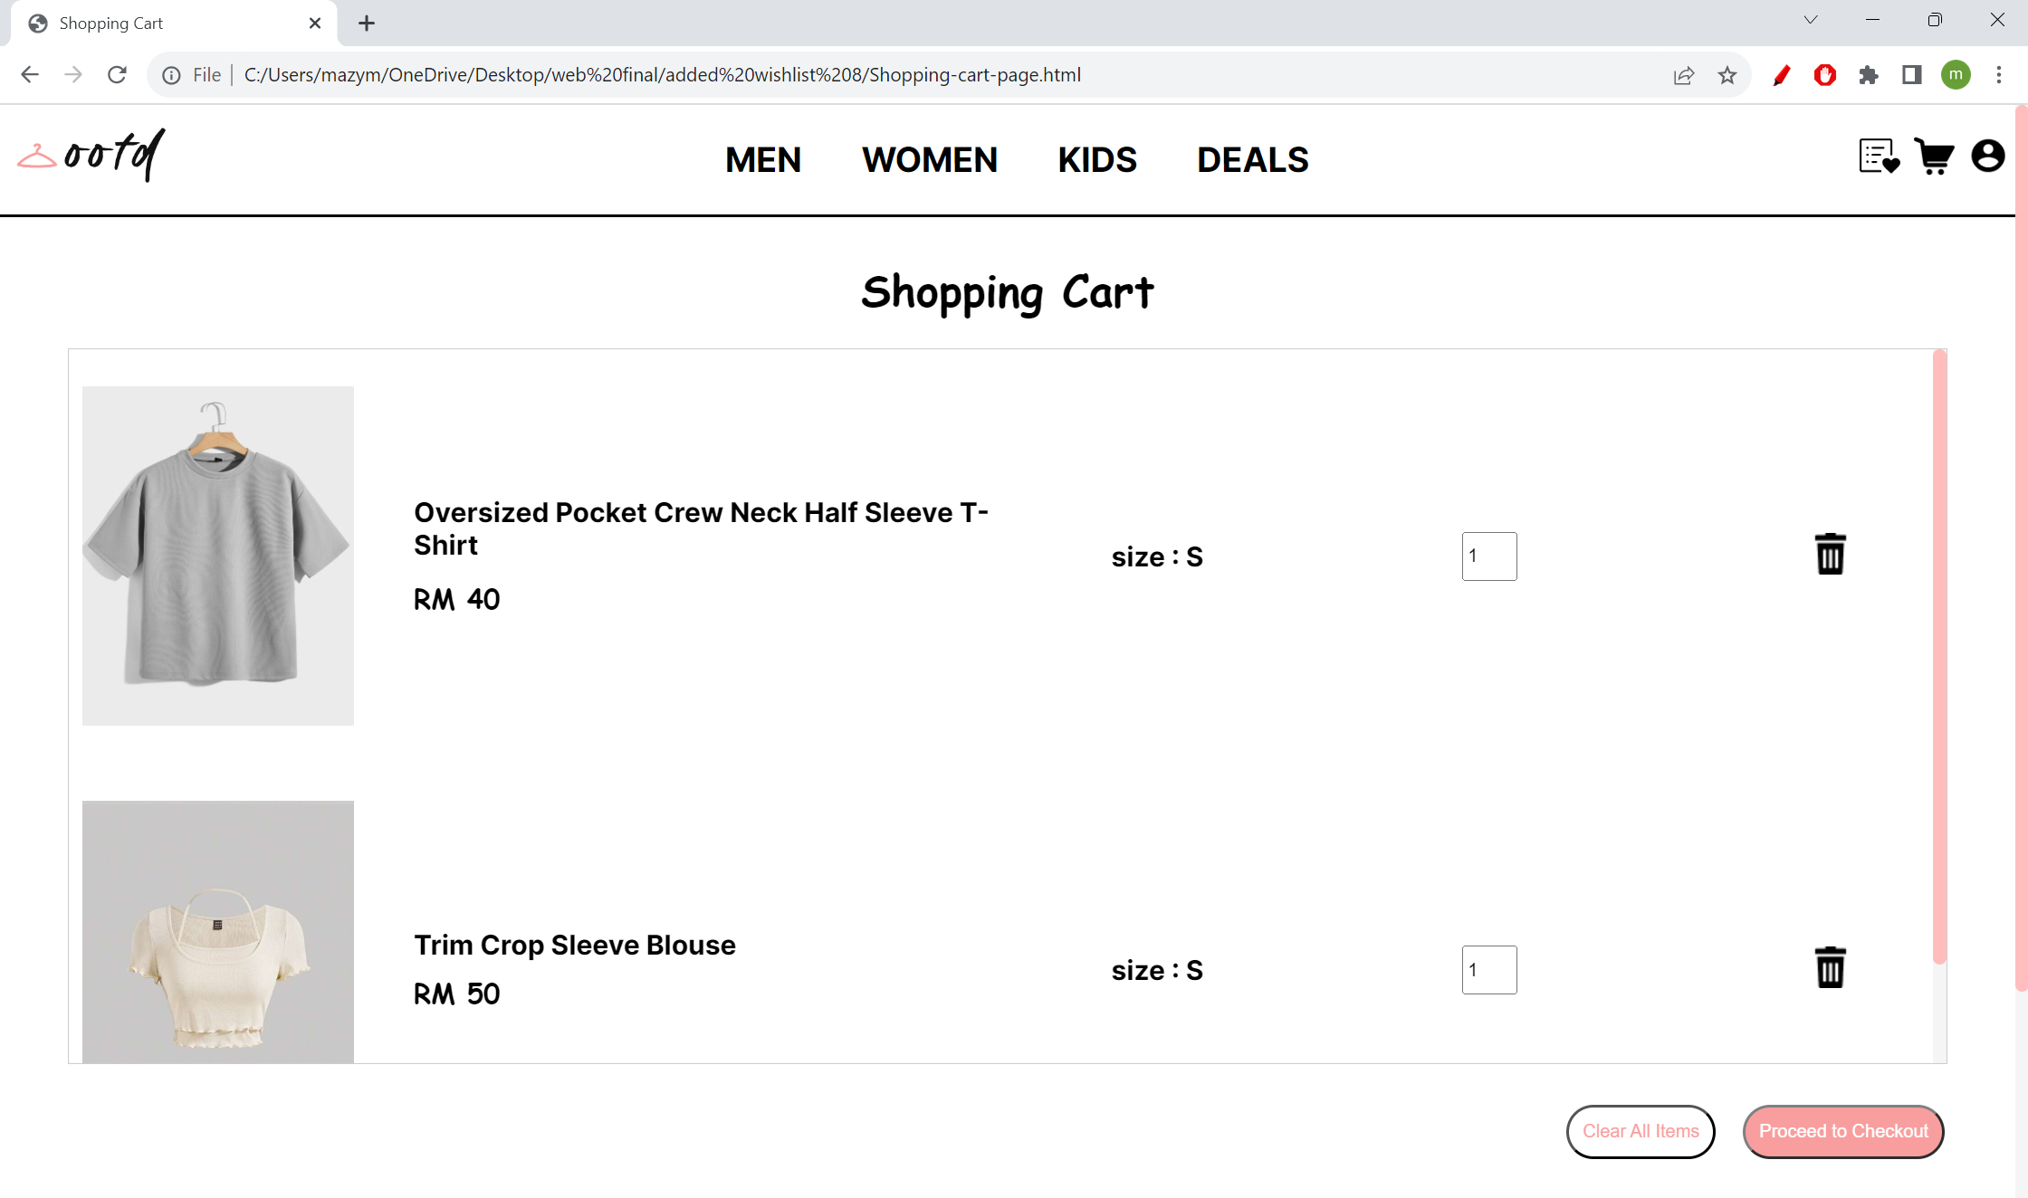

Initially, the shopping cart container is empty. When the user added items from the item page, the items and the selected size and quantity are displayed in the shopping cart container.

**Code Implementation**

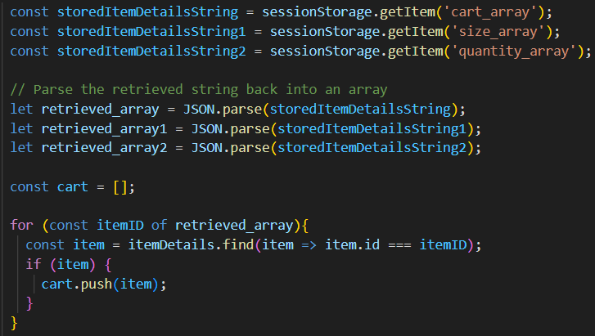

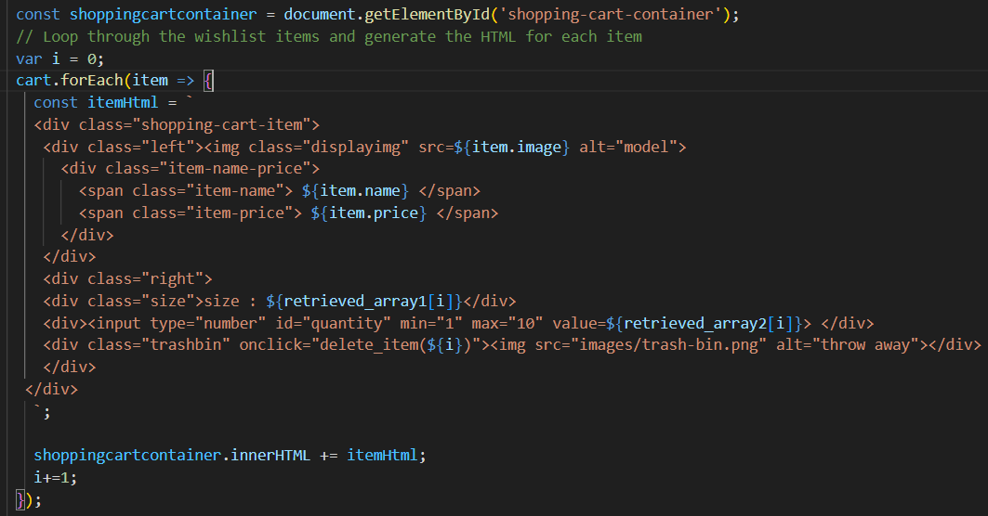

To be able to get the items that the user has added, the program first retrieved the 3 arrays that have the values of the item id, size and quantity from the sessionStorage. The items that match the id stored in the array are stored in the cart array. A for loop is used to loop through each items in the array and the new HTML for the items are added into existing HTML using the shoppingcartcontainer.innerHTML += itemHTML code. The desired size and quantity are also retrieved from the arrays according to the index of the item.

**Remove Item Function**



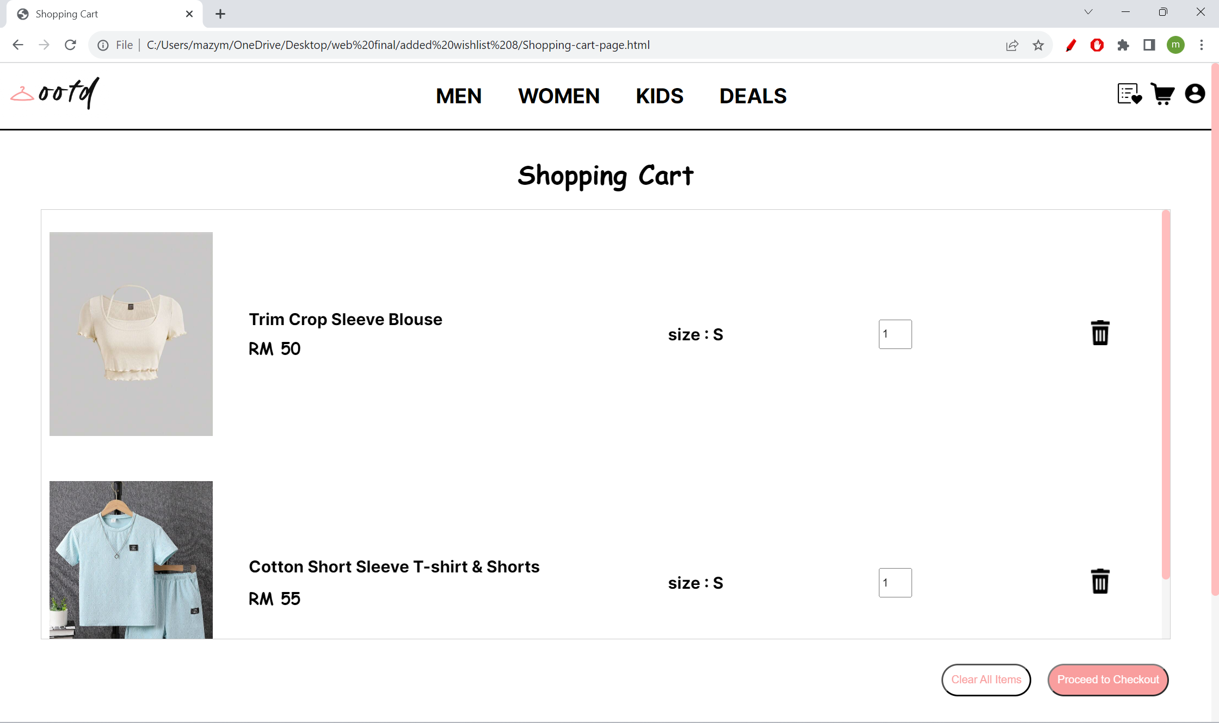

The items in the shopping cart can be removed by clicking on the bin icon on the rightest side of the item rows. This function is implemented by reusing the code from the Wishlist Page.

**Clear All Items Function**

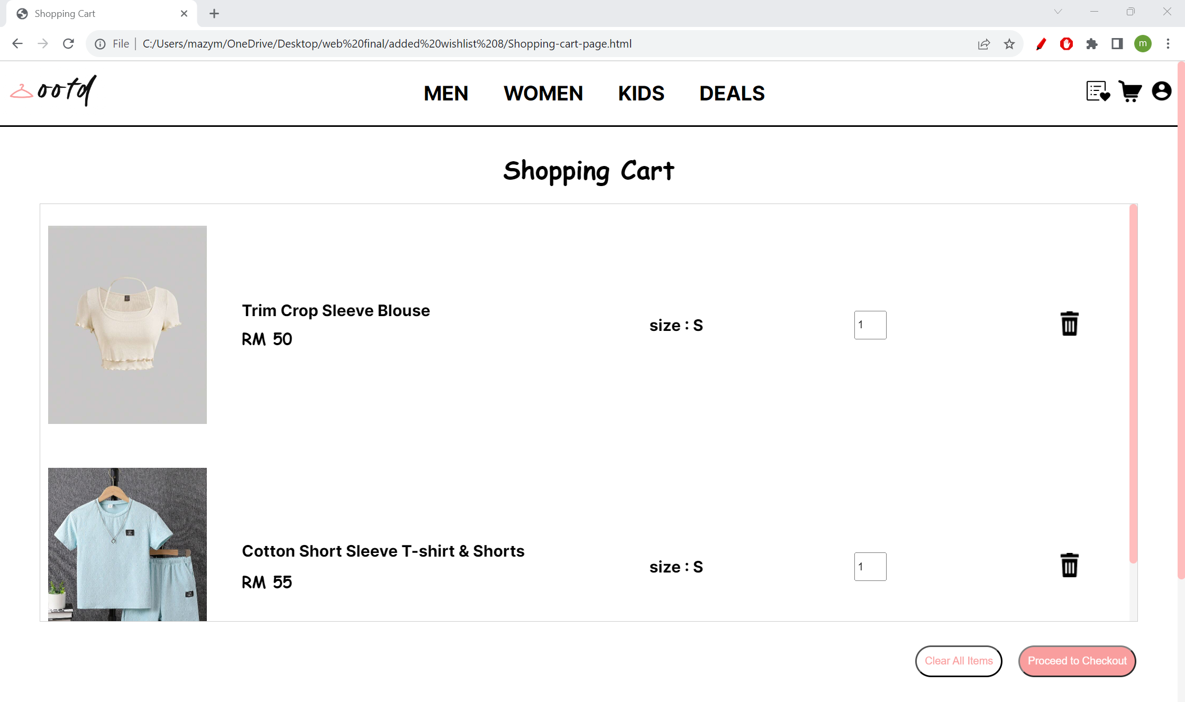

The “Clear All Items” button on the bottom right corner is clicked.

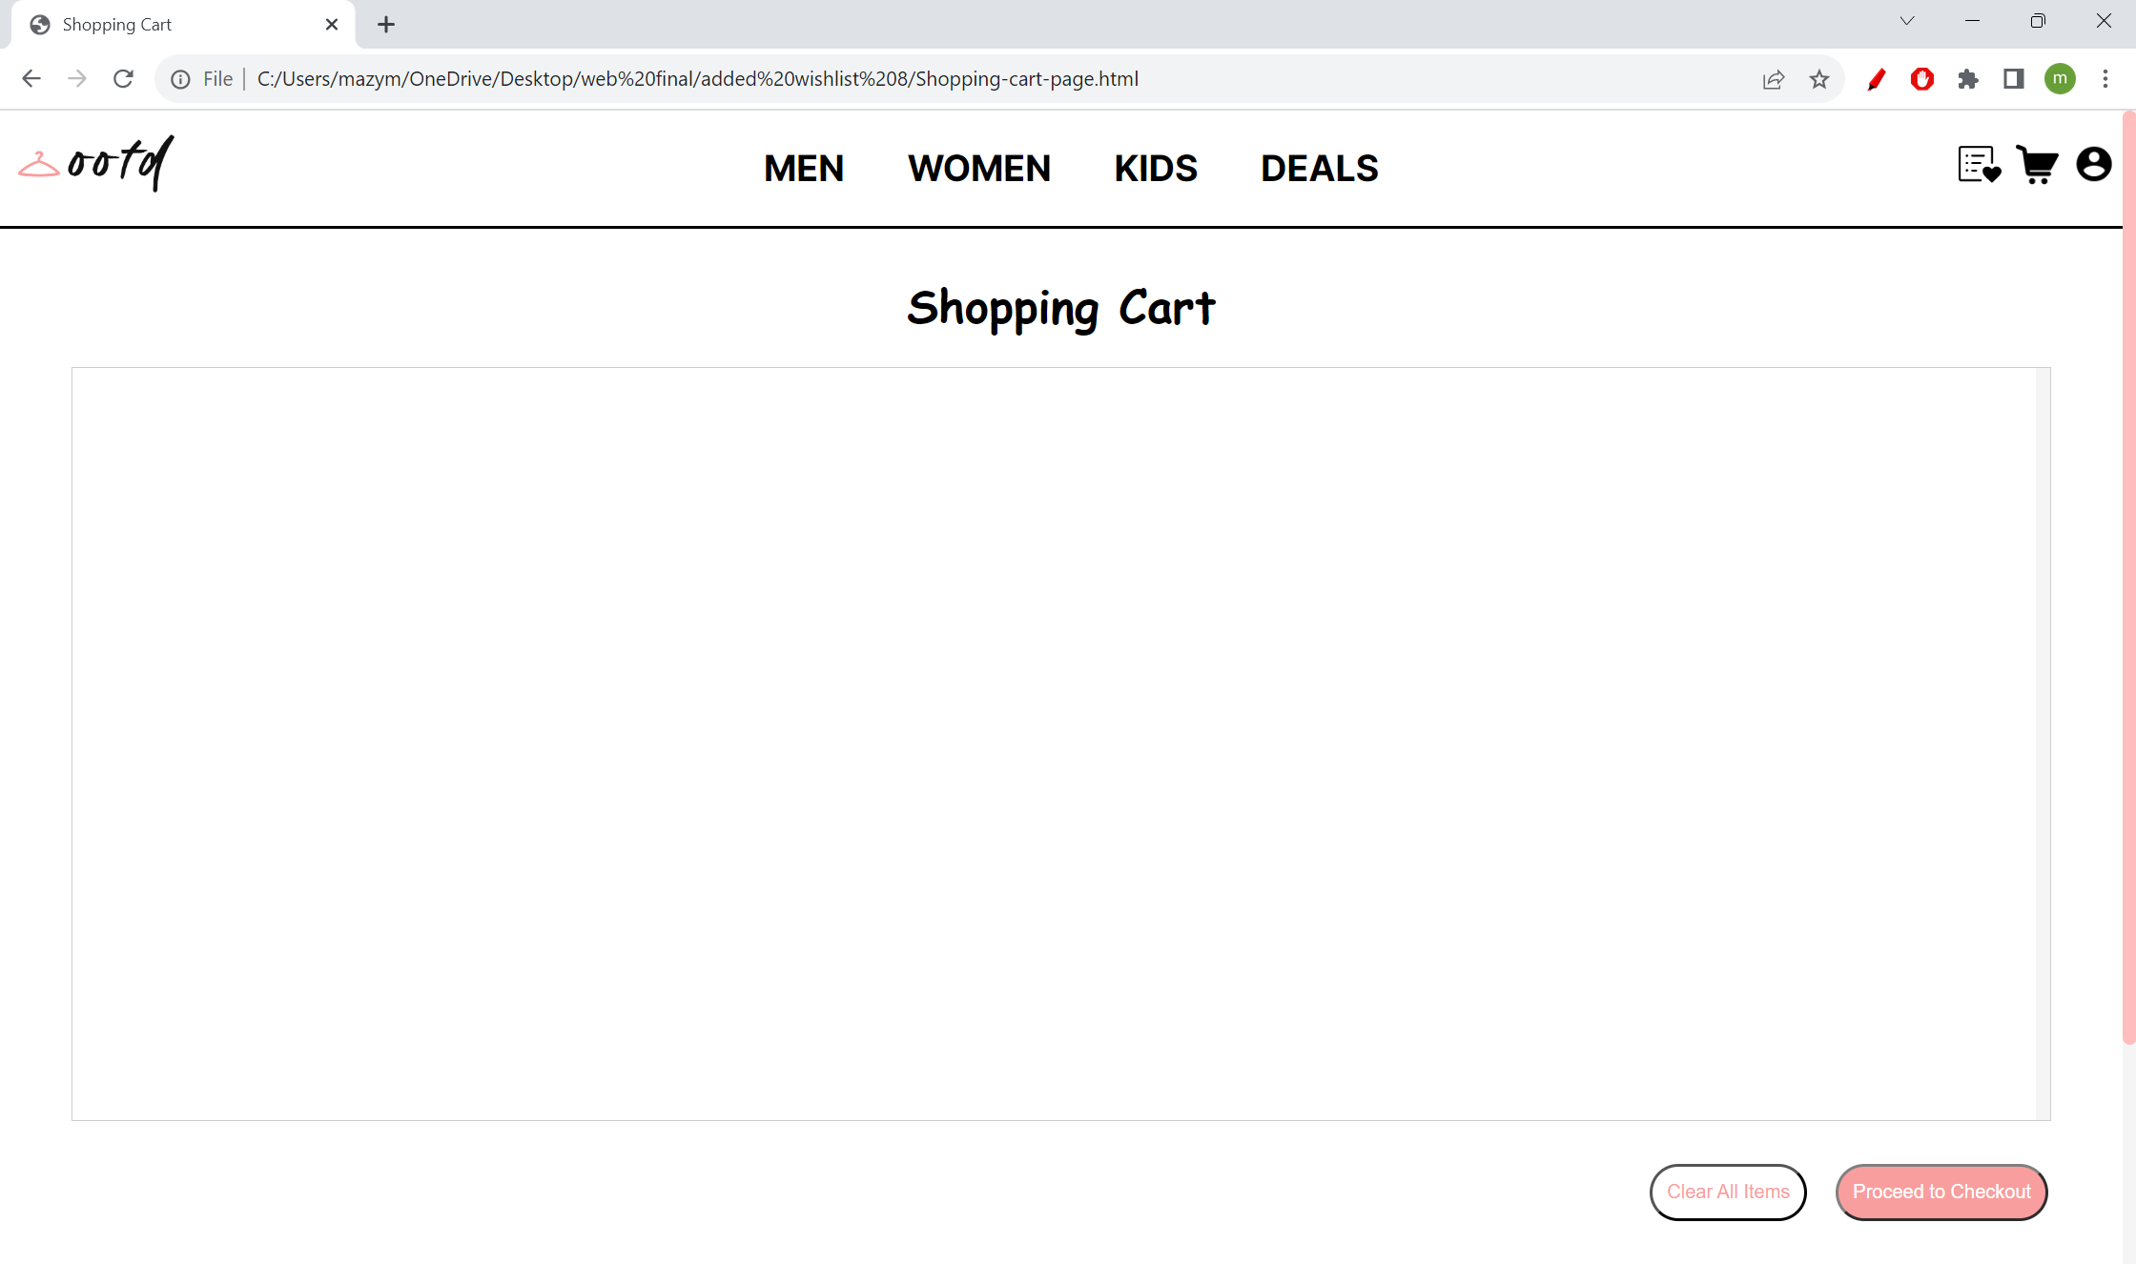

The result shows that the shopping cart is now empty again. Thus, we can confirm that the button is functioning as expected.

**Code Implementation**

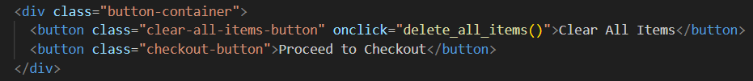

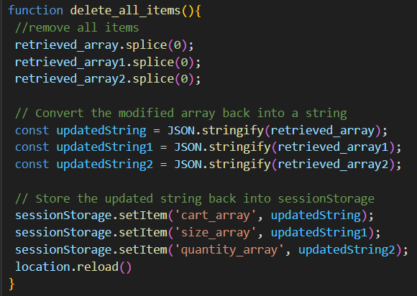

The delete_all_items() function is added onto the onclick property of the button. When the function is called, array.splice(0) is used to delete all the objects in the arrays. Then, the array is stringified and saved back to the sessionStorage. Finally, the page is reloaded to display the new Shopping Cart Page.

**Login Page**

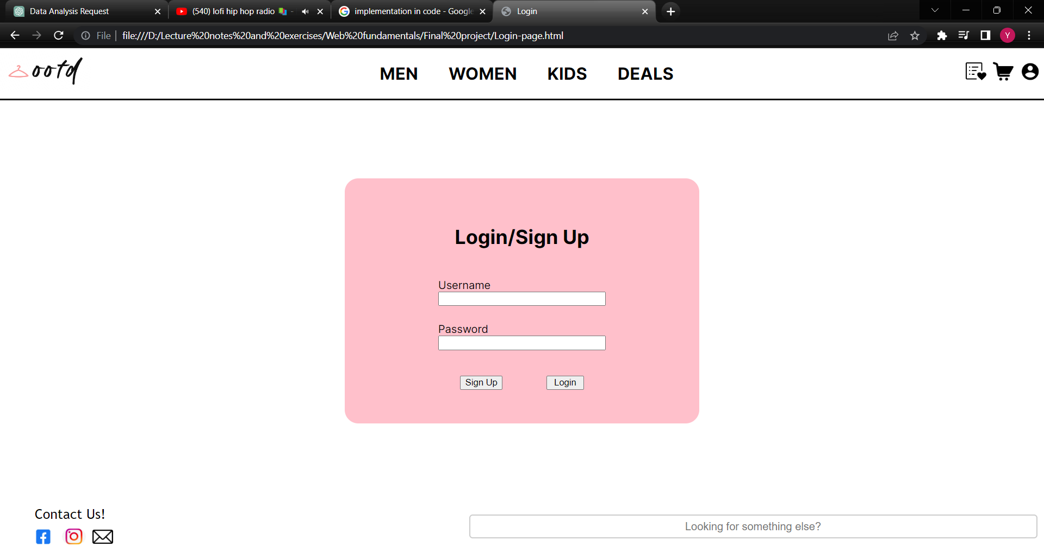

The following test cases focus on the login page of the website. First, the login function is tested by using a sample username and password. Then, the sign-up function is also tested.

**Login Function**

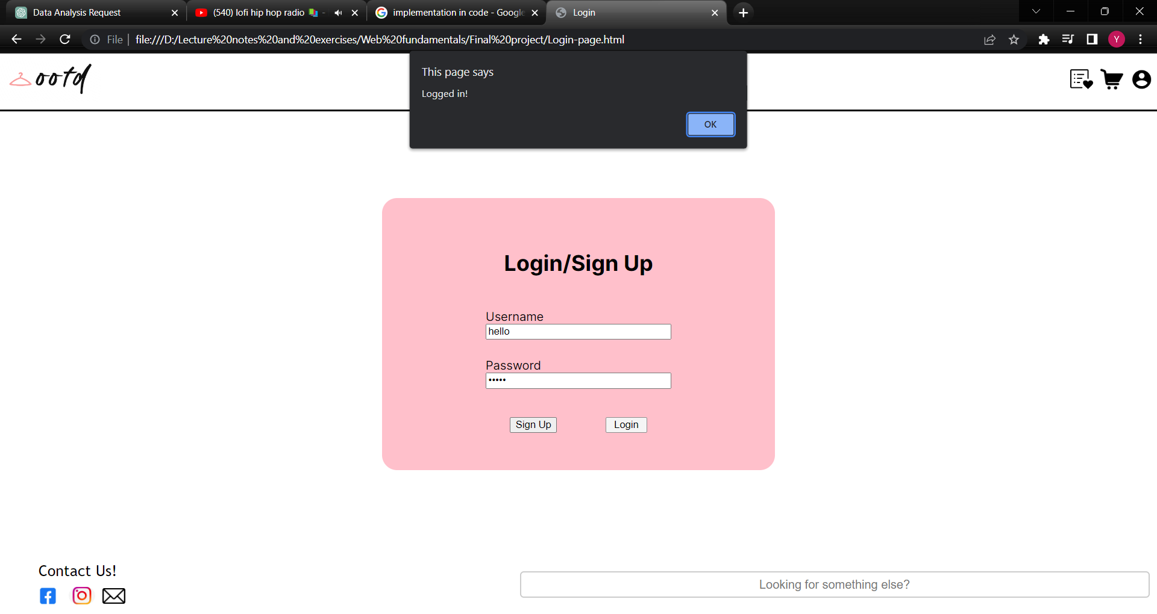

A sample user account with a username “hello” and password “world” is created for testing. When the correct login credentials are entered, the page will notice the user that the user has successfully logged in.

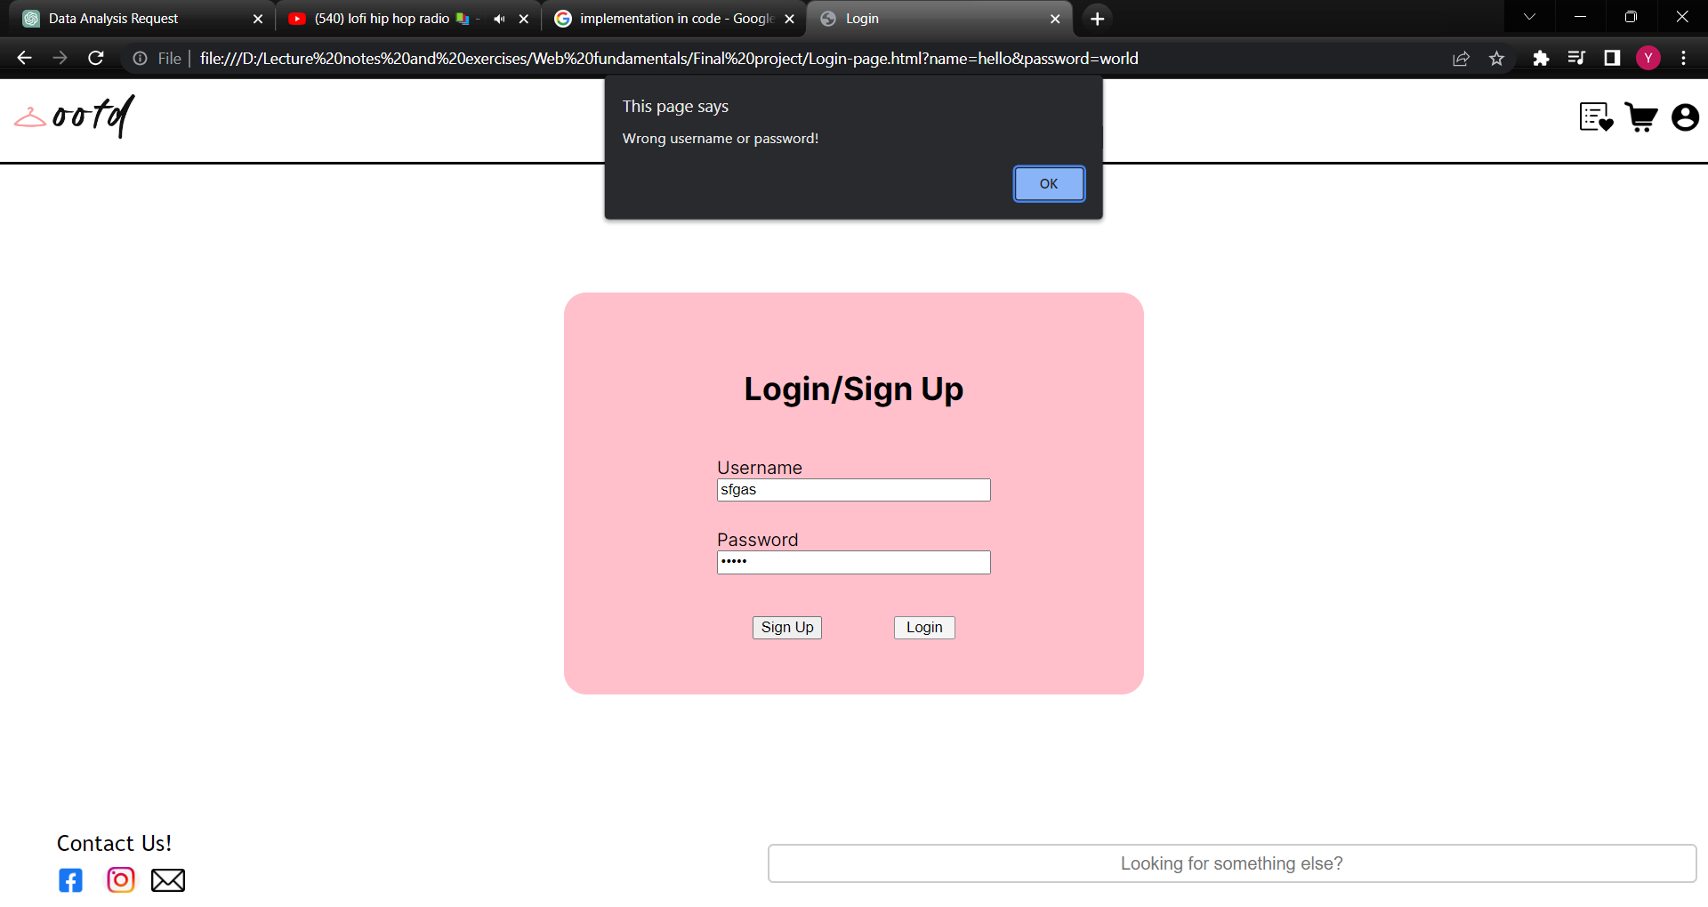

However, when wrong username or password is entered, the webpage will alert user that the entered login credentials are invalid.

**Sign-up Function**

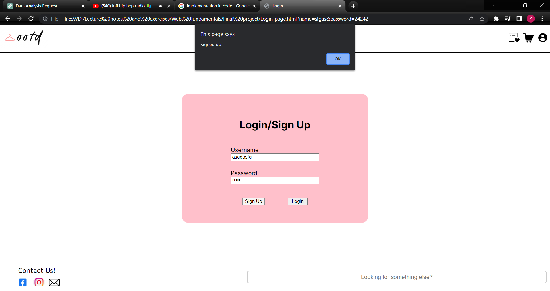

When both the username and password are entered, and the sign-up button is clicked, the webpage will tell user that the user has successfully signed up.

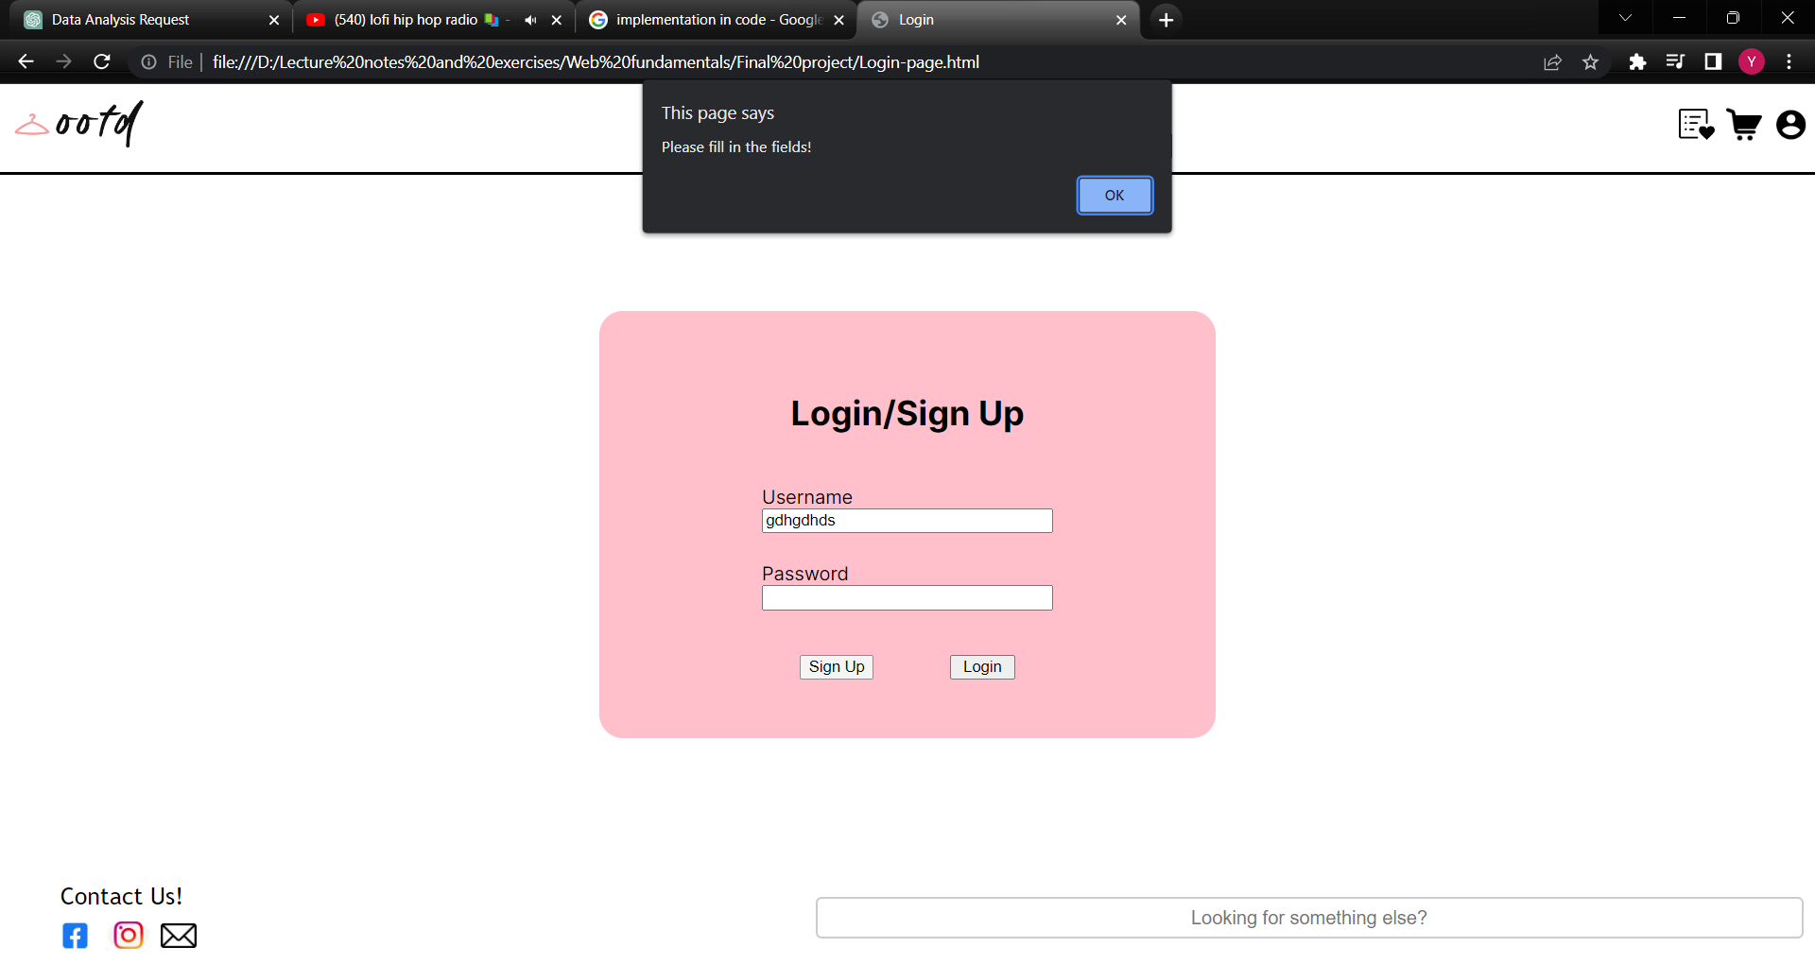

However, when one of the fields are not entered with a value, it will prompt the user to fill in both fields.

**Code Implementation**

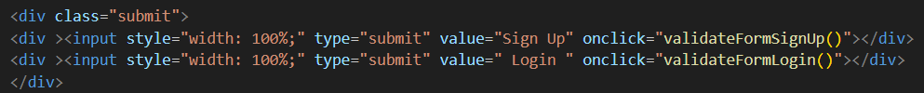

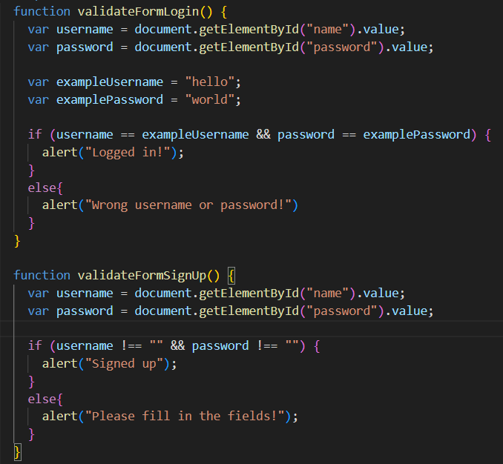

The validateFormSignUp() and validateFormLogin() functions are added to the buttons in the HTML code. When the button is clicked, the function uses the document.getElementById() function to obtain the value of the user input and processed the input by using an if-else statement. The attempt is then validated based on the condition and the message is displayed to the user.

**Contact Us Page**

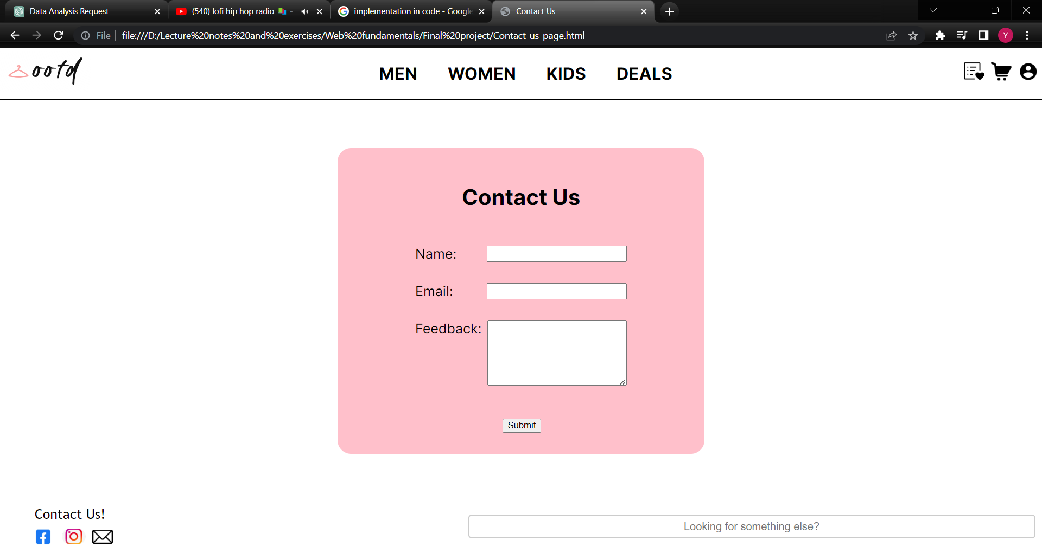

Finally, the contact us page will be tested. This page will validate the user input similar to the login page.

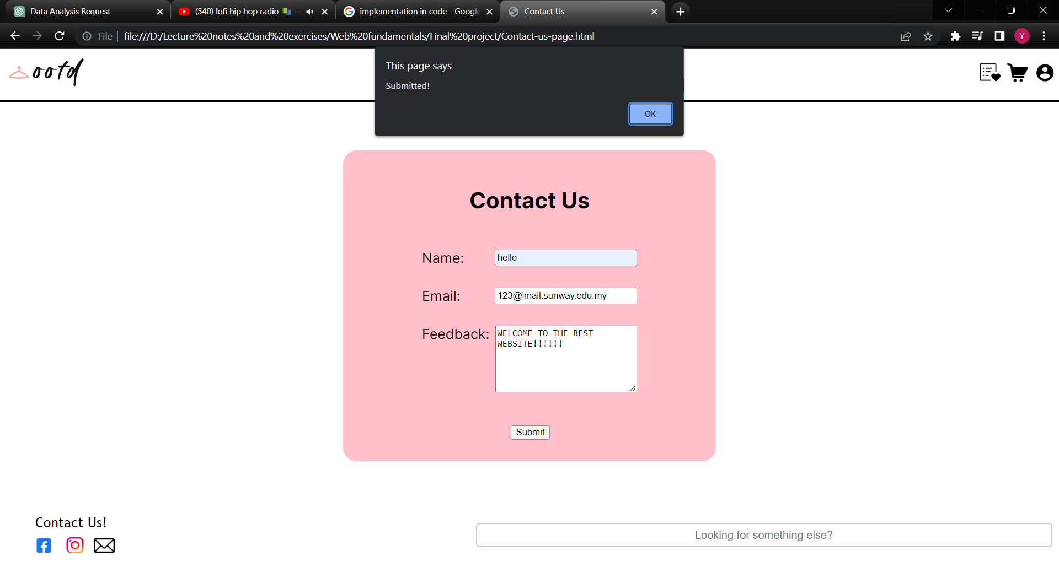

When valid inputs are entered by the user, the webpage will output a message that tells the user that the form is submitted.

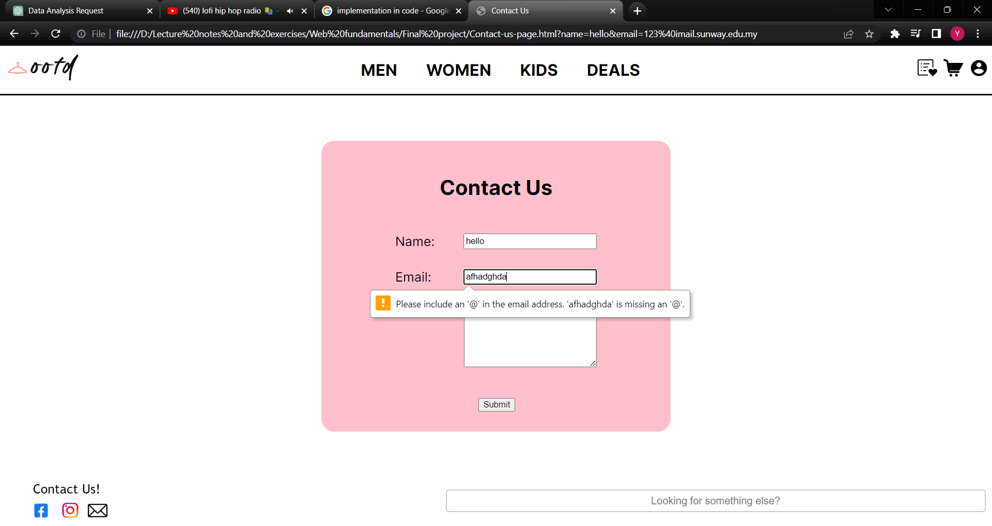

If the input is not correct, such as an invalid email is entered, the form will not be submitted. The test result shows that the validation of the form is working as intended as forms with improper format will not be submitted.

**Code Implementation**

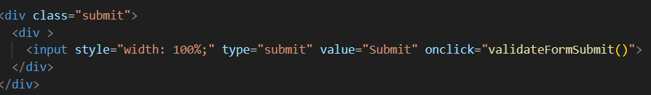

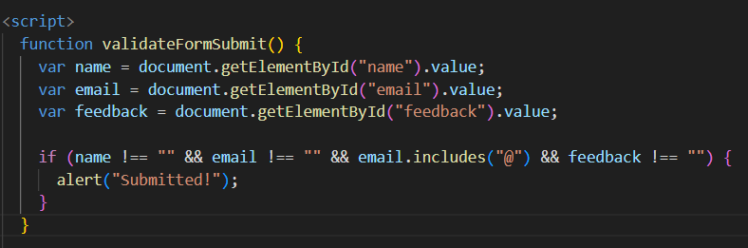

The logic behind the validation of the contact us form is similar with the previous test case for the login page. The validateFormSubmit() function is called when the submit button is clicked. By getting the values entered, the function checks if all the values are in the correct format. The user will be notified that the form has been submitted if the format is correct. Else, the user will not be able to submit the form.

**Webpage Reflexiveness**

**Navigation Menu**

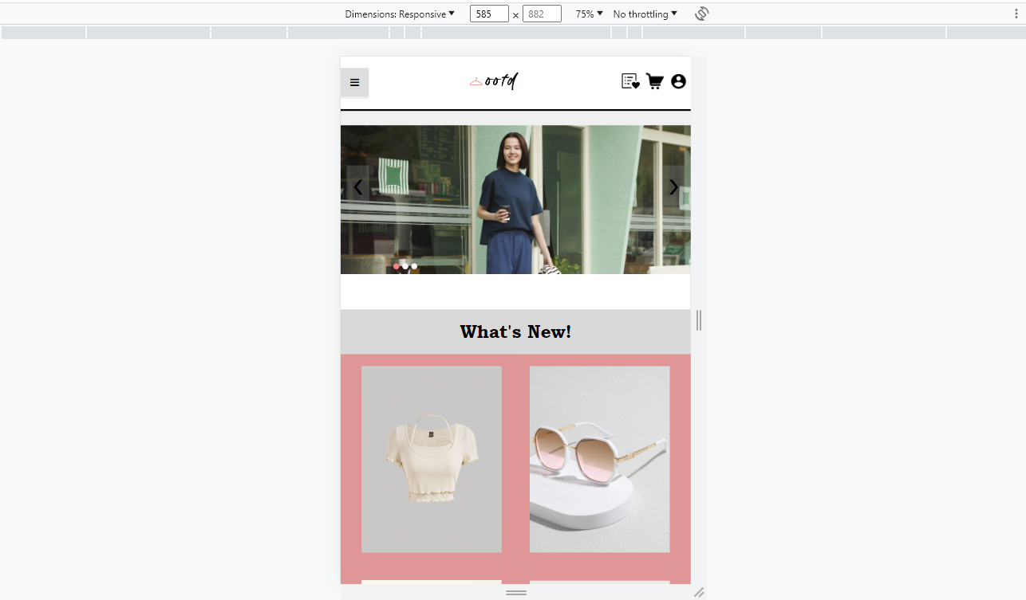 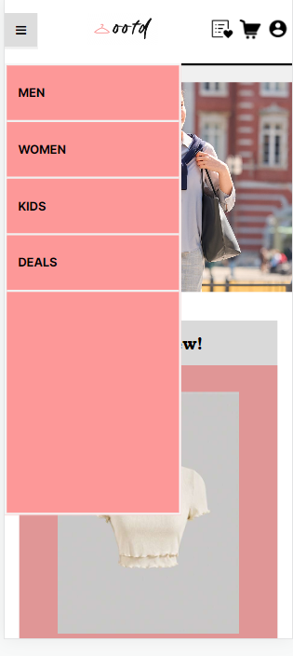

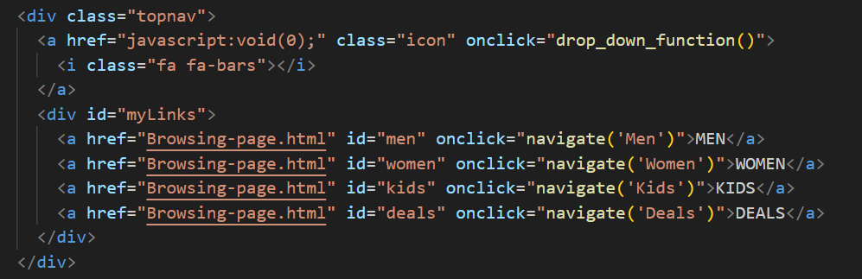

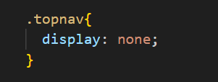 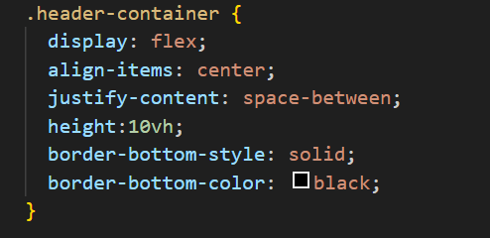

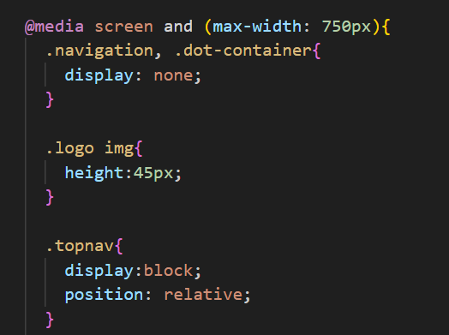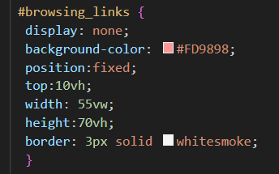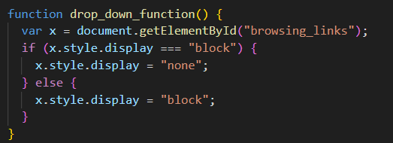

As the viewport gradually decrease, the inline navigation bar will not have enough space to display its full content. Thus, at 750px, which is the breakpoint of the navigation menu, a top navigation sidebar is implemented using the @media query. The top-nav side bar is originally not shown in a laptop viewport by using the display: none command line and will be display as a block as soon as it reaches 750 pixels. Since the header container was originally codded with a flex property with space between element, the navigation-sidebar, logo, and utility section will be spread out evenly across the header. As for the onclick drop_down_function, whenever the navigation bar (fa fa bar) is clicked, the display links to browsing pages will be change from none to block to showcase the navigation sidebar. Subsequently, if the navigation bar is clicked again, the display will be set as none.

**Home Page**

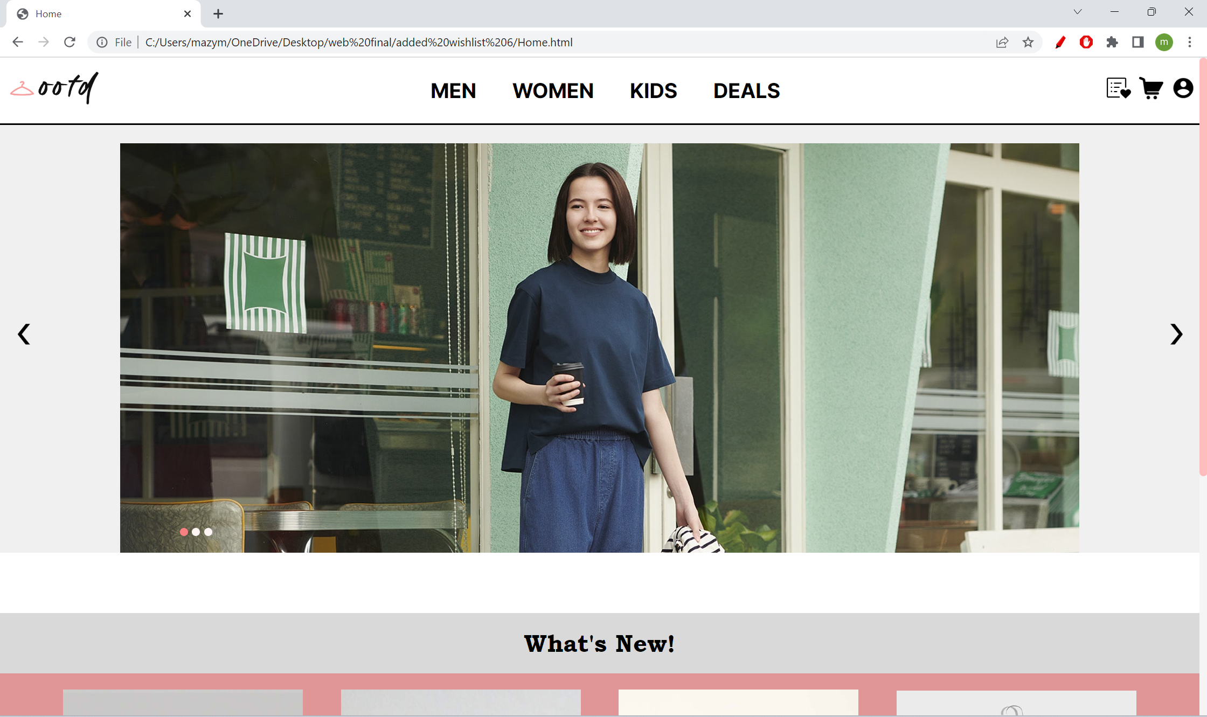

**Tablet view (Portrait)**

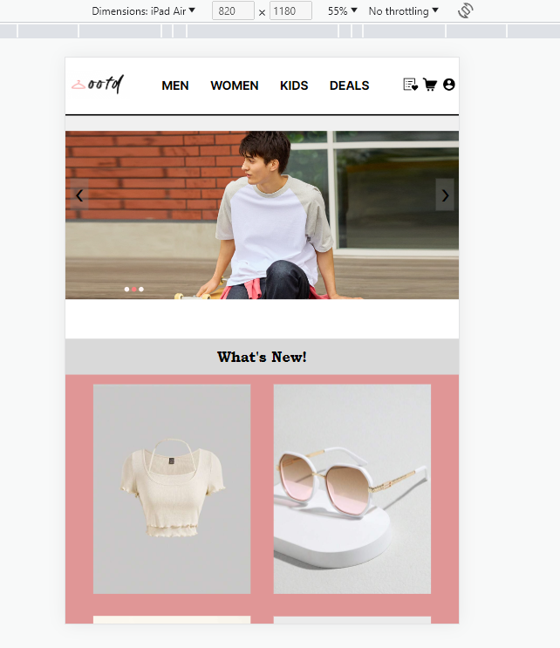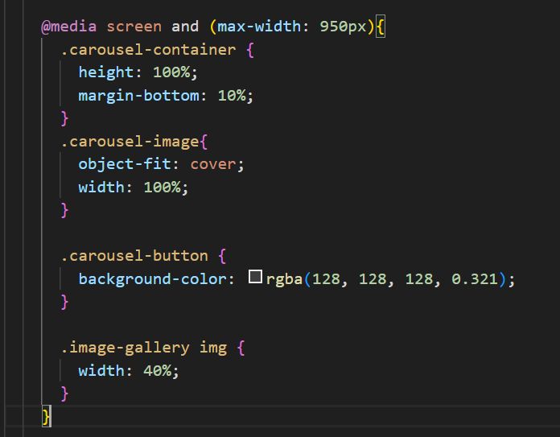

As soon as the Home Page reaches 950px, the carousel image fills the container and is applied with an object-fit: cover command as to ensure the ratio of the image stays the same even when the width of the container shrinks. Moreover, the carousel button opacity is reduced to ensure that the model-image can be seen clearly. The What’s new section images are also adjusted to fit two images a row only as compared to four images display on laptop viewport.

**Mobile view**

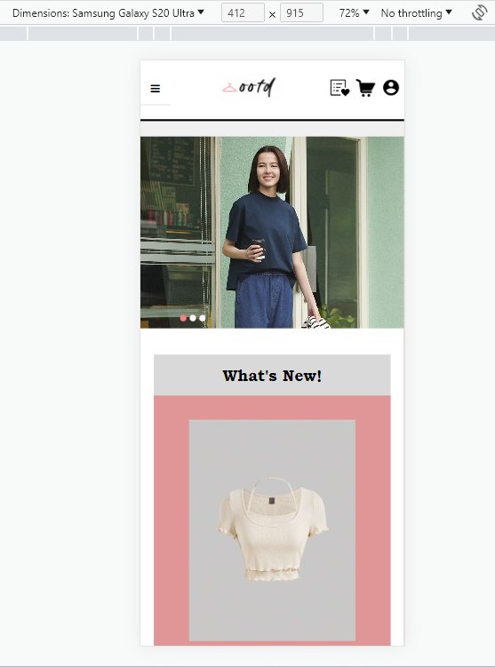 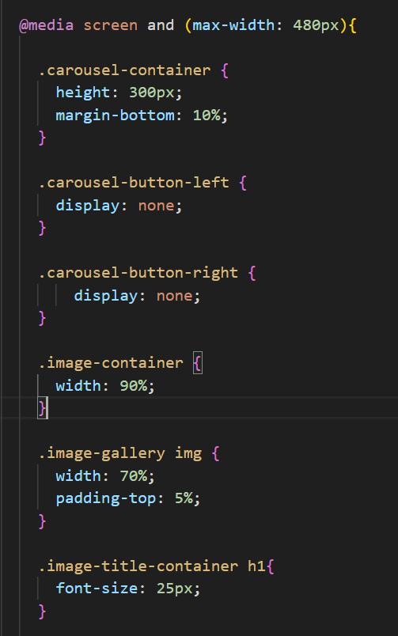

In mobile version, the left and right carousel button will not be displayed. The font size of the “What’s new” container is also reduced while displaying only one image at a time.

**Browsing Page**

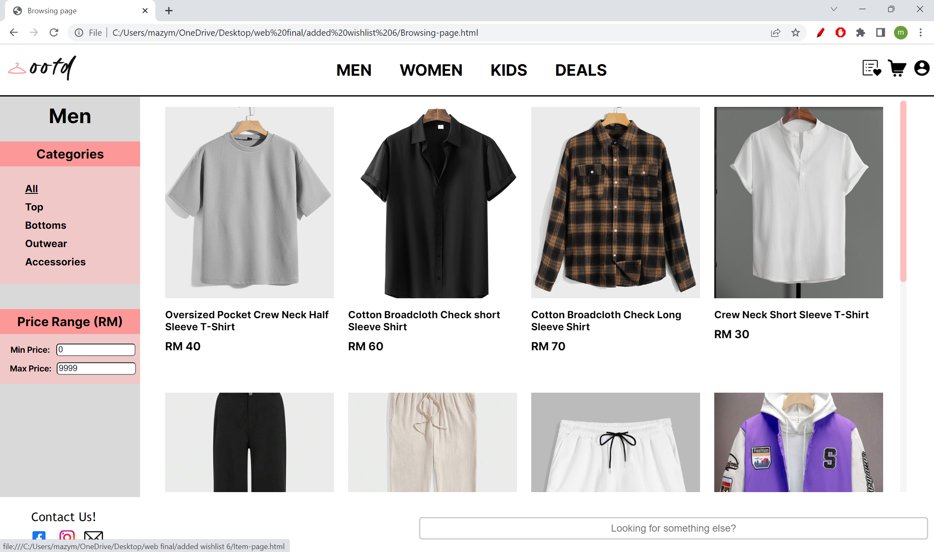

**Tablet view**

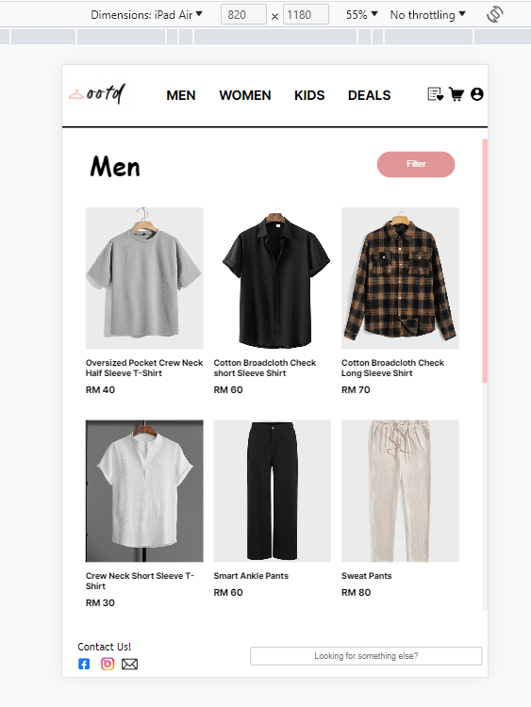 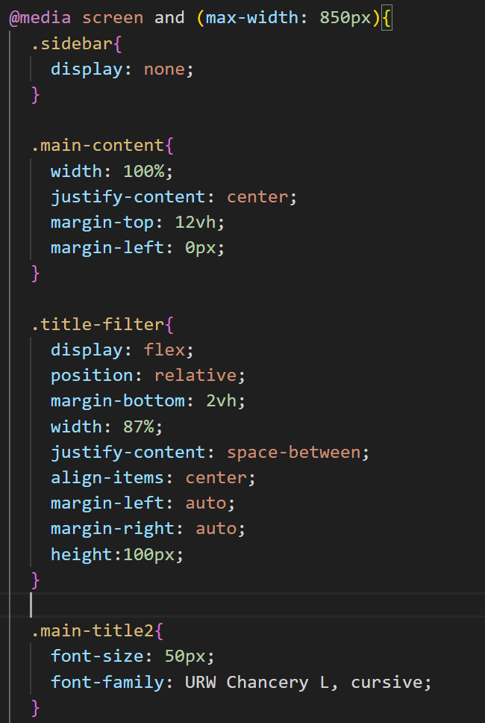

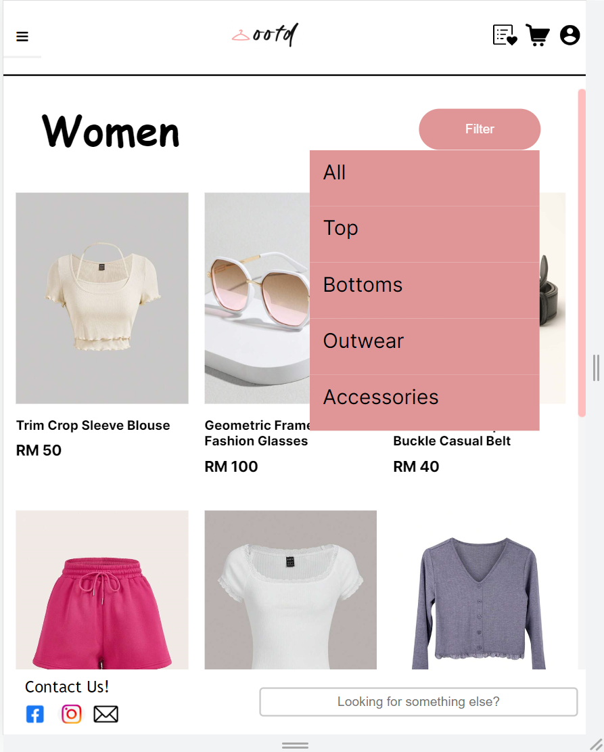 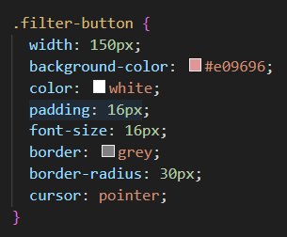

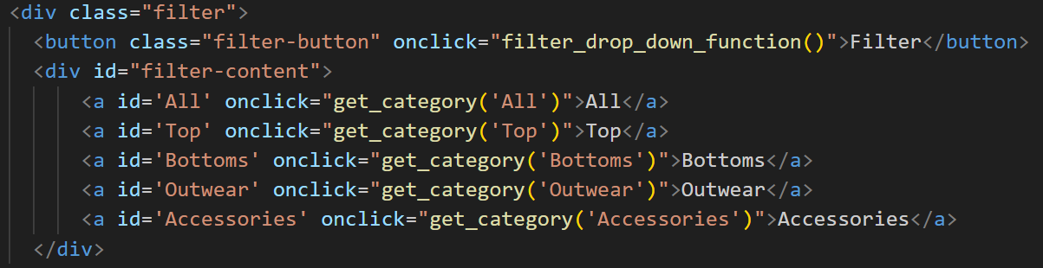 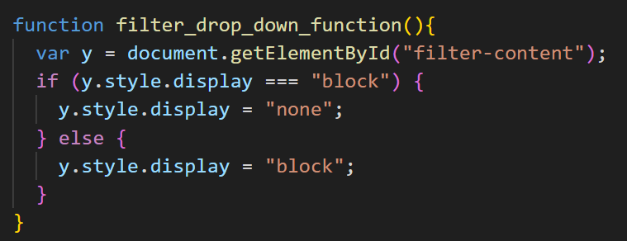 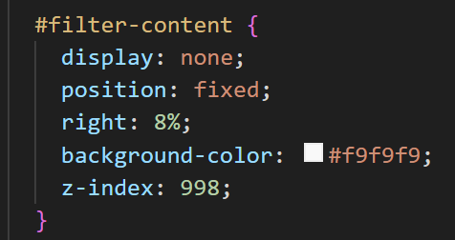

For the tablet view, the categorical-sidebar will not be shown, and it is replaced with a filter button to reserve most of the viewport for the main-content. The filter button uses the same drop-down function as the navigation sidebar to display the categories. The title as well as the filter button will be displayed in a flex box with a space between property. Subsequently, the width of the items is also adjusted to fit the container perfectly with 3 items per row.

**Mobile view**

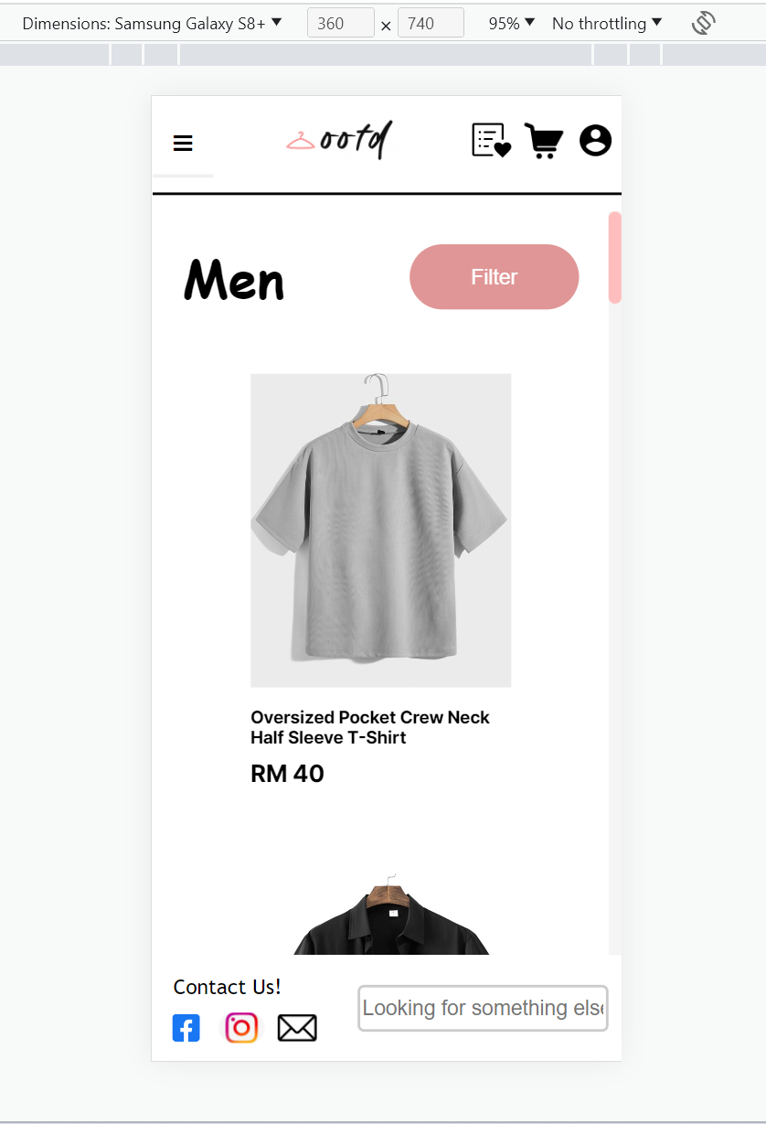 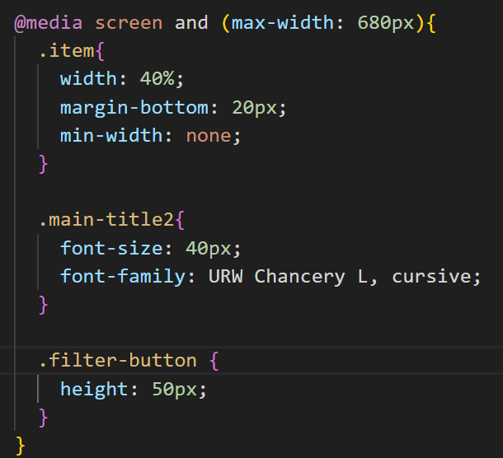

The mobile view is similar to the tablet view with some minor changes. Only an item per row is displayed by adjusting the width of the item container. The font size of the title and the height of the filter button is also reduced to accommodate the smaller screen size.

**Item Page**

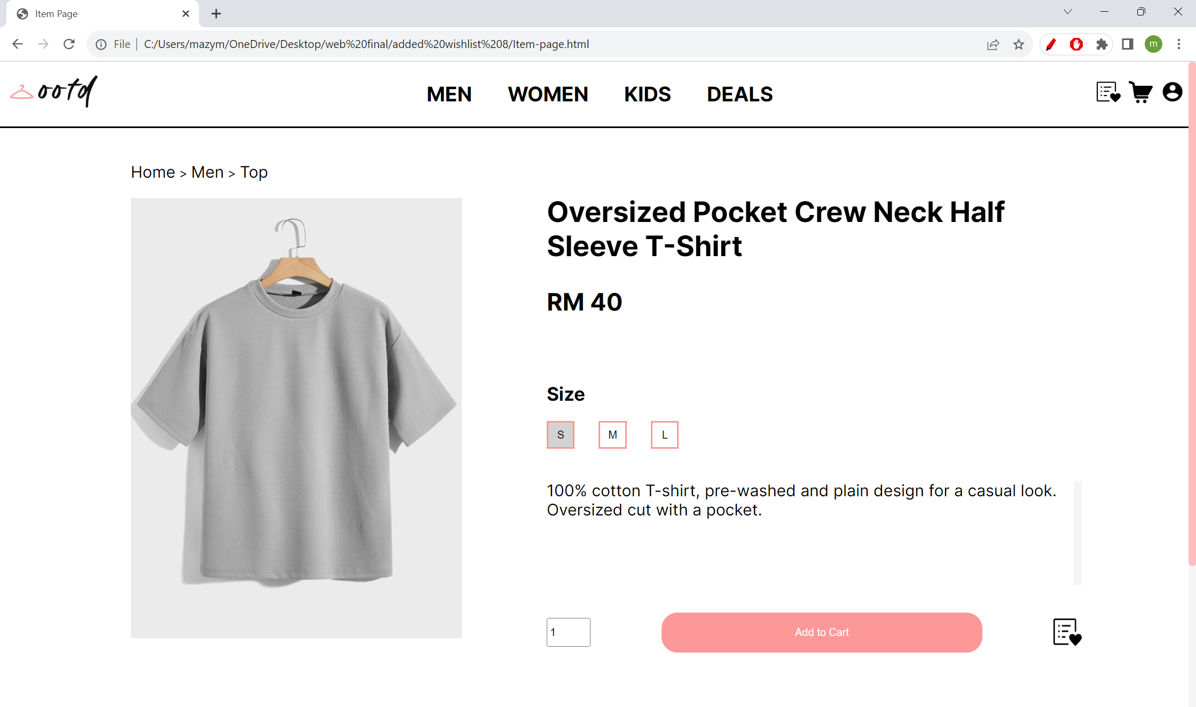

**Tablet view (Landscape)**

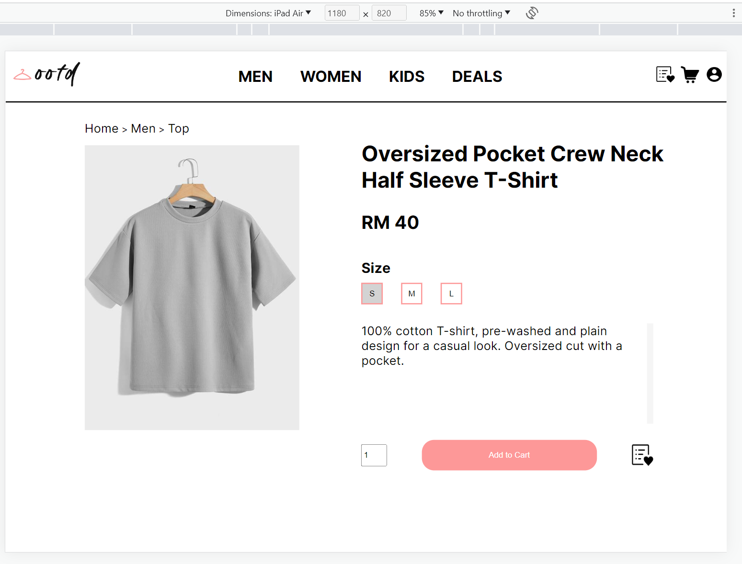

**Tablet view (Portrait)**

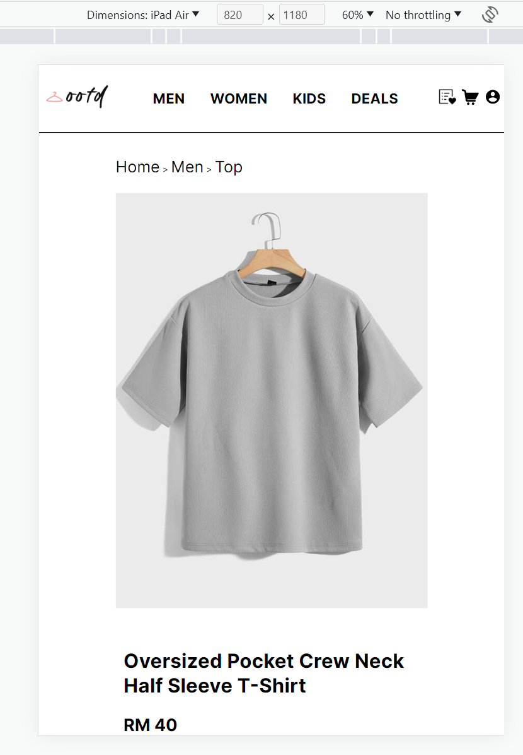 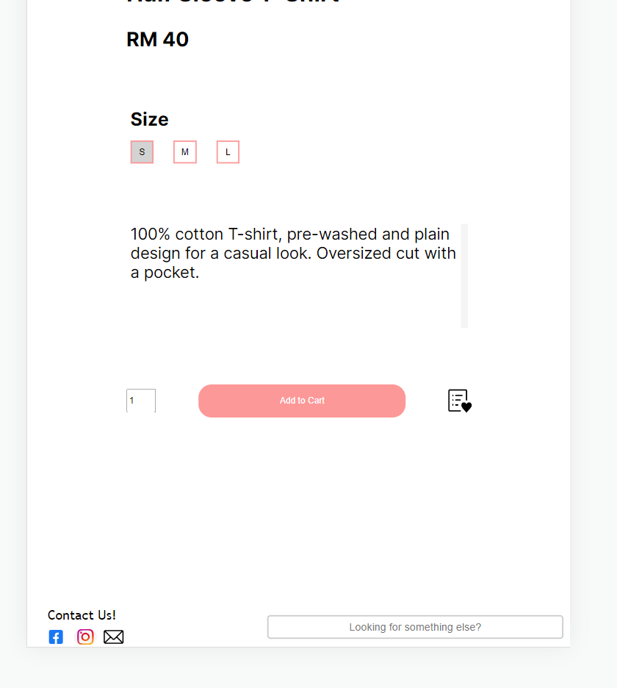

right

right

Left

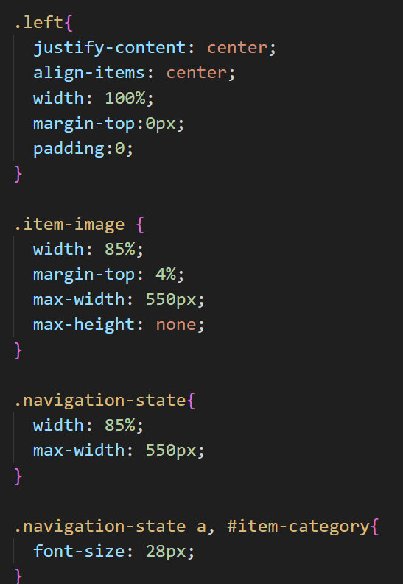 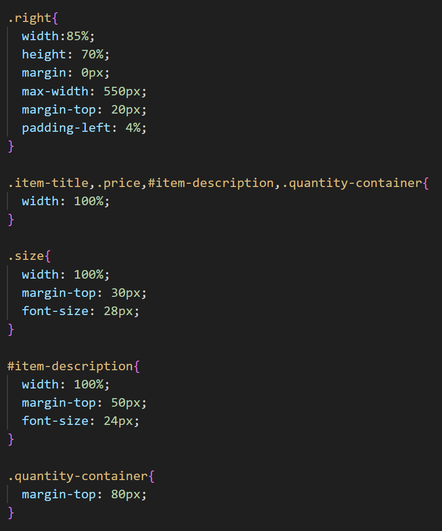

At 850px, a flex wrap property is used on the whole container as to allow the content to flow to a new line if the width is not sufficient. Consequently, the width of the left container and right container are set to 90% and 85% respectively to fill most of viewport width. The left division and right division are both display with a flex property to justify the content at the centre of the page. The overall text size is also adjusted to fit with the smaller viewport.

**Mobile view**

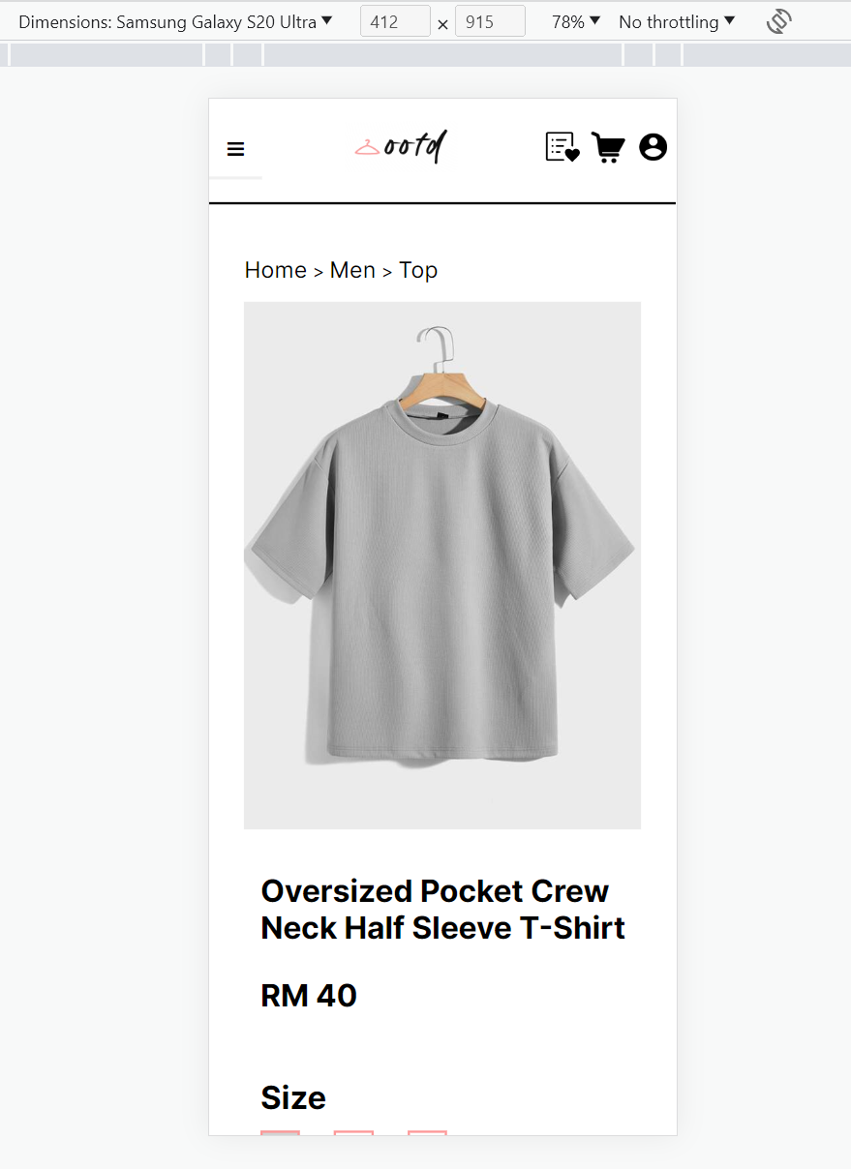 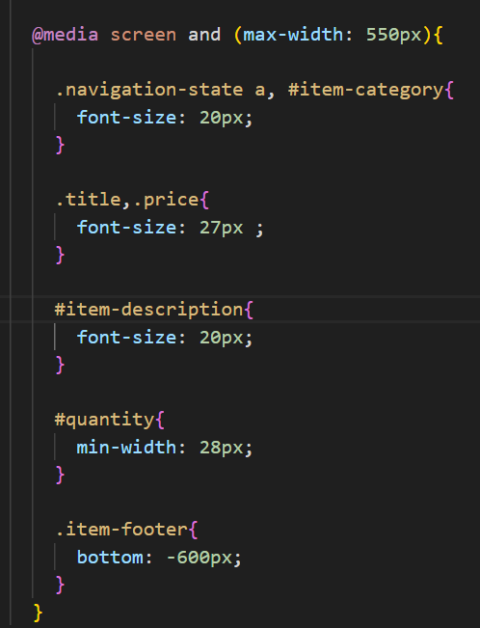

Mobile view is generally similar to tablet view with a little change in the font size and footer position.

**Shopping-Cart Page**

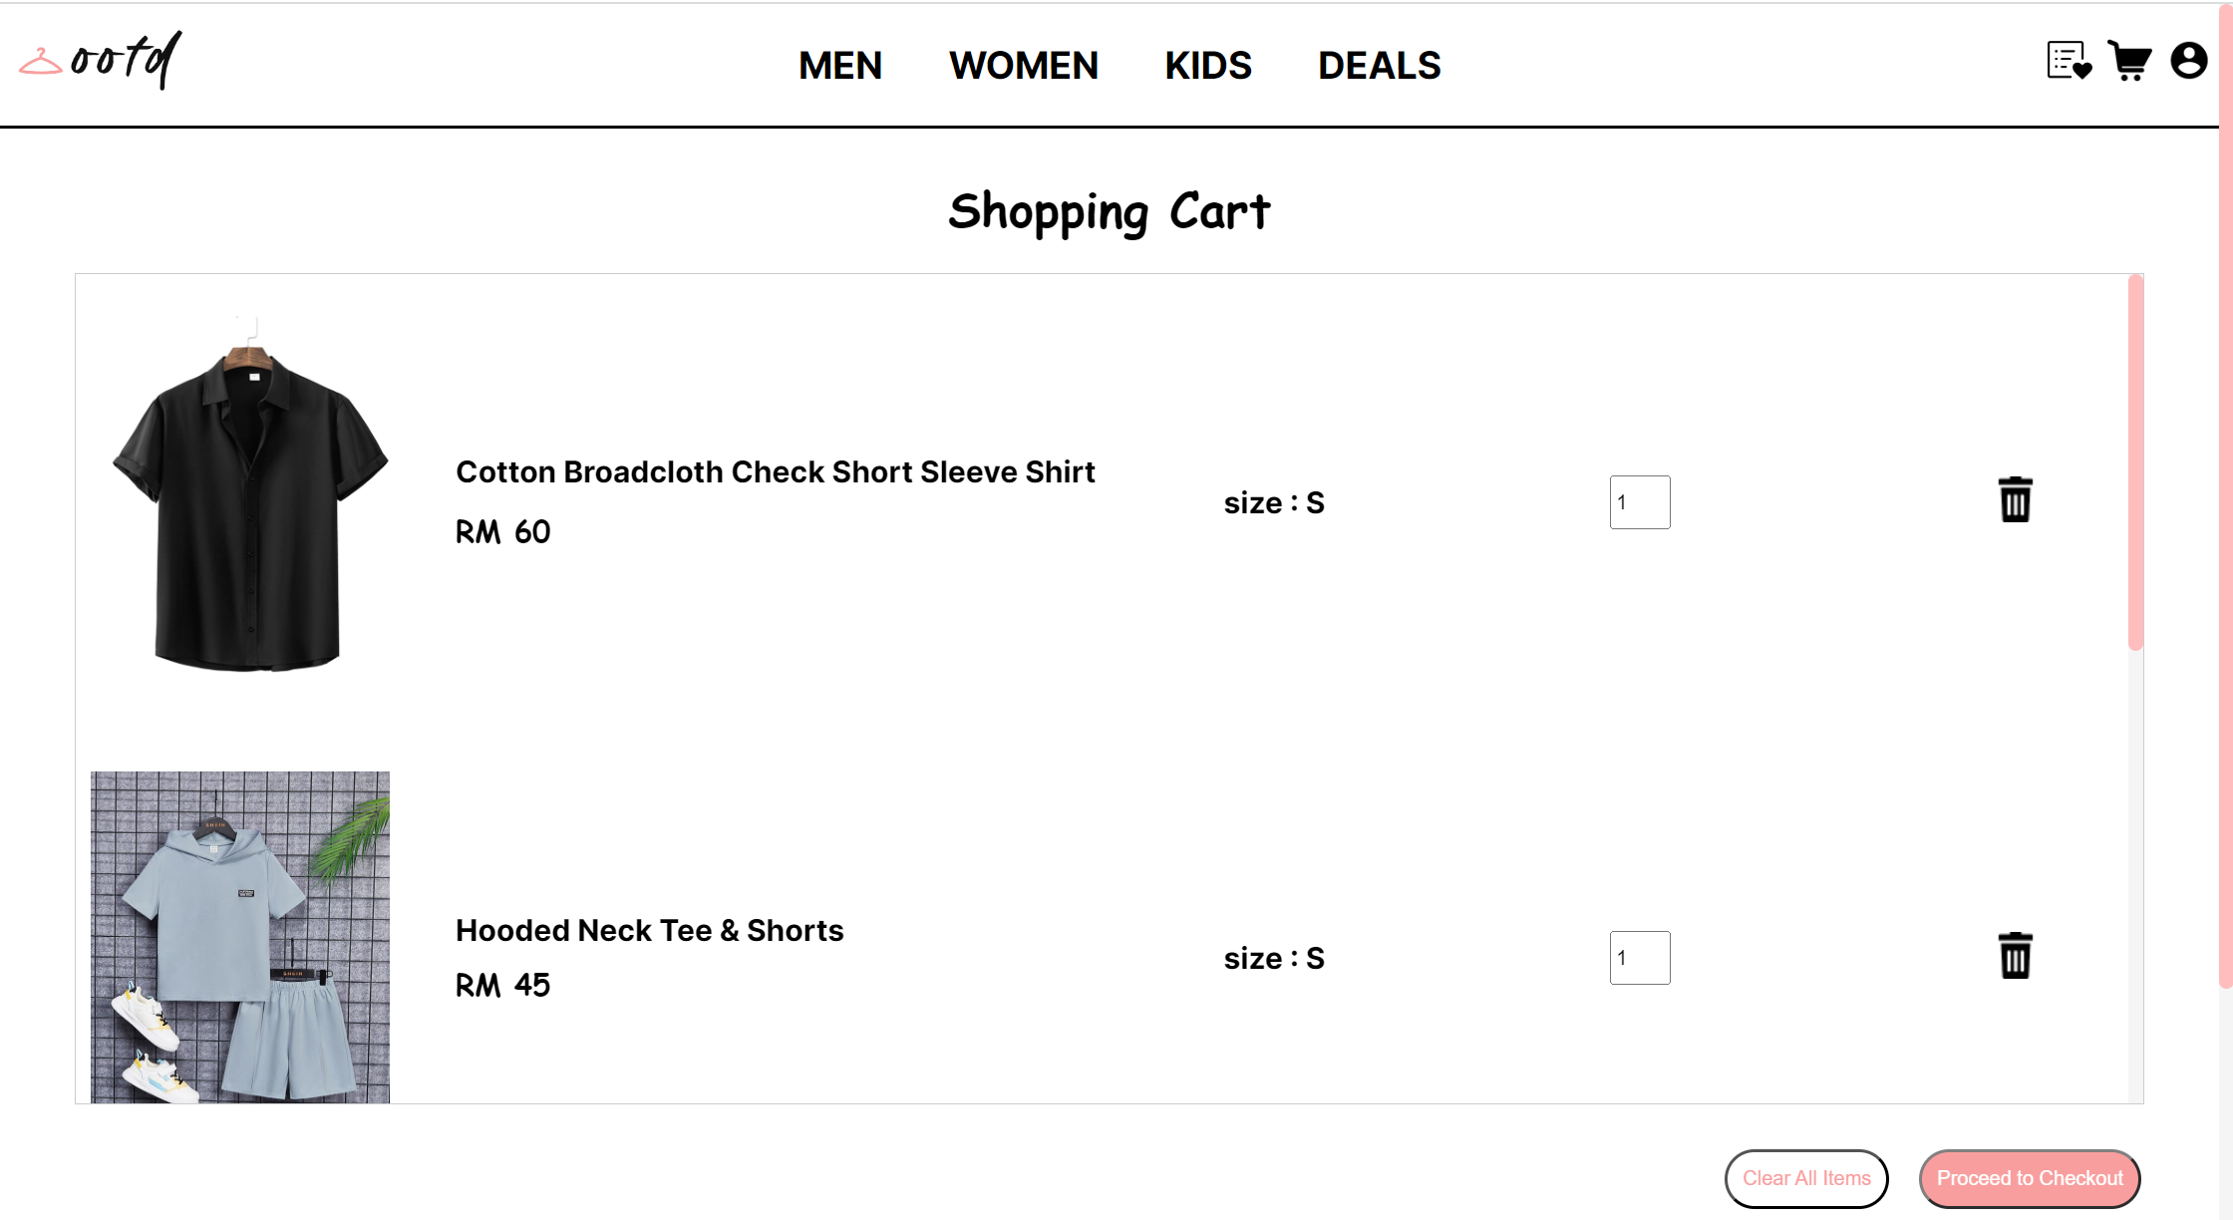

**Tablet view (Portrait)**

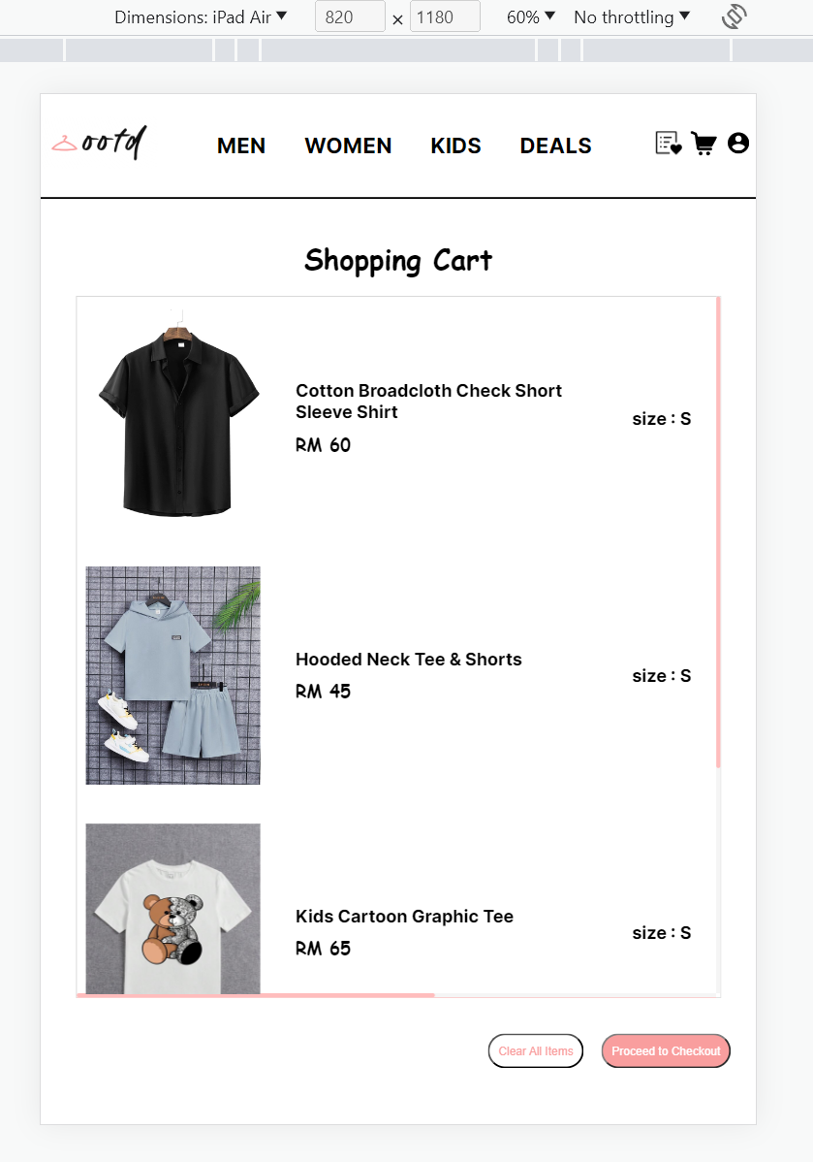 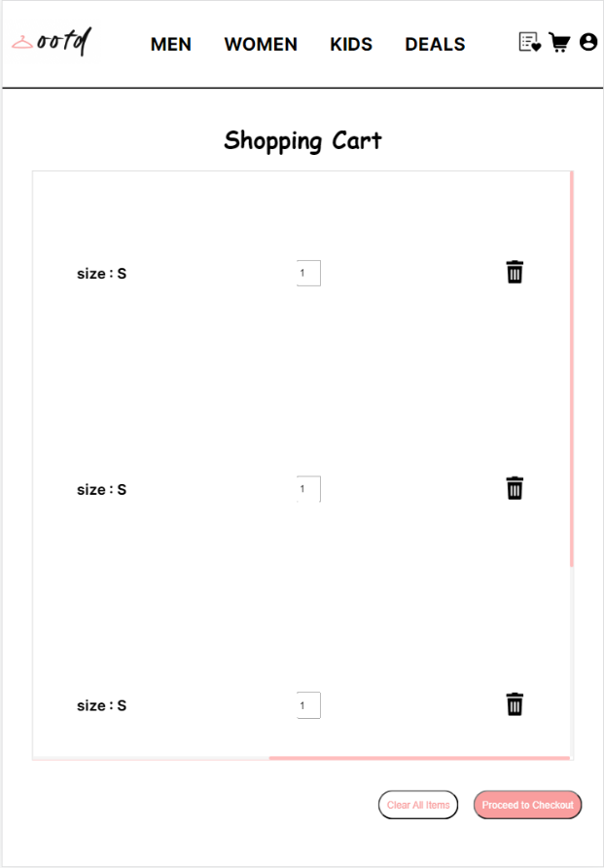

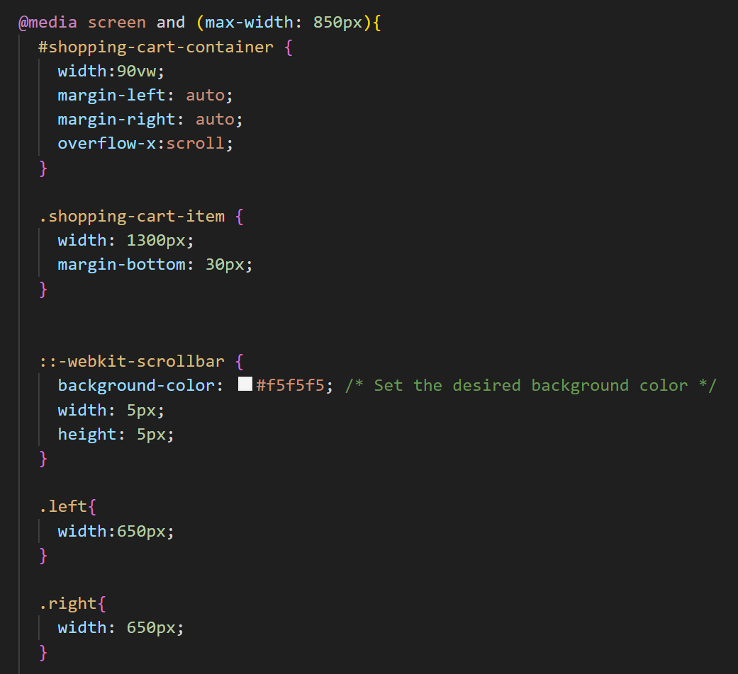

For the tablet view at 850px, the shopping cart container is set with to overflow on the x-axis to allow the user to scroll to see the full details of the items.The width of the item container is also set with a fixed width in pixel measurment instead of percentage to ensure that the exact width of space is reserved for each item per row.

**Mobile view**

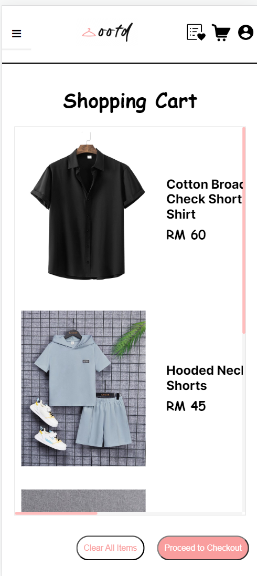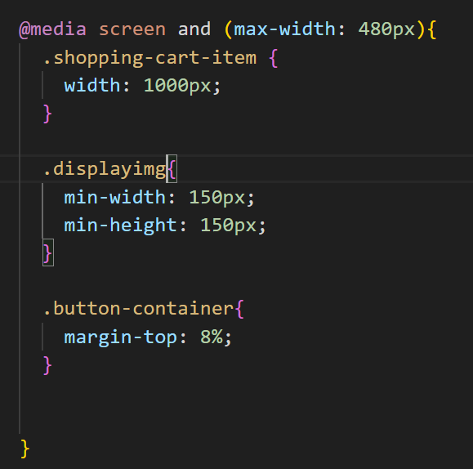

The mobile view inherits the elements from previous viewport with only a slight adjustment on the width of the container. A minimum width and height are set on the item images to ensure that the display of the item is clear.

**Wishlist Page**

**Tablet view (Landscape)** 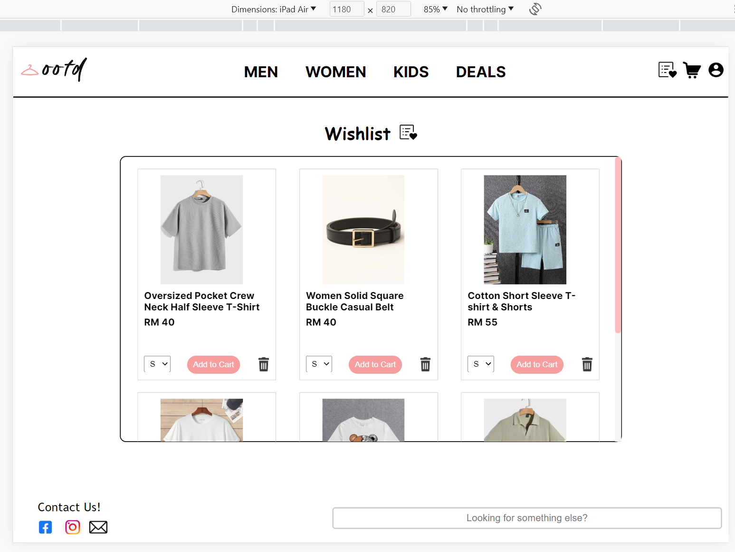

**Tablet view (Portrait)**

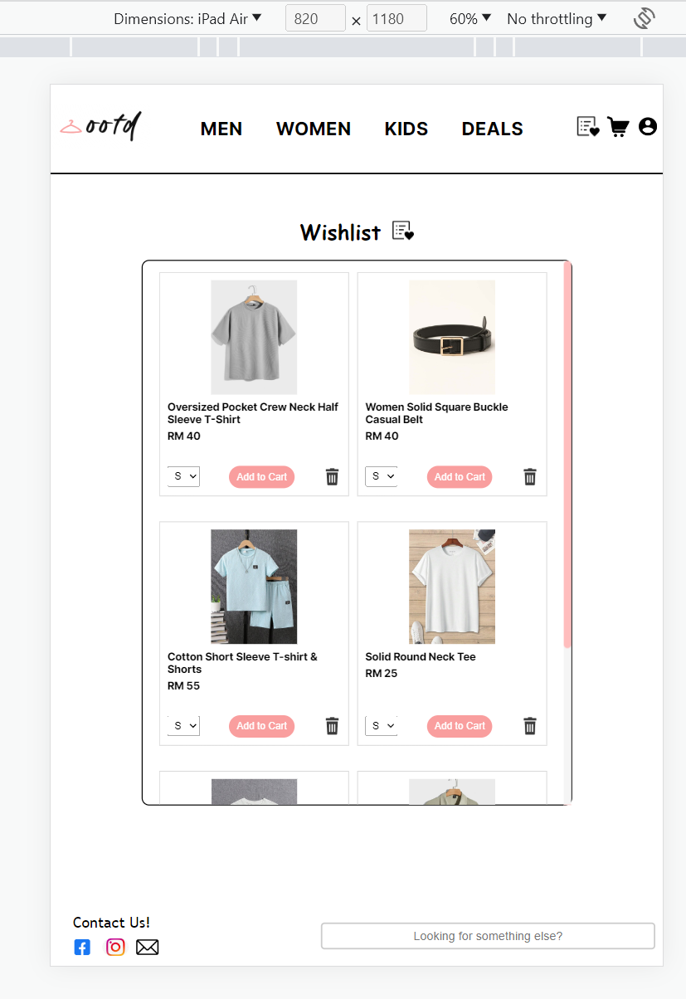

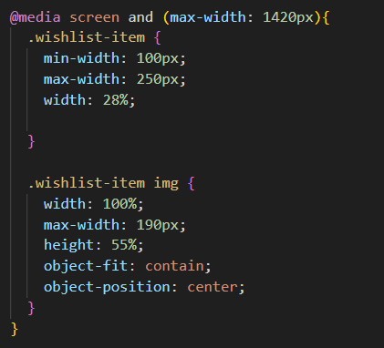 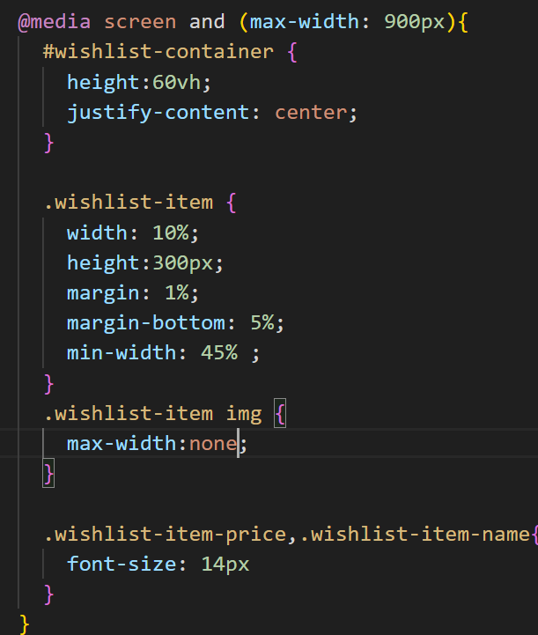

**Mobile view**

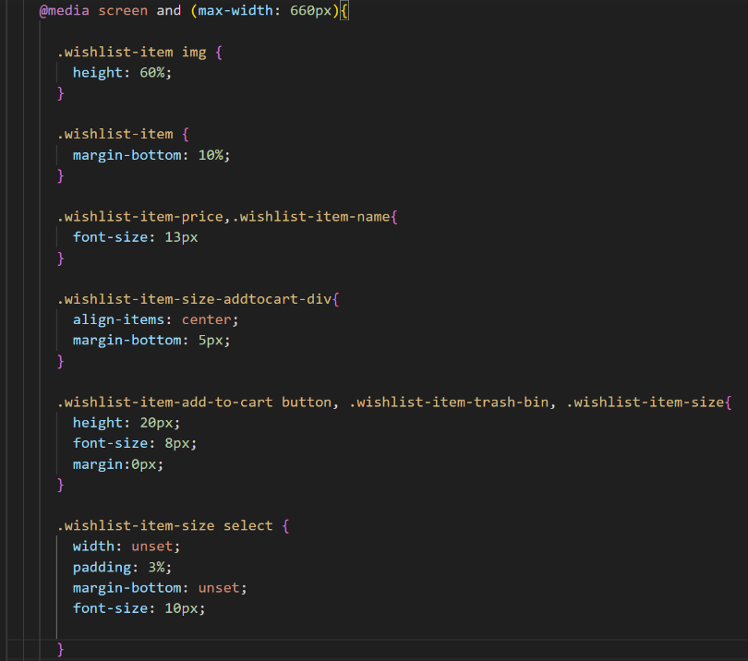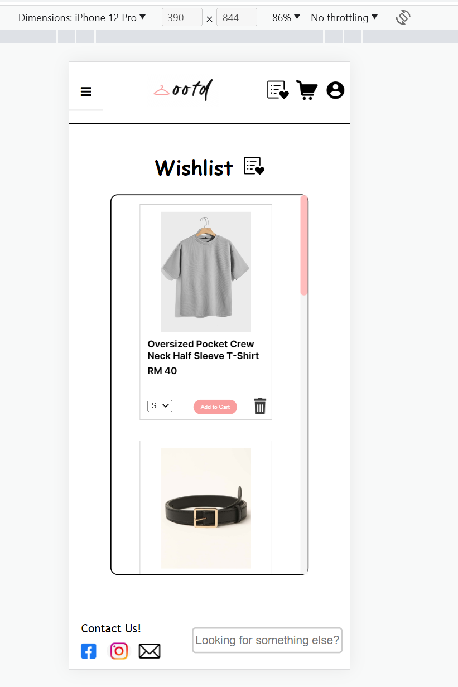

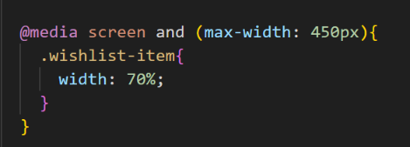

For the Wishlist Page, the size of the item containers, the item images and the font sizes are adjusted accordingly to fit the tablets viewport and mobile viewport. The test result shows that the Wishlist Page is successful of displaying items neatly across different viewports.

**Login Page**

**Tablet View (Landscape)**

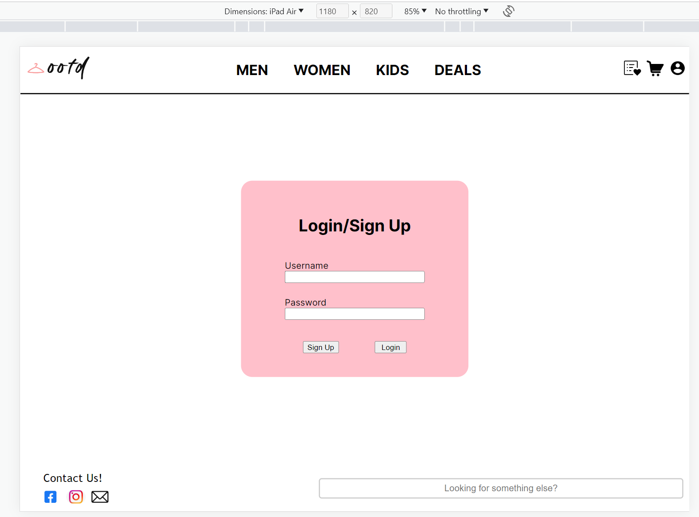

**Mobile View**

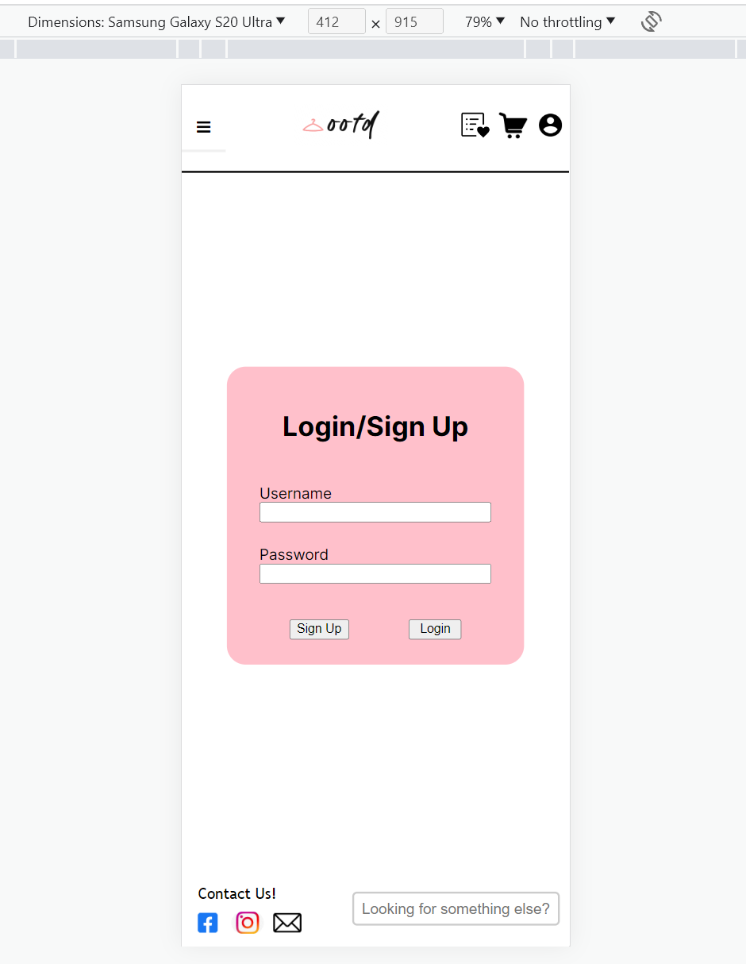

**Contact-Us Page**

**Tablet View (Landscape)**

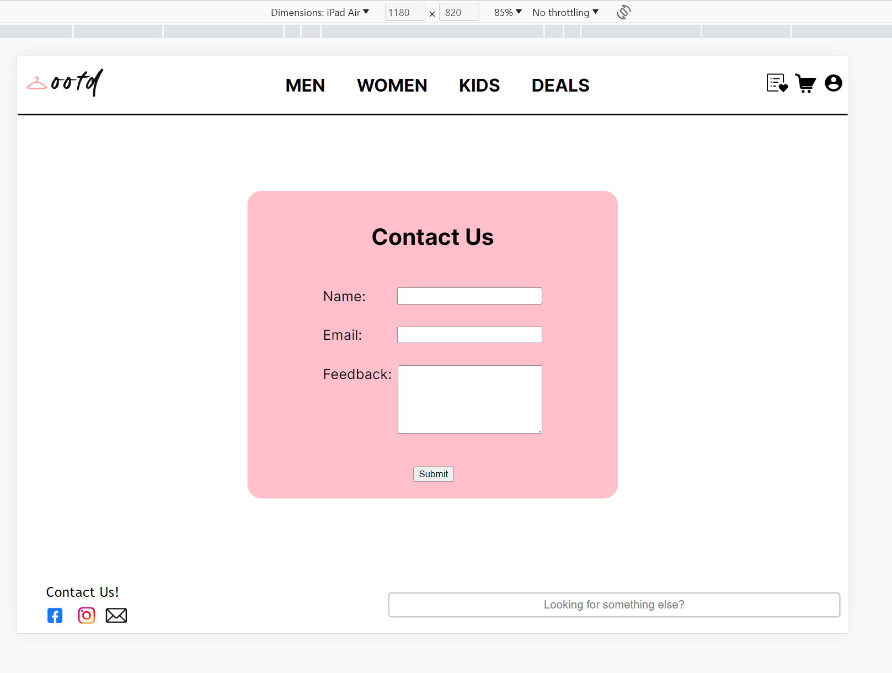

**Mobile View**

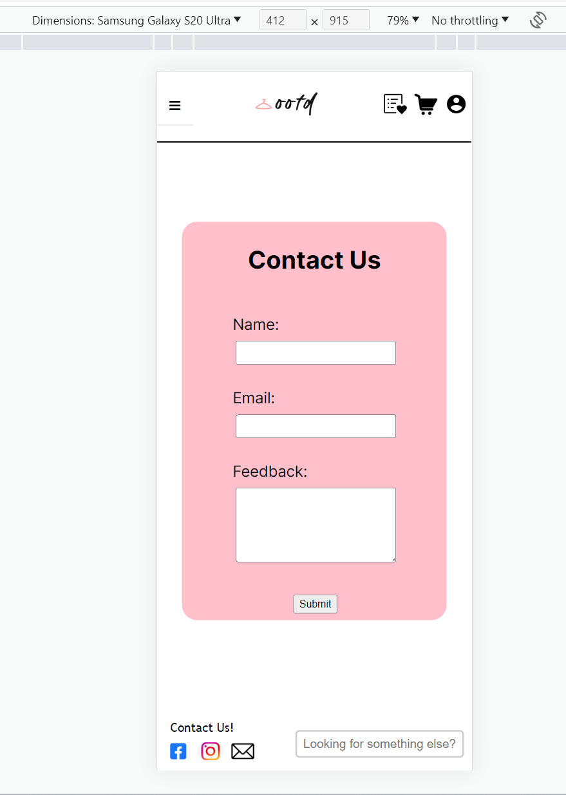 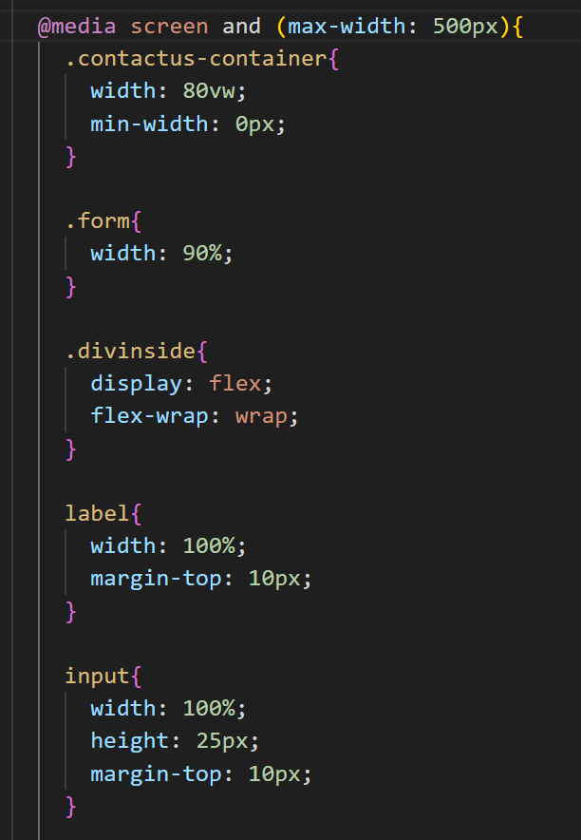

At 500px, which is the breakpoint of the Contact-Us Page, the content inside the form is set to a display of flex with a flex-wrap property to accommodate enough space for the label and input. The test result indicates that the label and input are wrap on different rows, thus proving the sucessfil implematation of the code.

**References**

*[If you have any references, provide the list in this section. Please use APA referencing style.]*

1Pair Women Geometric Frame Boho Fashion Glasses For Summer Vacation. (n.d.). SHEIN Malaysia. https://my.shein.com/1Pair-Women-Geometric-Frame-Boho-Fashion-Glasses-For-Summer-Vacation-p-15262900-cat-1770.html?src_identifier=fc%3DWomen%60sc%3DSHOES%20%26%20ACCESSORIES%60tc%3D0%60oc%3D0%60ps%3Dtab01navbar10%60jc%3Durl_https%253A%252F%252Fmy.shein.com%252Fcategory%252FShoes-Bags-Accs-sc-00828516.html&src_module=topcat&src_tab_page_id=page_Home1689561489569&mallCode=1

1pc Men Trucker Hat, Whale & Letter Embroidery Baseball Cap. (n.d.). SHEIN Malaysia. https://my.shein.com/1pc-Men-Trucker-Hat-Whale-Letter-Embroidery-Baseball-Cap-p-11181079-cat-2136.html?src_identifier=fc%3DMen%60sc%3DSHOES%20%26%20ACCESSORIES%60tc%3D0%60oc%3D0%60ps%3Dtab04navbar10%60jc%3DitemPicking_00811755&src_module=topcat&src_tab_page_id=page_goods_detail1689560915495&mallCode=1

Belt With Hole Punch. (n.d.). SHEIN Malaysia. https://my.shein.com/Belt-With-Hole-Punch-p-3375841-cat-1875.html?mallCode=1

Boys Letter Patched Detail Shirt & Shorts Without Tee. (n.d.). SHEIN Malaysia. <https://my.shein.com/Boys-Letter-Patched-Detail-Shirt-Shorts-Without-Tee-p-15805994-cat-2000.html?mallCode=1>

How To Create a Mobile Navigation Menu. (n.d.). Www.w3schools.com. https://www.w3schools.com/howto/howto_js_mobile_navbar.asp

Manfinity Basics Men Single Breasted Satin Shirt (n.d.). SHEIN Malaysia. https://my.shein.com/Manfinity-Basics-Men-Single-Breasted-Satin-Shirt-p-6633212-cat-1979.html?mallCode=1

Manfinity Basics Men Solid Drop Shoulder Tee (n.d.). SHEIN Malaysia. https://my.shein.com/Manfinity-Basics-Men-Solid-Drop-Shoulder-Tee-p-10543460-cat-1980.html?mallCode=1

Manfinity Basics Men Solid Waffle Knit Polo Shirt. (n.d.). SHEIN Malaysia. https://my.shein.com/Manfinity-Basics-Men-Solid-Waffle-Knit-Polo-Shirt-p-13187125-cat-1981.html?src_identifier=fc%3DMen%60sc%3DCLOTHING%60tc%3D0%60oc%3D0%60ps%3Dtab04navbar04%60jc%3DitemPicking_001121429&src_module=topcat&src_tab_page_id=page_goods_detail1689559482189&mallCode=1

Manfinity Hypemode Men Bear Patched Varsity Jacket Without Hoodie. (n.d.). SHEIN Malaysia. https://my.shein.com/Manfinity-Hypemode-Men-Bear-Patched-Varsity-Jacket-Without-Hoodie-p-11219127-cat-1983.html?mallCode=1

Manfinity Hypemode Men Flap Pocket Side Cargo Pants. (n.d.). SHEIN Malaysia. https://my.shein.com/Manfinity-Hypemode-Men-Flap-Pocket-Side-Cargo-Pants-p-12268658-cat-1978.html?mallCode=1

Manfinity Sporsity Men 1pc Letter Embroidery Two Tone Varsity Jacket. (n.d.). SHEIN Malaysia. https://my.shein.com/Manfinity-Sporsity-Men-1pc-Letter-Embroidery-Two-Tone-Varsity-Jacket-p-12294015-cat-1983.html?mallCode=1

Manifinity Basics Men Cotton Drawstring Waist Pants. (n.d.). SHEIN Malaysia. https://my.shein.com/Manfinity-Mode-Men-Solid-Straight-Leg-Pants-p-16918771-cat-1978.html?mallCode=1

Manifinity Hypemode Men Patched Detail Drawstring Track Shorts. (n.d.). SHEIN Malaysia. https://my.shein.com/Manfinity-Hypemode-Men-Patched-Detail-Drawstring-Track-Shorts-p-10192181-cat-1976.html?mallCode=1

Manifinity Mode Men Solid Straight Leg Pants (n.d.). SHEIN Malaysia. https://my.shein.com/Manfinity-Basics-Men-Solid-Half-Button-Shirt-p-13886450-cat-1979.html?mallCode=1

Men Black Square Buckle Belt. (n.d.). SHEIN Malaysia. https://my.shein.com/Men-Black-Square-Buckle-Belt-p-12434232-cat-2138.html?src_identifier=fc%3DMen%60sc%3DSHOES%20%26%20ACCESSORIES%60tc%3D0%60oc%3D0%60ps%3Dtab04navbar10%60jc%3DitemPicking_00811755&src_module=topcat&src_tab_page_id=page_goods_detail1689560915495&mallCode=1

Men Geometric Pattern Slippers For Indoor. (n.d.). SHEIN Malaysia. https://my.shein.com/Men-Geometric-Pattern-Slippers-For-Indoor-p-18273253-cat-2330.html?src_identifier=fc%3DMen%60sc%3DSHOES%20%26%20ACCESSORIES%60tc%3D0%60oc%3D0%60ps%3Dtab04navbar10%60jc%3DitemPicking_00811755&src_module=topcat&src_tab_page_id=page_goods_detail1689560915495&mallCode=1

Men Solid Round Neck Tee. (n.d.). SHEIN Malaysia. https://my.shein.com/Men-Solid-Round-Neck-Tee-p-14852096-cat-1980.html?src_module=Men&src_identifier=on=PRODUCT_ITEMS_COMPONENT`cn=MoreItemList`hz=0`ps=9_0`jc=itemPicking_001121429&src_tab_page_id=page_Home1689558207698&mallCode=1

Quilted Detail Baguette Bag. (n.d.). SHEIN Malaysia. https://my.shein.com/Quilted-Detail-Baguette-Bag-p-11729366-cat-1764.html?mallCode=1

ROMWE Guys Plaid Button Front Pocket Drop Shoulder Shirt. (n.d.). SHEIN Malaysia. https://m.shein.com/ar-en/Guys-Plaid-Button-Front-Pocket-Drop-Shoulder-Shirt-p-7268872-cat-1979.html?ref=ar&rep=dir&ret=maren

ROMWE Prep Guys Letter Graphic Striped Trim Shorts. (n.d.). SHEIN Malaysia. https://my.shein.com/ROMWE-Prep-Guys-Letter-Graphic-Striped-Trim-Shorts-p-10746507-cat-1976.html?mallCode=1

ROMWE Prep Guys Letter Patched Detail Flap Pocket Drawstring Shorts. (n.d.). SHEIN Malaysia. https://my.shein.com/ROMWE-Prep-Guys-Letter-Patched-Detail-Flap-Pocket-Drawstring-Shorts-p-15938383-cat-1976.html?mallCode=1

SHEIN EZwear Solid Drawstring Waist Shorts. (n.d.). SHEIN Malaysia. https://my.shein.com/SHEIN-EZwear-Solid-Drawstring-Waist-Shorts-p-13939373-cat-1912.html?mallCode=1

SHEIN Kids EVERYDAY Boys Letter Patched Detail Tee & Shorts. (n.d.). SHEIN Malaysia. https://m.shein.com/za/SHEIN-Boys-Two-piece-Outfits-p-15768451-cat-2000.html?ref=za&rep=dir&ret=mza

SHEIN Kids EVRYDAY Boys Letter Graphic Pocket Patched Shirt Without Tee. (n.d.). SHEIN Malaysia. https://my.shein.com/SHEIN-Kids-EVRYDAY-Boys-Letter-Graphic-Pocket-Patched-Shirt-Without-Tee-p-15212671-cat-1996.html?src_identifier=fc%3DKids%60sc%3DBOYS%60tc%3DTOPS%60oc%3DShirts%60ps%3Dtab03navbar07menu05dir02%60jc%3Dreal_1996&src_module=topcat&src_tab_page_id=page_real_class1689555634084&mallCode=1

SHEIN Kids EVRYDAY Boys Letter Patched Hooded Neck Tee & Shorts. (n.d.). SHEIN Malaysia. https://my.shein.com/SHEIN-Kids-EVRYDAY-Boys-Letter-Patched-Hooded-Neck-Tee-Shorts-p-10613763-cat-2000.html?mallCode=1

SHEIN Kids EVRYDAY Boys Slogan Graphic Tee. (n.d.). SHEIN Malaysia. https://my.shein.com/SHEIN-Kids-EVRYDAY-Boys-Slogan-Graphic-Tee-p-14165776-cat-1999.html?mallCode=1

SHEIN Kids Y2Kool Girls Strawberry Pattern Drop Shoulder Cardigan. (n.d.). SHEIN Malaysia. https://my.shein.com/SHEIN-Kids-Y2Kool-Girls-Strawberry-Pattern-Drop-Shoulder-Cardigan-p-4385266-cat-2536.html?src_identifier=fc%3DKids%60sc%3DGIRLS%60tc%3DVIEW%20ALL%60oc%3D0%60ps%3Dtab03navbar08menu01%60jc%3Dreal_1991&src_module=topcat&src_tab_page_id=page_goods_detail1689557755516&mallCode=1

SHEIN MOD Slant Pocket Belted Shorts. (n.d.). SHEIN Malaysia. https://my.shein.com/SHEIN-MOD-Slant-Pocket-Belted-Shorts-p-13701869-cat-1912.html?mallCode=1

SHEIN MOD Solid Lettuce Trim Crop Halter Tee. (n.d.). SHEIN Malaysia. https://my.shein.com/SHEIN-MOD-Solid-Lettuce-Trim-Crop-Halter-Tee-p-14404298-cat-1738.html?src_identifier=fc%3DWomen%60sc%3DCLOTHING%60tc%3D0%60oc%3D0%60ps%3Dtab01navbar05%60jc%3DitemPicking_001121425&src_module=topcat&src_tab_page_id=page_Home1687319013600&mallCode=1

SHEIN MOD Solid Pleated Detail Wide Leg Shorts. (n.d.). SHEIN Malaysia. https://my.shein.com/SHEIN-MOD-Solid-Pleated-Detail-Wide-Leg-Shorts-p-16476403-cat-1912.html?mallCode=1

SHEIN Qutie Lace Trim Scoop Neck Tee. (n.d.). SHEIN Malaysia. https://my.shein.com/SHEIN-Qutie-Lace-Trim-Scoop-Neck-Tee-p-13872354-cat-1738.html?mallCode=1

SHEIN X LOOK SHEIN Kids EVRYDAY Boys Cartoon Graphic Tee. (n.d.). SHEIN Malaysia. https://my.shein.com/SHEIN-X-LOOK-SHEIN-Kids-EVRYDAY-Boys-Cartoon-Graphic-Tee-p-14806541-cat-1999.html?mallCode=1

Solid Button Front Lettuce Trim Tee. (n.d.). SHEIN Malaysia. https://my.shein.com/Solid-Button-Front-Lettuce-Trim-Tee-p-14158158-cat-1738.html?mallCode=1

Tween Girl Flap Pocket Ruffle Hem Denim Dress. (n.d.). SHEIN Malaysia. https://my.shein.com/Tween-Girl-Flap-Pocket-Ruffle-Hem-Denim-Dress-p-17885861-cat-2590.html?src_identifier=fc%3DKids%60sc%3DGIRLS%60tc%3DVIEW%20ALL%60oc%3D0%60ps%3Dtab03navbar08menu01%60jc%3Dreal_1991&src_module=topcat&src_tab_page_id=page_goods_detail1689557755516&mallCode=1

**Appendix**

*[Include meeting records and activity logs in this section.]*

**Meeting Record**

|  |  |  |
| --- | --- | --- |
| Date | Attended by | Item Discussed |
| 10/7/2023 | All Members | * Coding on header and footer |
| 12/7/2023 | All Members | * Coding on Home Page |
| 13/7/2023 | All Members | * Coding on Browsing Page |
| 15/7/2023 | All Members | * Coding on login and contact page |
| 17/7/2023 | All Members | * Coding on item page |
| 18/7/2023 | All Members | * Coding on shopping cart and Wishlist Page |
| 19/7/2023 | All Members | * Discussion on improvement on every page |
| 21/7/2023 | All Members | * Discussion on structure of report |

**Activity Log**

|  |  |  |
| --- | --- | --- |
| Date | Progress | Recorded by |
| 10/7/2023 | Completed header and footer | Liew Jieh Cheng |
| 12/7/2023 | Completed Home Page | Liew Jieh Cheng |
| 13/7/2023 | Completed Browsing Page | Liew Jieh Cheng |
| 15/7/2023 | Completed login and contact us page | Liew Jieh Cheng |
| 17/7/2023 | Completed item page | Liew Jieh Cheng |
| 18/7/2023 | Completed shopping cart and Wishlist Page | Liew Jieh Cheng |
| 21/7/2023 | Started writing report | Liew Jieh Cheng |
| 23/7/2023 | Completed most of the report. | Liew Jieh Cheng |
| 24/7/2023 – 28/7/2023 | Refine and finalize on report | Liew Jieh Cheng |